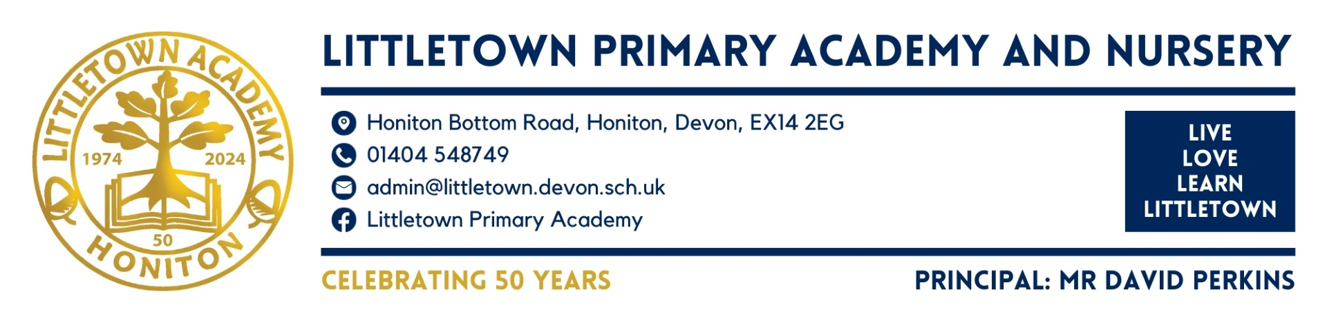

Key Stage 1 class teacher starting September 2024 - Full Time Permanent Post

At Littletown Primary Academy, we aim for a high standard of education for all children that offers a wide range of learning opportunities. We have high expectations of behaviour that are based on respect, positive rewards and developing children’s sense of responsibility and self-esteem.
We pride ourselves on our caring and supportive environment. We encourage special talents, skills and interests such as Technology, music, sport and art. We aim for children to be healthy, safe and to play an active part in the school and wider community.

The children, staff and governors at Littletown Primary Academy are looking for a teacher who is:
• Passionate, creative and committed.
• Committed to all children.
• Committed to safeguarding and promoting the welfare of all children.
• An excellent practitioner with excellent classroom management skills.
• Able to plan and assess effectively for all children.
• Able to promote high standards of achievement and behaviour.
• Supportive of the ethos of the school.

In return, we can offer you:
• A nurturing and exciting place to learn and work – Ofsted 2019
• Enthusiastic children who want to do their best.
• Supportive parents.
• Happy staff, who work together as a team.
• A commitment to professional development.
• A vibrant school with good resources.

Littletown Primary Academy is committed to safeguarding and promoting the welfare of children and young people and expects all staff and volunteers to share this commitment. Please find our Safeguarding Policy on our Website https://www.littletown.devon.sch.uk/website. As part of our Safer Recruitment all shortlisted candidates will have an online search. The successful candidate will be required to have an Enhanced Disclosure and Barring Service check in line with the Government’s safer recruitment guidelines. Littletown Primary Academy is committed to equal opportunities.

Visits to the school are actively encouraged.
Applications from ECT candidates would be warmly welcomed.
Please email admin@littletown.devon.sch.uk if you would like to arrange a school visit.
Closing date for application: 1st May 2024

