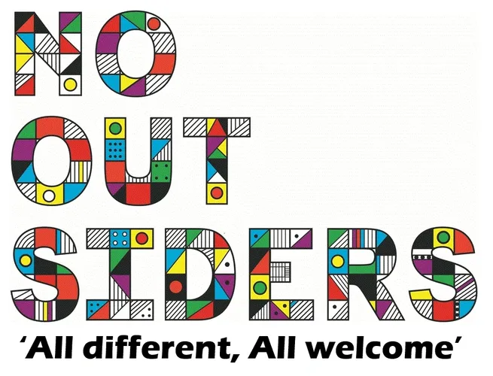

What is No Outsiders?
Our Vision: Inclusive education, promoting community cohesion to prepare young people and adults for life as global citizens.
No Outsiders is a charity started by Andrew Moffat MBE which uses picture books to teach about difference and equality. Difference is protected under British Law and there are very clear aims in the Equality Act which provide guidance for schools to: have due regard for the need to eliminate discrimination, promote equality and opportunity and foster good relations between different people.
Earlier this year we shared our PSHE curriculum unit 'Celebrating Difference’ in the newsletter with you alongside our work to become a Rights Respecting Schools, (with our recent achievement of the Bronze award), both closely a-lining with the No Outsiders program.
We are extremely thankful to the PTFA who have kindly supported us becoming a No Outsiders school and have funded the No Outsiders picture books for the whole school to use within our end of the day allocated story time.
Please see the link below which gives a little more information about No Outsiders from Andrew Morrit.
Teaching children diversity and tolerance | Andrew Moffat, Birmingham | Global Teacher Prize
Mrs Hawkins

