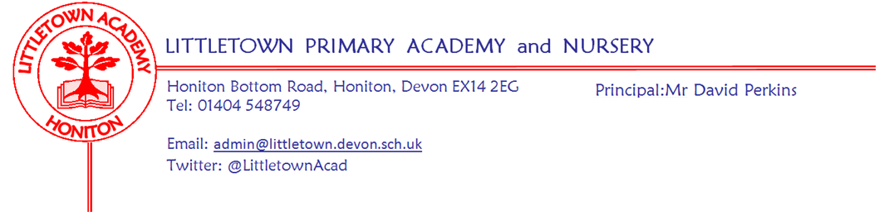

Live . Love . Learn - Littletown
Reception Summer Term 2023 Information
We hope you had a lovely Easter break with your family and we also hope you enjoyed sharing your child’s Tapestry with them and your close family, to celebrate their learning last term. We are looking forward to this new term and starting our engaging Sealife Cornerstones project.
As we head into Summer we will be spending more time outside and using the field for PE. Please apply suncream in the morning before school to last throughout the day - we cannot apply in school. Also ensure your child is wearing sensible footwear (open toed shoes/sandals are not allowed) and has a named sunhat in school.
Literacy
In literacy we will be continuing with our daily Read Write Inc sessions to support children’s reading and writing as well as our daily handwriting. This term children are developing their sentence writing and ensuring they are using fingers spaces, full stops and capital letters at the beginning. We are continuing to practise clear correct letter formation to write recognisable letters and ensure our writing can be read by others. Levelled activities to support your child's reading and writing are available on the school website including handwriting practise sheets.
Children will continue to have access to a range of writing materials for free writing including books, cards, lists, invitations and letters. If you are writing with your child at home please ensure they are holding their pencil correctly and firmly. Please also encourage writing in lowercase letters apart from at the start of their name or at the beginning of a sentence. We will continue to develop language through information books, storytelling, small world play and role play.
Please record any book reading and reading activities, including learning sounds, in your child’s Reading Record. The expectation is for parents to record in the book at least 4 times a week and staff check the Reading Record once a week. You can just write ‘book’, ‘sounds’ or more if needed e.g. if your child has found the book tricky or is struggling with a particular sound.
Book Packs (the plastic wallet) with the reading record and reading book)) must be in school every day. Children will not be given a book without a book pack as they protect our new books.

In school we have phonic lessons daily alongside supporting the children with their sounds. However, in order to make progress with their reading and writing, children need to read regularly and practise learning their new phonic sounds at home. For support please have a look at the school website and/or Tapestry.
Maths
In maths we will be continuing recognising and ordering numerals 1-20 and beyond and working on knowing 1 more and 1 less of any number. We will be learning to add and subtract to 10 and beyond, using objects and number lines for support to solve simple maths problems. We will be recalling number bonds to 5 and working on finding and knowing number bonds for all numbers to 10. We will also be looking at 3D shape, weight and capacity.
We have done a lot of work already in Reception subitsing amounts up to 10, counting and reciting numbers, teaching children to count with 1:1 correspondence; saying a number name after each object is counted. At home please ensure they are touching items when they are counting and ask them ‘how many’ when they have finished. Around the home continue counting e.g. stairs, teddies, food and look at numbers in the environment when you are out and about or around the home. Play games, puzzles, sing number songs or listen to number rhymes on the BBC Children’s Radio (https://www.bbc.co.uk/teach/school-radio/nursery-rhymes-songs-index/zhwdgwx?scrlybrkr ).

PSHE (including Relationship, Sex and Health Education) - Jigsaw
Relationships topic: For the first half of the summer term, with Jigsaw Jennie and Jerrie's help, we are learning how to make good friends to stop ourselves feeling lonely, think of ways to solve problems to stay friends, understand the impact of unkind words and learn to manage our feelings.
Changing Me topic: More information to follow.

Our Topic - Under the Sea
This term we are going to learn about some amazing creatures that live under the sea. There’s an exciting world below the surface of the ocean and we are excited to visit Plymouth Aquarium next week to inspire and excite the children about this terms learning.
Using our art skills we’ll make portholes, sea vehicles and sea creatures using a range of different materials. We will be doing observational drawings of shells and looking at the different textures on their surface. We’ll explore floating and sinking and the properties of different materials.
We’ll listen carefully to lots of stories and poems about the ocean and creatures that live in the sea. By reading non-fiction books, we’ll find out lots of interesting facts, for example; discovering how many different types of sharks there are, how jellyfish and octopus move and how sea creatures protect themselves from danger. Some of our favourite stories are: Commotion in the Ocean, Shark in the Park, A Hole in the Bottom of the Sea and The Fish who could Wish.
In our ‘seashore cafe’, we’ll take on different roles and think about how we speak to each other. Using our mathematical and literacy skills, we’ll create menus, take peoples orders, sell items and add amounts together.
Help your child prepare for their project
Rock pools are remarkable places. Why not visit your local beach and see what you can find or visit the library to find out all about your favourite creature that lives in the sea? You could also create fantastic seashore collages using recycled materials. Alternatively, make a miniature ‘beach in a box’ using sand, pebbles, shells and toys.

Key reminders
Outdoor Classroom: Outdoor Classroom will continue every week on Fridays. If we ever need to change our plans for outdoor classroom because of special events, children should continue to come in non-uniform on Fridays. As we are in Summer please ensure your child has a sun hat and sun cream applied at home before school.
Book Bags: Please bring book bags to school every day (with your child’s Reading Record and reading book).
Water Bottles: Please ensure your child has a bottle of water (not juice) in the classroom for drinking throughout the day. They may have juice in their lunchbox but no fizzy drinks. Water bottles are refilled throughout the day by staff.

Packed Lunches: We have peanut allergies in school so we ask that no children have nuts or nut based snacks/spreads in their lunchboxes. We are a healthy school and ask that children do not bring in chocolates or sweets for lunch.
School Dinners: Please ensure you book your child’s school dinner by Friday midnight for the following week. If your child does not eat enough school lunch we will send a note home to inform you.

Medication: Please let us know if your child has to take any prescribed medication at school. There is a green form for you to fill in so that we can administer it. We can only give prescribed medication and the medication must have the prescription label on. Please phone the school if your child is off sick. If you have a medical appointment please let the office know.

Birthdays: If it is your child’s birthday they can come to school in their home clothes. Please do not bring cake/sweets in to share.

Toys: We ask that toys/valuables are not brought into school.

Junk Materials: We are desperate for yogurt pots, small boxes (not cereal size boxes) and cardboard tubes (not toilet rolls). Please ensure they are clean because the children use these to build models with.
Key dates for the Autumn term
Wednesday 26 April Reception trip to Plymouth Aquarium
Monday 1 May Bank Holiday
Monday 8 May Bank Holiday
Friday 26 May Break up for half term (1 week)
Monday 5 June Return to school
Tuesday 11 July Foundation Stage Sports Day (am) - (Reserve Date in case of bad weather Tuesday 18 July)
Tuesday 25 July Break up for Summer Holiday
Thank you for your support,
Miss Croft, Mrs Katene & Mrs Hawkins
Miss Croft’s Class: classrnc@littletown.devon.sch.uk Mrs Katene & Mrs Hawkins: classrnkmh@littletown.devon.sch.uk

