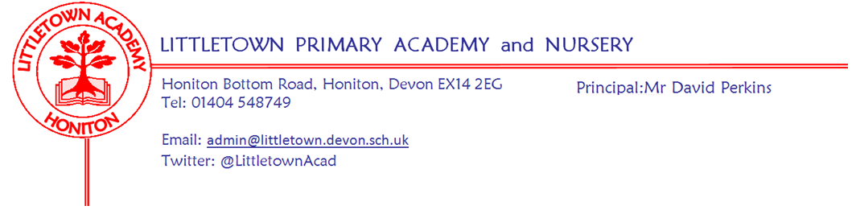
Nursery Summer Term 2023 Information

Welcome Back!: We hope you have all had an exciting and relaxing Easter holidays. We hope your child is excited to be back at Nursery for our Summer Term. We are thrilled with how settled and happy all the children seem to be, but please do speak to us if you have any concerns.

Topic: This half-term, we will be enjoying a topic that has been chosen and planned following the children’s interests. We will be thinking about farms, farming and the animals we might find on a farm in our topic ‘Who’s down at the farm?’. We will also continue to think about Spring, Summer and the changes we see during these seasons.

We will continue having daily phonic inputs where we will developing the children’s listening skills, thinking about rhythm and rhyme, and zipping sounds together to make words (blending – c-a-t, cat), the first step in learning to read, as well as breaking words down using ‘robot talking’ to segment words into the sounds that make them (cat = c-a-t), the first step in learning to spell. For those children who are ready and are showing an interest, letter sounds will be introduced to the children during their play. In the first half-term, we will be introducing the pictures from the Read, Write, Inc. phonics scheme that are associated with each letter sounds, to help them become familiar with these. After half-term, we will start to teach the first set of letter sounds during our phonics sessions. There will be lots of opportunities daily to work on the children’s fine motor control including; cutting with scissors, pencil grip and control and strengthening the muscles in our hands and fingers using playdough etc... We will also be providing lots of opportunities for the children to mark-make in their child-initiated learning and encouraging children to continue trying to write their names.

In maths we will be consolidating our number work so far this year, ensuring children are secure with recognising numbers, counting out the correct number of objects to match these numbers and counting beyond 10. eWe will explore positional language, 2D and 3D shapes and numbers that are 1 more and 1 less than a given number.

In our Jigsaw (Personal, Social and Health Education) lessons, we will be thinking about ‘Relationships’, focusing on who is in our family, making friends, dealing with conflicts with friends, managing our feelings and working together with our friends.

Routine reminders:
Dropping off at the start of the day: Please remember that our Nursery start time is 9am. Children can be dropped off from 8.55am, unless your child is booked into Breakfast Club.

Collecting at the end of the day: Our doors open at 2.50pm for afternoon collection. Please ensure that if someone on your named list is collecting your child after Nursery, that they know your chosen password. Your child’s safety is of the utmost importance to us so they will be asked for this.
Clothing: Please ensure all items are named including shoes and wellies.

Sunhats and sun-cream: Please ensure your child has a named sunhat at Nursery every day. All children need to have sun-cream applied before they arrive at Nursery. Most sun-creams are water resistant and last at least 6 hours. We will make sure the children do not spend extended periods of time directly in the sun. Please do not send your child with any sun-cream in their bag.

Footwear: During the summer term we will aim to have the climbing tower open as much as possible. If girls wear skirts, they sometimes like to wear shorts underneath. As stated in our risk assessment, children will only be allowed to use the tower if they are wearing suitable footwear. Children wearing open-toed sandals, Crocs or welly boots will not be able to use the tower as these shoes do not provide enough grip.

Book Bags: All children in Nursery have a book bag. Please encourage them to bring their book bag each day in order to put their letters and creations inside. Please do not send any other bags such as rucksacks. We try to limit the amount of things coming into Nursery from home and we simply don't have room for the children to bring and store rucksacks every day. We will continue to support the children with choosing two books each week to bring home and share with you. Please ensure all books are returned to Nursery. If you find you have a book which is damaged, please hand it to a member of staff so that we can throw it away and replace it. No child gets excited or enthusiastic about a book which is torn or damaged!

Outdoor Classroom: Our ‘Little Explorer’ sessions will continue this term, they will start this week, and will be on a Thursday until May half term. Please see further details about these sessions further down this letter.

Water Bottles: Over the Summer Term we will really be focussing on developing the children’s independence, including encouraging them to recognise when they are hungry and thirsty. Children need to continue to bring in water bottles but these will be saved for lunchtime and when we have a drink during our end of the day story. During the day, children will have access to a water station where they can access cups and jugs of water. They will be frequently reminded and encouraged to go and pour themselves a drink. This will also develop their strength and control when lifting and pouring from jugs. In addition to this we will operate a ‘snack cafe’. During the morning we will open the ‘snack cafe’ and children will be encouraged to come and get themselves a drink (milk or water) and fruit, when they feel hungry and thirsty. They will need to wash their hands first, post their name card into the postbox to say they have come for their turn, and then sit and drink/eat their chosen drink and snack in the snack cafe. The name card system will ensure that we can check all children stop at some point to come and have their drink and fruit. The cafe will be manned by an adult who will support hygiene, name recognition, selection etc… They may have juice in their lunchbox but no fizzy drinks.

Packed Lunches: We have peanut allergies in Nursery so we ask that no children have nuts or nut based snacks/spreads in their lunchboxes. We are a healthy school and ask that children do not bring in chocolates or sweets for lunch.
Toys: We ask that toys/valuables are not brought in to school, unless by prior arrangement with a member of staff.

Important Dates this half term:
Monday 17th April – Children return to Nursery
Monday 1st May - Bank Holiday
Friday 5th May - Coronation Celebrations - More details to follow
Monday 8th May - Bank Holiday
Friday 26th May - Children break up for the May half-term
Monday 5th June – Children return to Nursery
Wednesday 28th June - Nursery Trip to Northcott Theatre, Exeter to see ‘The Snail and the Whale’
Friday 30th June - Summer Fete
Tuesday 11th July - Morning - Sports Day
Tuesday 18th July - Morning - Reserve Sports Day
Tuesday 25th July - Last day of term

‘Little Explorer’ sessions

This term, we will continue our ‘Little Explorer’ sessions. During these sessions, we will use a variety of areas around the school, including our own garden, the wildlife area next to the nursery, the pond area and the field.

The Nursery children will enjoy their ‘Little Explorer’ sessions, every Thursday morning, beginning on Thursday 28th April, for up to an hour. After the May half-term, our sessions will swap to a different day and will continue to change each half term, so that throughout the year, all children have the chance to have at least one half term of ‘Little Explorer’ sessions.

On this day, please ensure your child is appropriately dressed for being outdoors i.e. jeans and tracksuit bottoms (not best clothes – they will get extremely muddy). They will need to wear their normal shoes to Nursery and bring named welly boots in a separate named carrier bag. If they have an all-in-one puddle suit, please provide this too. Please could you provide the following items in a named bag and place on the rail outside in the morning:

Wellington boots are essential!
Clothes appropriate for weather – hats, gloves, warm waterproof coat/ puddle-suit etc.
A sunhat and sunscreen already applied if the weather is good.

In preparation for these sessions, please practise with your child the routine of taking their shoes off, placing them in their carrier bag, and putting their own wellies on, as well as the process in reverse! We will be working outside in all weathers, except in extreme weather conditions!

