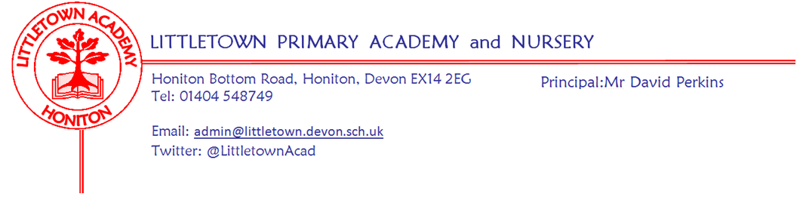

Live . Love . Learn - Littletown
Year 3 Summer Term 2023 Information

We are very pleased to be welcoming the children back after the Easter Holidays. We have lots of exciting activities planned for the children to help them with their learning this term.
Literacy
For the first part of the spring term, we will be reading Journey by Aaron Becker. The final writing outcome for this text will be to write an adventure story. During the second part of the spring term, we will be reading Zeraffa Giraffa by Diane Hoffmeyer.

Maths
This term will focus on fractions, time, angles & properties of shape, mass and capacity. The children will continue to develop their multiplication facts fluency using Times Tables Rock Stars.

Cornerstones Topics
Our main topic for this term is ‘Emperors and Empires’. We will send a letter home with more information including ways to support your child at home with this theme. This theme will continue for the whole of the summer term.
Our first Science unit will be ‘Plant Nutrition and Reproduction’ and after half term, ‘Light and Shadow’.
During art, the children will be drawing and painting fruit, vegetables, and plants, in our topic ‘Beautiful Botanicals’. They will then move on to making their own mosaics. After half term our DT topic will be ‘Greenhouse’ - more information will follow about our next DT Day.

PSHE (including Relationship, Sex and Health Education)
Relationships: In this unit, we will be focussing on family roles and responsibilities, friendships, keeping safe online and being a global citizen.
Changing Me: This topic will cover Relationships and Sex Education. Further, more specific details will be sent out separately nearer the time.

P.E
During the first half of term, our indoor P.E unit will be swimming and our outdoor unit will be athletics - we will also be preparing for our Sports Day. After half term, our indoor unit will be dodgeball and our final outdoor games unit will be rounder’s!

Computing
Using Purple Mash we will be learning how to create spreadsheets. After half-term we will move on to look at databases.

Music
In music we will be listening to and appraising different types of classical music, as well as singing and playing instruments. We will continue to work on pulse and rhythm, glockenspiel skills and learning to sing new songs.

R.E
In RE we will be comparing and contrasting festivals and pilgrimages within Buddhism, Judaism and Islam.

Key reminders
P.E. All children will need to wear their PE kit on their timetabled PE days of Monday & Wednesday for both classes. They are also allowed to wear navy blue tracksuit bottoms when the weather is colder (PE hoodies are now also available to buy, these are only for PE). Please remember to name all kit and uniform just in case it is mislaid by the children.
Swimming: Children will need swimming kits every Tuesday between 25th April and 13th June. Children will not need a PE kit on the Monday of these weeks.
Reading Records: Reading Records need to be handed in to school on a Monday and House Points will be given if children have read five times in a week. Children can record their own reading in their Reading Record but please could you check they have completed it before they hand it in.

Home Learning: Cornerstone home-learning activities will be sent home at the beginning of each new topic which are optional to do and children will be able to earn House Points for each piece completed. We will also share their work as a class towards the end of the topic. We will expect children to learn multiplication facts using Times Tables Rock Stars. Please let your teacher know if your child does not have access to a computer to do Times Table Rock Stars and we will provide them with the opportunity to access it during the school day. Weekly spellings will be put into Reading Diaries every Monday and children will be quizzed on these spellings the following Monday. Children have the opportunity to learn these spellings at school, but have the option of practising them at home too, if they wish!

Water Bottles: Please ensure your child has a bottle of water (not juice) in the classroom for drinking throughout the day. They may have juice in their lunchbox but no fizzy drinks.
Packed Lunches: We have peanut allergies in school so we ask that no children have nuts or nut based snacks/spreads in their lunchboxes. We are a healthy school and ask that children do not bring in chocolates or sweets for lunch.
School Dinners: Please ensure you book your child’s school dinner by Friday midnight for the following week. If your child does not eat enough school lunch we will send a note home to inform you.

Medication: Please let us know if your child has to take any prescribed medication at school. There is a green form for you to fill in so that we can administer it. We can only give prescribed medication and the medication must have the prescription label on. Please phone the school if your child is off sick. If you have a medical appointment please let the office know.

Birthdays: If it is your child’s birthday they can come to school in their home clothes. Please do not bring cake/sweets.
Key dates for the Summer Term

Swimming Dates: Tuesday 25th April - Tuesday 13th June 2023
May Day Bank Holiday: Monday 1st May 2023
King’s Coronation Bank Holiday: Monday 8th May 2023
Half Term: Monday 29th May - Friday 2nd June 2023
Roman Day: Tuesday 20th June 2023
Outdoor Classroom: Tuesday 27th June 2023 (for both classes)
Year 3 and 4 Sports Day: Wednesday 12th July am (Reserve Wednesday 19th July am)
End of Term: Tuesday 25th July 2023

Thank you for your continued support,
Mrs Davis, Mrs Searle, Miss Bodgin and Mrs McFadden

Mrs Searle & Mrs Davis: class3jssd@littletown.devon.sch.uk

Miss Bodgin & Mrs McFadden: class3rbam@littletown.devon.sch.uk

