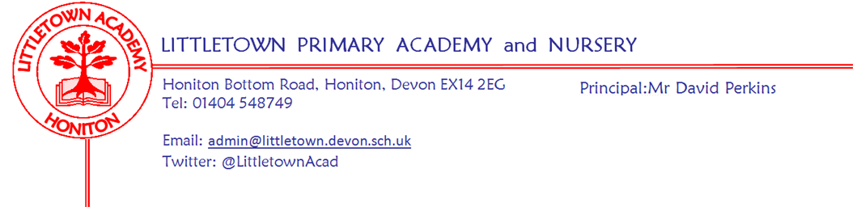
Year 5 Summer Term 2023 Information
Literacy
Our writing outcomes for this term are persuasion/information: hybrid leaflet and an information text for a gallery. They will also be given a list of spellings that they will become familiar with throughout the week via various activities. We ask that these spellings are practised at home. Reading comprehension skills will be developed through a discrete weekly sequence of lessons. The reading comprehension texts will link with the writing texts each half term.
Maths
Maths is taught 5 times a week using Power Maths. Each lesson begins with a power up that is designed to give the children a quick reminder of past learning. We then move on to the main focus of that day’s lesson. This term, we will be focussing on

- Decimals and percentages
  - Writing thousandths as decimals
  - Ordering and comparing decimals
  - Rounding decimals
  - Understanding percentages
  - Equivalent fractions, decimals and percentages
  - Formal written methods for multiplication and division
- Decimals
  - Adding and subtracting decimals
  - Decimal sequences
  - Problem solving involving decimals
  - Multiplying decimals by 10, 100 and 1,000
  - Dividing decimals by 10, 100 and 1,000
- Geometry - properties of shape
  - Measuring angles in degrees
  - Measuring with a protractor
  - Drawing lines and angles accurately
  - Calculating angles on a straight line and around a point
  - Calculating lengths and angles in shapes
  - Recognising,drawing and reasoning involving parallel and perpendicular lines
  - Regular and irregular polygons
  - Reasoning about 3D shapes
- Geometry - position and direction
  - Reflection/reflection with coordinates
  - Translation/translation with coordinates
- Measure - converting units
  - Metric units
  - Imperial units of length, mass and capacity
  - Converting units of time
  - Timetables
  - Problem solving - measure
- Measure - volume and capacity
  - Comparing volume
  - Estimating volume
  - Estimating capacity

History
This half term, our driver topic is Groundbreaking Greeks. This project teaches children about developments and changes over six periods of ancient Greek history, focusing on the city state of Athens in the Classical age, and exploring the lasting legacy of ancient Greece.

Design and Technology
Our design and technology companion project for this term is Architecture. As part of the project, the children will learn about how architectural style and technology has developed over time. They will use this knowledge to design a building with specific features.

Science
During our science companion project Properties and Changes of Materials this term, the children will explore the wider properties of materials and their uses. They will learn about mixtures and how they can be separated using sieving, filtration and evaporation. The children will study reversible and irreversible changes and use common indicators to identify irreversible changes.

Art and Design
During our art and design companion project Mixed Media this term, the children will learn about paper crafts, papermaking and collage techniques including paper, fabric, mixed media and photo collage. They will use what they have learnt to create a final small-scale mixed media collage.

The children will also learn about the expressionist art movement and the ‘Father of Expressionism’, Edvard Munch, through our second art and design companion project Expressionism.

PSHE (including Relationship, Sex and Health Education)
During the first half of the term, we will be looking at the Jigsaw unit Relationships. Within this unit, we will be focussing on recognising me, safety with online communities, being in online communities, online gaming, my relationship with technology: screen time and relationships and technology.
After half term, our focus will be ‘Changing Me’. More information about what we will cover during this unit will follow.

Music
During the first half term, we will study musical elements based around the song Dancing in the Street by Martha and the Vandellas. The children will learn through an integrated approach to music where games, the dimensions of music (pulse, rhythm, pitch etc), singing and playing instruments are all linked.

The last half term will see the children consolidate their learning from throughout the year. They will revisit songs and musical activities as well as the following areas of study;

- Listening and appraising classical music
- Embedding the foundations of the interrelated dimensions of music using voices and instruments
- Singing
- Playing instruments within the songs
- Improvisation using voices and instruments
- Composition
- Sharing and performing the learning that has taken place

Religious Education
Over the course of the first half term, we will be looking at the religious festivals Pentecost (Christianity). During the final half term, the children will learn about Guru Arjan Gurpurab (Sikhism).

French
The final areas of study for the year will be Ma Famille (my family) and Au Salon du Thé (at the cafe).

Computing
We start off the term finishing off some learning based around Coding. Then, we move onto Spreadsheets where the children will learn to use various functions within spreadsheet software, such as conversion of measures, formulae and calculations.

Physical Education
The term begins with a focus of Athletics in our outdoor PE sessions and Indoor Adventurous Activities during our indoor PE sessions

In the final half term of the academic year, the children will develop their skills within Rounders for outdoor PE and will take part in some Yoga sessions during indoor PE
Key reminders
PE Kit: Please remember that PE kit should be worn into school on PE days. In year 5, our PE days are Tuesday and Thursdays. On swimming days, the children are welcome to wear their PE kits with their swim wear underneath.

Uniform: Please name all items of school uniform.

Home learning: Reading Diaries should be handed in to your child’s class teaching assistant every Monday. Please ensure that your child is recording their reading and that you sign to say that they have read. Please encourage your children to read at home at least 5 times a week, ideally for 20 minutes every day. Remember that all reading is valuable. Additional reading materials can be found on Lexia and Oxford Owl, (https://www.oxfordowl.co.uk/for-home/find-a-book/library-page/). Your child can of course read any book from home.

Please encourage your child to use Times Tables Rockstars as much as possible to practise their multiplication and division facts.

Ideally, for home learning in Year 5 we expect...
Reading at least 5x a week
Spelling practice regularly
TTRockstars regularly
Topic activities - just pick a few things over the course of the half term, linked to our topic.

Water bottles: Please ensure your child has a named bottle of water to drink in the classroom every day.

Medication: Please let us know if your child has to take any prescribed medication at school. There is a green form for you to fill in so that we can administer it.
Weather: If the weather forecast for the day is sunshine, please make sure your child comes to school with a hat. At this time of year, it is vital that your child brings a coat to school as rain can suddenly
Belongings: Please ensure that you are only sending your child into school with the things they need for that day. We are trying to minimise cloakroom traffic and if possible, eliminate the need for large school bags.
Packed Lunches: We have peanut allergies in school so we ask that no children have nuts or nut based snacks/spreads in their lunchboxes. We are a healthy school and ask that children do not bring in chocolates or sweets for lunch.

Key dates for the Spring Term
Monday 1st May - Bank Holiday (May Day)
Monday 8th May - Bank Holiday (King’s Coronation)
29th May - 2nd June - Half Term
12th July (afternoon) - Year 5/6 Sports Day

Thank you for your support,
Mr Priddle and Mrs Heywood
Mr Priddle’s Class: class5cp@littletown.devon.sch.uk
Mrs Heywood’s Class: class5zh@littletown.devon.sch.uk

