Littletown Primary Academy
Honiton Bottom Road, Honiton, Devon, EX14 2EG
01404 548749
admin@littletown.devon.sch.uk
www.littletown.devon.sch.uk

TEACHING AND LEARNING POLICY
This Policy was adopted by the Full Governing Body of
Littletown Primary Academy

on……………………………………..

signed…………………………………………………..
(Chair of Governors

Date Policy to be reviewed on:

…………………………………
LITTLETOWN PRIMARY ACADEMY and NURSERY

Teaching and Learning Policy

Introduction
Children learn through their total experience. This policy guides what children do, what teachers do, how time is managed, the organisation of the classroom and what the school as an organisation does to create an effective, safe and inspirational learning environment in which the individual needs of each child can be met.
At Littletown Primary Academy we believe in the concept of lifelong learning and the idea that both adults and children learn new things every day. We maintain that learning should be a rewarding and enjoyable experience for everyone. Through our teaching we equip children with the skills, knowledge and understanding necessary to be able to make informed choices about the important things in their future lives. We believe that appropriate teaching and learning experiences help children to lead happy and rewarding lives.

‘Learn’ is one of school values and underpins school life in and out of lessons as follows:
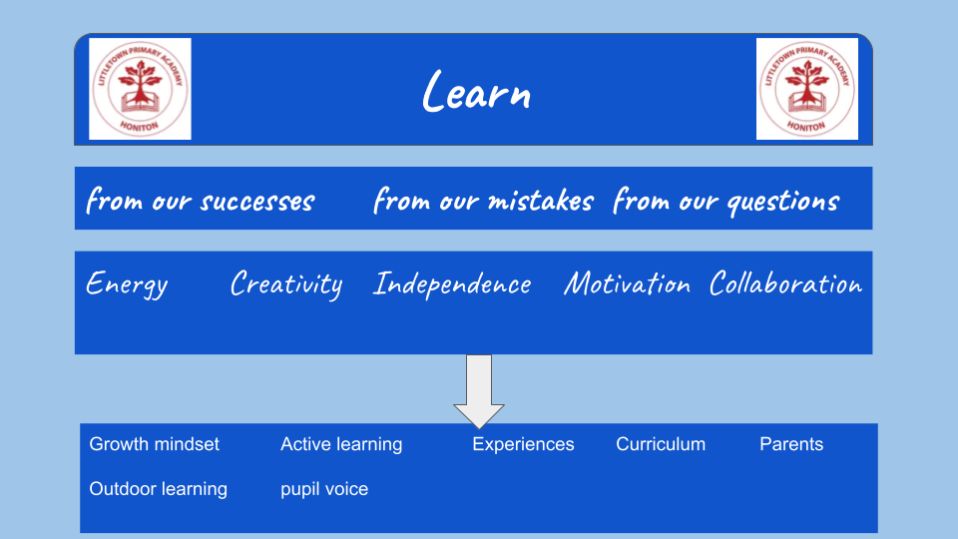

Aims and objectives

Through our teaching we aim to:

- Remove all barriers to aspiration and achievement
- Offer a wide range of opportunities for all
- Develop pride and respect towards self, others and the environment
- Develop independent and creative thinkers who enjoy learning
- Develop resilience and perseverance through metacognition and growth mindset
- Create an ethos that is safe, caring, happy, supportive and welcoming
- Have a strong partnership with parents, carers and communities
Children at Littletown should have the opportunity to:
- Succeed across the curriculum
- Feel safe and valued; have the confidence to question
- Develop and extend their learning
- Develop their strengths and improve areas for development
- Learn in a range of ways including actively and independently
- Be supported and led when required
- Be challenged
- Given a voice
- Explore and evaluate in each lesson
- Access quality resources
- Collaborate with others and learn from each other
- Celebrate successes

As part of our curriculum development we have developed five pillars that underpin Littletown Learning.
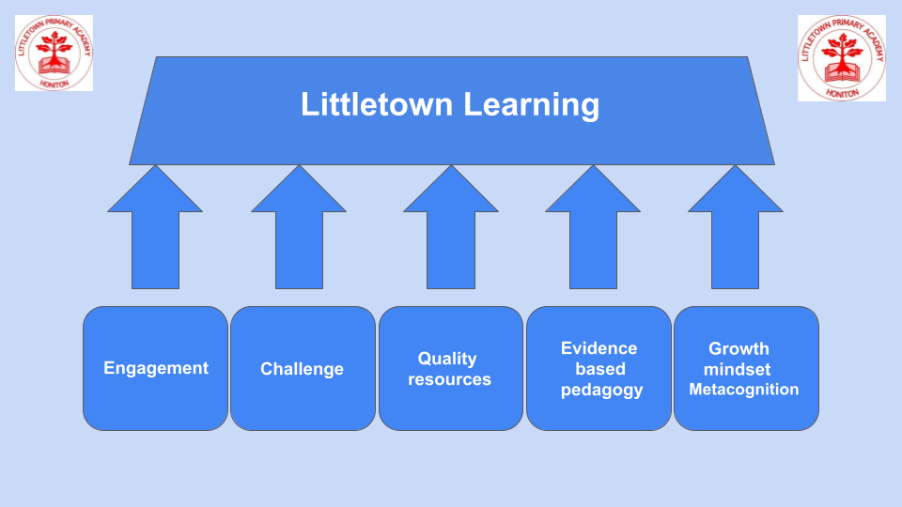
These five pillars are understood and discussed with the children via the child friendly version in the form of the Littletown Learning Rocket:
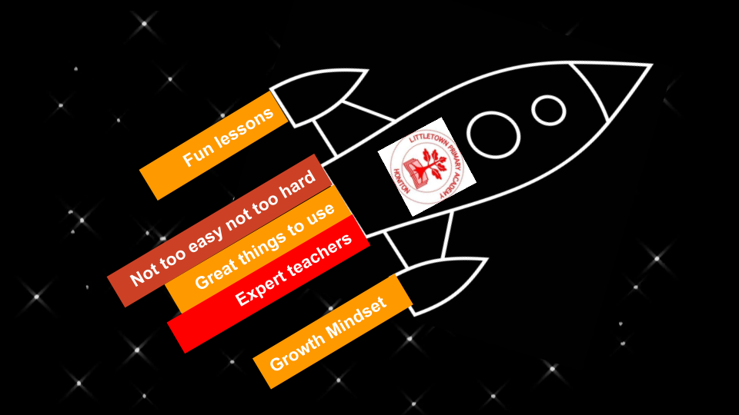

Engagement
We want the children to fall in love with the subjects they study at our school. Our curriculum design intends to ensure high levels of engagement and enjoyment in all subjects motivating children to want to learn and want to produce high quality learning for genuine purpose and/or audience. However, focus remains on engagement with learning objectives rather than just activities. ‘Engage’ is the first cornerstone of the four cornerstones which underpin the pedagogical pathway through the Cornerstones curriculum which is used in the school as a vehicle for several subjects.

Challenge
Mastery approaches and clear progression in planning of lessons ensure children engage with high levels of challenge. Low threshold, high ceiling activities are used wherever possible and curriculum vehicles with inherent mastery approaches ensure children spend the vast majority of their learning time in their zone of proximal development (Vygotsky 1978). The term “proximal” refers to those skills that the learner is “close” to mastering. Teachers are accountable for ensuring children receive the right level of challenge and support/scaffold to remain in this zone. Children understand this ‘sweet spot’ of challenge as their ‘goldilocks zone’ and it is discussed regularly in classrooms. Attitudes to challenge are reflected within the Growth Mindset pillar below.

Quality resources
Just as Formula 1 drivers don’t waste their time building their car from scratch, we don’t expect teachers to design the curriculum from scratch. As Formula 1 drivers solely focus on getting their car around a specific circuit as quickly as possible, we want teachers focussed on delivering curriculum content as well as possible to meet the needs of their specific classes. We have therefore researched, selected and adopted high quality evidenced based curriculum vehicles which ensure consistency, progression, coverage, breadth and research based pedagogy for the specific subjects. Many of these have been sourced and proposed by subject leaders in the school. Details on these can be found in brief below and in more detail via individual subject curriculum statements.

Evidenced based pedagogy and ongoing research
Teaching and learning reflects current impactful research which is shared, discussed and implemented as part of ongoing Continued Profession Development for staff. This includes philosophies such as Cognitive load theory, Rosenshine principles for guided instruction and research conducted by the Educational Endowment Foundation amongst others. The National College is used as the main medium for exposure to pedagogical theory and research and is regularly followed up and revisited in staff meeting discussions.

The school will always seek opportunities to engage with and learn from current academic pedagogical research. This may result in deviance from the above policy for periods of time for some classes/year groups/subjects as the school trials approaches or is an early adopter of curricular resources such as the PSHE curriculum in 2019. This is all part of our culture of a perpetually improving school.

Learners as individuals

We acknowledge that people learn in many different ways. We take into account these different forms of intelligence when planning teaching and learning styles.
We offer opportunities for children to learn in different ways. These include:
- investigation and problem solving
- research
- group/paired work
- independent work
- use of technology
- fieldwork and visits to places of educational interest
- participation in athletic or physical activity
- guest visitors and performers
- learning for purpose and presenting/expressing learning

Outdoor classroom, in our outdoor learning area or beyond, will be planned weekly for the foundation stage and once every half term for key stages one and two, with a focus on problem solving and team building.

Subjects

Our curriculum is arranged in subjects which match the National Curriculum. All subjects have a subject leader who report to and work alongside the Principal and Senior Leadership Team to improve provision and outcomes. High quality, evidence based pedagogical approaches and curriculum vehicles are used to support teachers in delivering this curriculum to the highest level. Regular monitoring and evaluation which includes evidence gathering and pupil voice ensure impact matches curriculum intent. Curriculum vehicles can be found in Appendix A.

Principles of lesson structure

All lessons are different and subjects, classes and content all require individual consideration in lesson planning. However, at Littletown we focus on the vast majority of lessons following broadly the following structure to maximise learning time in lessons:
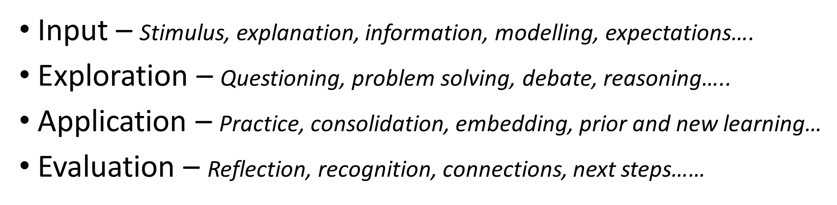
Exploration and Evaluation are crucial to ensure a mastery approach to learning in all subjects and to ensure new knowledge commits to working memory and then long term memory.

When planning learning for children with special educational needs, we give due regard to information and targets contained in the children’s Education Health Care Plans and ‘My Plans’ which are continually updated on our ‘Provision map’ monitoring system. Teachers modify learning and teaching as appropriate for children with disabilities.

We seek to extend learning opportunities for children who have a particular gift or talent.

Teaching Assistants (TAs) are used effectively to support learning. Sometimes they work with individual children or small groups both inside and outside of the classroom depending upon the nature of the learning involved. Teaching Assistants do not work solely with lower ability groups, but work across the full range of abilities so that all children get individual/ small group time with the class teacher over time.

Teaching Assistants may be involved in some planning and assessing of children’s work. However, the teacher is accountable for outcomes and has overall responsibility for the learning that takes place in TA led groups.

Learning environments

We provide a rich and varied learning environment, both indoors and outdoors, that allows children to develop their skills and abilities to their full potential. We believe that successful learning takes place most in an environment that is:
- Safe, both physically and in terms of relationships
- Controlled and well organised with familiar routines
- Fit for purpose
- Stimulating
- Positive
- Inspiring

Resources and environments consider Cognitive Load Theory in ensuring stimulus does not overwhelm learners.

We strive to make sure our classrooms are attractive learning environments.

Our displays will achieve one or more of the following:
- Support, revise and extend learning
- Celebrate and value children’s work
- Prompt ideas
- Remind children of key facts and vocabulary
- Help with self/ peer and class assessments and targets

Monitoring and Evaluating learning

Monitoring and evaluation of teaching and learning is conducted via learning conversations and lesson visits. We do not conduct lesson observations. A conversation with the visited teacher takes place before and after the lesson visits using an agreed framework.

When monitoring and evaluating teaching and learning in a class or a subject the following are considered in dialogue with teachers:

- Classroom visits as part of Learning Conversations
- Discussions/ conferencing with pupils about their learning
- Learning Walk evidence
- Scrutiny of pupils’ learning
- Data conversations on progress and attainment
- Sharing pupils’ work with colleagues agreement, trialling and celebrating successes.

Role of the Parents/Guardians
Parents are partners in their child’s learning. We do all we can to inform parents about and involve parents in what and how their children are learning by:

- Holding parents consultation evenings to discuss children’s progress.
- Providing an annual report for parents in which we explain the progress made by each child and indicate how each child can be improved further.
- Termly curriculum newsletters for each year group
- Express events and celebrations of children’s learning
- Regular information and training to help them support their children at home

Role of the Principal and Governing Body

The Governing body alongside the Principal will:

- Support the use of appropriate teaching strategies by allocating resources effectively
- Ensure that the school buildings and premises are best used to support successful teaching and learning
- Monitor teaching strategies in the light of health and safety regulations
- Monitor how effective teaching and learning strategies are in terms of raising pupil attainment
- Ensure that staff development and performance management policies promote good quality teaching

Equal Opportunities
All children have equal access to the curriculum regardless of their gender, disability or ability. We plan work that is differentiated for the performance of all groups and individuals and are committed to creating a positive climate that will enable everyone to work free from any kind of intimidation and harassment to achieve their potential.
Review

September 2023

Appendix A
Curriculum vehicles (Implementation)

Subject | Curriculum vehicle | Pedagogical principles | Notes
Reading | Accelerated Reader | Children develop decoding and comprehension seamlessly and simultaneously  Children always select books matched to correct level
Writing | Pathways to write | Mastery approach rooted in quality texts
Maths | Power Maths | Mastery approach with consistent vocabulary and modelling  Follows ‘concrete, pictorial, abstract’ progression | Textbook resource with online teacher hub
Science
Geography, History, Art, Design Technology | Cornerstones Curriculum22 | A knowledge rich approach  4 phase structure using 4 cornerstones: Engage, Develop, Innovate, Express.  Purposeful learning outcomes for real audiences | Fully sequenced and interconnected curriculum
Computing | Purple Mash | Engaging, purposeful challenge or game based approach for computing knowledge and skills  Integrating 21st century life skills in use of technology | Utilised using individual pupil chromebooks
Religious Education | Devon agreed syllabus for RE | Open and enquiring approach to core concepts and making connections
Music | Charanga music | Highly engaging, knowledge and skill based.  Quality resources with clear progression | World leading resource with vast library of resources
Personal, Social and Health Education | Jigsaw PSHE | Mindful approach.  Spiral curriculum with consistency and progression  Includes emotional literacy, social skills and spiritual development | Includes whole school assemblies
Physical Education | Get Set 4 PE | Progressive activities with high engagement.  Differentiation to ensure challenge for all pupils
French | Language Angels | Designed by experts and language specialists | Year 3 - 6 only

