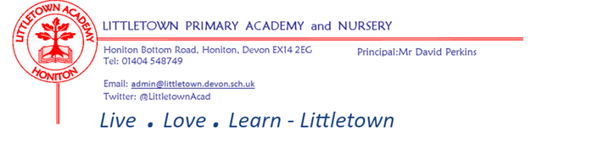VACANCY

Receptionist/Admin Assistant required 1st September 2025.

8.45am – 1pm Monday – Thursday and all day Friday - 23 hours per week

Permanent Term Time only – 39 weeks per year

Grade C - £12.85 - £13.26 per hour

We are seeking a hard-working and enthusiastic individual to join our friendly and busy admin team.

You will be the first point of contact for all visitors and telephone callers so possessing a friendly, approachable and professional manner is essential.

In addition, we are looking for a cheerful and motivated individual who:

- Has administrative and excellent communication skills;

- Enjoys working as part of a team;

- Works well under pressure;

- Is hard-working, efficient and energetic;

- Has excellent IT skills across a range of applications;

Experience of working in a school environment would be advantageous, but ability and aptitude are more important.

We are unable to accept a CV without a completed application form. Please collect application form from the school office.

We are committed to safeguarding and promoting the welfare of children and vulnerable adults, and expect all staff and volunteers to share this commitment.

This role requires a DBS disclosure. This role requires the ability to fulfil all spoken aspects of the role with confidence and fluency in English.