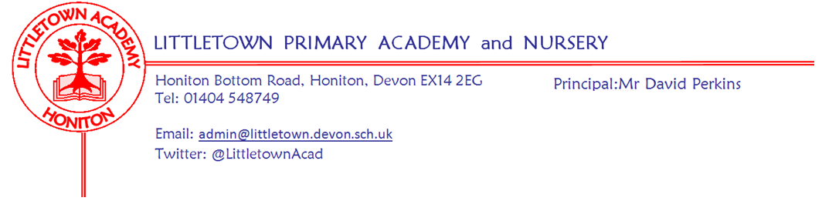
Friday 18th September 2020

Dear Parents and Carers,

I would like to start by wishing Mr and Mrs Perkins a huge congratulations from all of the children, staff, parents and governors on the safe arrival of their new daughter born last weekend. Mr Perkins has asked me to pass on his thanks for all of the best wishes he and his family have received this week.

I would also like to say what a super second week we have all had at Littletown. The children continue to amaze me with how quickly they have adapted to being back in school, their confidence and commitment towards their learning is already extremely impressive. l would like to give a special mention to our new Reception classes who have all been in together over the last 2 days. I have seen 58 smiles, heard 58 giggles, and would like to reassure all new parents how well they have settled into school life. However, I am very aware that they will probably tell you that they haven't done anything at school apart from play and eat lunch and in the next few weeks, as they get tired, they will probably quote to you that they have ‘done school!’

Curriculum Newsletters
Today you will receive your year group Curriculum Newsletters outlining the learning taking place this Term.

Lunches
Please remember to order your child’s school dinner by midnight Friday. You will need to order a lunch even if your child is entitled free school meals or Universal Infant free school meals.

Home learning for Covid related absences
If your child is at home isolating due to another family member being unwell/awaiting a covid test result but they are well in themselves please ensure you notify the school as there will be home learning available for your child via a padlet.

Hand Washing
Please feel reassured that hand washing in school is part of the school risk assessment and is an integral part of each class timetable. The children have become very familiar with these routines and I often see them walking around the classroom to ensure they are using the soap effectively for the appropriate amount of time. We have been seeking further guidance this week on the use of hand sanitiser in school, however, due to the majority of the sanitiser packaging saying ‘keep out of reach of children, high alcohol content’ and complicated first aid issues if consumed or if in contact with eyes we have have made the decision not to allow children to bring these in to school.

A Plea…..
It has been brought to my attention that some parents have been smoking whilst lining up outside of the school. Please can I ask all parents to be respectful of others and refrain from smoking in such close proximity to the children. May I also ask you to encourage your children to cross the road outside of school at the crossing area, a few children have been seen running across the road to/from their parents in between both parked and moving cars.

Sport After School Clubs
We have had a few questions about the after school clubs offered by Mr Conybere. Please can I ask all parents/carers to contact Mr Conybere directly if there are further questions. His email is elitecoachingadam@gmail.com

Mealtime Assistant Vacancy
We have a vacancy for a Mealtime Assistant - Monday to Friday term time only 11.45 - 12.45pm - 5 hours per week - £9.25 per hour. Duties will include:-
1. Supervising children whilst eating their lunch and clearing away
2. Playground supervision & leading play initiatives with groups of children
3. Promoting positive relationships between children
4. Communicating with teachers and school support staff

Please email admin@littletown.devon.sch.uk for an application form.
Please see below the important information sent out in the previous newsletter regarding Pupil Premium and Covid flow charts.

Yours faithfully,

Michala Hawkins
Vice Principal

Covid-19 suspected and confirmed case flow charts
Although we have tried to explain in previous letters, it can be hard to understand what is expected of you as parents with the whole Covid situation. Therefore, I attached with this newsletter the actual set of flow charts we are using in schools. They are also on our website here:
https://www.littletown.devon.sch.uk/website/flow_chart_for_covid_symptoms_/506011 Hopefully this will both make it clear to you how to proceed at any given point in the process if relevant, but also reassure you that I am not just making it up as I go along and that there are very clear and consistent procedures in place. The risk assessment that the school is operating under, acts both to keep children and staff as safe as possible whilst still operating the school successfully, but also allowing for the least amount of disruption for families, should any positive cases in school occur.

I know access to testing is a growing concern. Testing is available via post. We have been given the following additional guidance as a school. If you are unable to book a local testing slot then they can email
d-ccg.devon.urgenttesting@nhs.net making clear the test is for either a child attending school or a member of school staff, and they will be supported to access local testing.

If you have any questions, queries or concerns about symptoms, testing etc please do contact us so we can help or if we can’t, signpost you to someone who can.

Are you eligible for Pupil Premium funding?
Since September 2014, all children in Reception and Years 1 and 2 have qualified for free school meals, regardless of their family income. This ends as your child moves into Year 3 - Key Stage 2.

From year 3 onwards, children whose parents are getting any of the following are entitled to free school meals:
- Universal Credit (provided you have an annual net earned income of no more than £7,400, as assessed by earnings from up to three of your most recent assessment periods).
- Income Support (IS).
- Income-based Jobseekers Allowance (IBJSA).
- Income-related Employment and Support Allowance (IRESA).
- The guaranteed element of State Pension Credit.
- Support under Part VI of the Immigration and Asylum Act 1999.
- Child Tax Credit (provided you’re not also entitled to Working Tax Credit and have an annual gross income as assessed by Her Majesty’s Revenue and Customs, that does not exceed £16,190).
- Working Tax Credit run-on (the payment you get for a further 4 weeks after you stop qualifying for Working Tax Credit).

Children who receive a qualifying benefit in their own right can also get free school meals.

If you believe that your child would qualify for free school meals, it’s important that you visit www.devon.gov.uk/supportforschools/services-and-contacts/free-school-meals
and fill in the online form.

Please refer to the SAFS Padlet page https://padlet.com/lianechilds/ewjn9i9gxfpw or contact school for support with the using the online application form.

