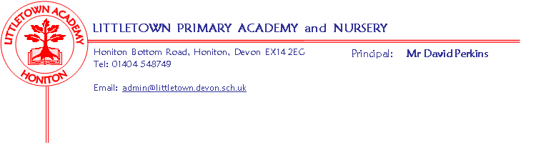
Year 5 Spring Term 2020 Information
Literacy
For the first half of the term, we will be basing our literacy and comprehension lessons around Shakespeare’s The Tempest, exploring language, scripts, poetry and performance. This links in with our Cornerstones project Alchemy Island.
During the second half of the term, our CLPE text will be Tom’s Midnight Garden. The children will explore this book through letter writing, poetry and descriptive writing.
Maths
Maths is taught 5 times a week using Power Maths. Each lesson begins with a power up that is designed to give the children a quick reminder of past learning. We then move on to the main focus of that day’s lesson. This term our units will be Multiplication and Division, Fractions, Decimals and Percentages.
Cornerstones
This half term we will be introducing our new topic, Alchemy Island, and in the following half term we will be beginning our topic entitled Time Traveller. You should have already received the parent information and home learning pages for Alchemy Island.
Key reminders
- Please remember that P.E. kits need to be in school every day.
- Please name all items of school uniform.
- Please ensure that your children are not coming onto the playground too early in the morning as we cannot be responsible for them before 8.50am.
- Please encourage your children to read at home for at least 20 minutes every day and to use Times Tables Rockstars and Spellodrome as much as possible to continue improving their skills. This is still a homework requirement.

Key dates for the spring term
Parents’ meetings w/c 10th February.
Roundball Outdoor Classroom 7th February.

