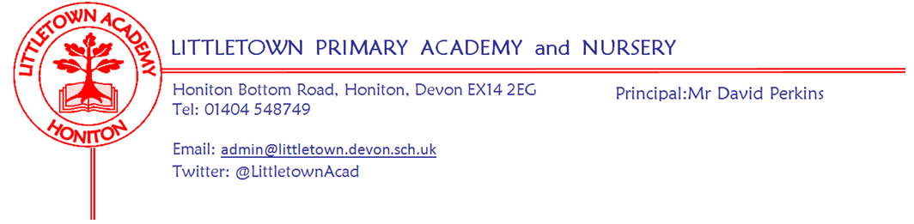
Year 6 Autumn Term 2020 Information
Literacy
Literacy sessions will take place every day. Writing, including sentence construction and grammar, will be taught through a variety of teaching sequences, using two main texts – The Silver Sword and Pig Heart Boy. There will be cross curricular links with our Cornerstones topics (A Child’s War and Blood Heart). Handwriting, SPAG, Spelling and Reading Comprehension will be further developed within discrete lessons.
The children will be using Lexia at least three times a week to further develop their reading and spelling skills. There is an expectation that the children will spend at least 30 minutes per week working on Lexia at home.

Maths
Maths sessions will take place every day. These will be taught using the Power Maths scheme where pupils will be encouraged to gain a deeper understanding of the following areas: Fractions, decimals and percentages, coordinates, algebra, area and perimeter, ratio and proportion and measures.
In addition, the children will consolidate their arithmetic skills and formal written calculation methods, applying these skills to develop their mathematical reasoning. They will continue to develop these skills in discrete Arithmetic sessions. The children will continue to develop their Multiplication Facts fluency using Times Table Rock Stars (TTRS) online and TTRS paper based activities.

Cornerstones
Information about each topic will be sent home at the start of the topic and will include home-learning activities.
A Child’s War – A siren sounds and a Spitfire zooms overhead! It’s 1939 and Britain is at war. During the term, we’ll imagine what it was like to be evacuated; using different source materials, we’ll learn about evacuation and write letters to our families ‘back home’. We’ll plot the Second World War’s events on a timeline and learn about rationing. From a range of sources, we’ll find out about children and school during the war. We’ll learn about what it was like during the Blitz and think about how soldiers might have felt. In D&T, we’ll make Anderson shelters and cook delicious wartime food.
Blood Heart – We will explore our circulatory system by dissecting an animal heart, finding out about the different parts and how the blood flows. We will measure our heart rates and test how it is affected by exercise. In D&T, we’ll make model hearts. We’ll learn about how smoking affects the heart and write adverts to persuade people to stop smoking. We’ll visit the ‘Give blood’ website, and make a flow diagram to illustrate the circulation process.
Key reminders
P.E.
Children will require PE shoes in school all week, especially on their timetabled PE days of Wednesday and Thursday. Should the restrictions on PE uniform change, we will let you know.
Medication Forms
If your child requires any medicine during school times, a medical form must be completed. All medicines should be prescribed by a doctor. Please collect a form from the office.

Homework
Homework will be set each Friday and should be returned to school, by the following Thursday.
Each week, the children will be given a spelling list which we will be focusing on in school the following week. The children can work on these, at home, if they wish.
There will be a 10 minute Literacy Workout, a 10 minute Maths Workout and a 10 minute Reading Comprehension. The HWK will be marked during the day on Fridays. As always, we expect the children to read for about 20 minutes per day and learn Multiplication Facts using Times Table Rock Stars.
Pupil Planners
Year 6 have Pupil Planners which are similar to those they will use at secondary school. The children are expected to record any reading they do, along with time spent on Lexia. If parents wish to make a comment about reading they may but there is no expectation to do so. We would like parents to sign the Pupil Planner to show they have seen their child reading and spending 30 minutes per week on Lexia. Pupil Planners need to be brought to school on Monday when they will be checked. The Pupil Planner is also a good place for parents to write any messages for the teacher. If you do this, please make sure your child knows to show it to their teacher.
Library AR books
6CP are timetabled to change their library books on a Wednesday and 6JF are timetabled to change their library books on a Friday. When they have finished their books and they are returned to school, the books need to be quarantined before they can go back into circulation in the library. All of this means that the children will be limited on the books they can obtain from school. Please support your child by using Oxford Owl (free online reading resource) or books from home/local library.

Key dates for the autumn term
Friday 16 October: Break up for 2 week half term holiday
Monday 2 November: Return to school
Friday 20 December: End of term
Class email addresses:
Mrs Fallon’s Class: jfallon@littletown.devon.sch.uk or julie.fallon@littletownacademy.org
Mr Priddle’s Class: cpriddle@littletown.devon.sch.uk or christopher.priddle@littletownacademy.org
Year 6 Team (Mrs Fallon and Mr Priddle)

