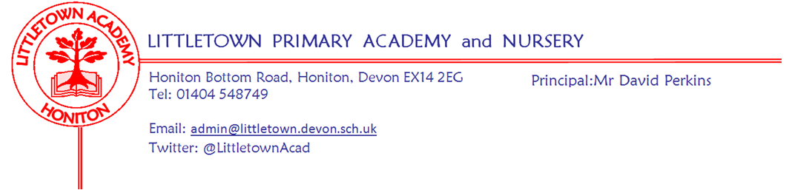
Friday 22nd January 2021
Dear Parents and Carers,

Today marks the halfway point of this disrupted lockdown half term. If I were to be making a half time team talk, I would once again be praising the attitude and effort of everyone in the LittletownBigTeam. We continue to see amazing learning taking place both in school and at home. I know that there is growing anxiety about the fact that we may not in actual fact be half way through this lockdown. All we can do is take each day and week at a time and respond to announcements and changes as they arise. Thank you to all of you for continuing to ensure Littletown succeeds in these challenging circumstances. Remember, whether your child is in school or at home, we are here to support you to the very best of our ability. Please do keep in touch with us and help us to help you as best as we can.

There are many complexities in the way the school is operating currently. Next week sees an additional element of complexity added into the mix. It is good news as it should make all of us safer, but please do read the information immediately below carefully.

Lateral flow testing (LFTs) for Primary school staff
Although, only relevant to those in school for now, this will be relevant to all parents when school fully reopens.
As of next Monday we will be joining all Primary schools across the country in carrying out Covid-19 tests twice weekly for all school staff and regular visitors. This is to reduce the asymptomatic transmission of the virus in school settings, reduce the rate of infection and overall, make our communities safer.

Staff will test on Wednesday afternoon/evening and on Sunday. Positive test results will result in isolation of contacts from a 2 day period prior to testing and may well therefore, result in a bubble closure. Parents will be contacted via parent pay email just as has been the case with bubble closures so far this year. Every staff member who tests positive will isolate and book a Polymerase Chain Reaction test (PCR test) - these are the tests that have previously been available at sites such as Honiton Road Park and Ride in Exeter. In some cases it is possible that this returns a negative case and in such a case, isolating contacts will then be invited back into school.

We don’t know how the commencement of this testing programme will impact on schools. However, it is possible that we see more bubble closures than we have seen so far. We still have many questions about this and we very much hope they will be answered by Monday! If you have any questions, I will try and answer to the best of my knowledge so please feel free to ask! head@littletown.devon.sch.uk

Yours faithfully,
David Perkins
Principal

In school bits

Remote learning on non school days
We have many children who are in school for some days and at home on other days. Please can I remind parents that on days when they are at home they must fully engage in the remote learning set for those days. My teachers are amazing, but they are not able to teach a full week of learning to children who are in a few days of the week. When children come in to school later in the week, teachers will assume that learning prior to that day in the week has been completed. Children will find it very hard to access the learning in class if they haven’t done this. Do get in touch if you have any questions about this.

Road Closure Honiton Bottom Road
Well done for dealing with the road closure so far. Sadly the map I was provided with was wrong so you have not been able to turn around via the mini roundabout. Sadly, due to the poor weather the start was delayed and works will now continue into at least Monday next week.

------------------------------------------------------------------- ----------------------------------------------------------------------------------

At home bits

Thank you so much for responding so well to our request last week about ‘batching’ learning submissions. This has made a big difference to staff workload and improved the quality of feedback children and parents are receiving via Tapestry, email and Google classroom.

We have continued to help lots of families out with keyboards, chromebooks and free mobile data. Please see again all the relevant information below and get in touch head@littletown.devon.sch.uk if you think we can do anything to support you.

Devices
Lots of children are now using Playstations or Xboxes as additional devices and we have given out several USB keyboards to assist with this. If you would like one to enable you to do the same, please let me know head@littletown.devon.sch.uk

In some circumstances we are also able to support families by issuing chromebooks to use at home. Priority goes to families with multiple children and no single device. If you think that your circumstances may mean that you are eligible for this then please get in touch head@littletown.devon.sch.uk

Please see below helpful information from last week’s newsletter about google classroom, Xbox and Playstations and getting me to assist you in free phone data for hotspots.

Google classroom
Our partners at Computeam have made this helpful suite of videos for those of our using google classroom with your children for the first time. It does take a little getting used to, but it is a brilliant way for children to receive and submit learning, so please do persevere with it and email me or the year remote learning email address if you are having issues. https://vimeo.com/showcase/parenthowtoguides

Xbox and Playstation
It is easy to use google classroom and open padlet pages and watch the lesson videos on your tv via an Xbox or Playstation if you have them. With a USB keyboard, (which we can provide if necessary) these devices can be effectively used as PC computers. This could be a game changer for families sharing devices. The following link shows you how to do this easily on either device:
https://franklin2017.s3.amazonaws.com/6/ckeditor/Access_Google_Classroom_with_PS4_and_Xbox_p2sCytqjNo.docx%20%282%29

Hotspots and data
Remote learning is a real challenge for those of you without wifi and some of the videos etc can eat through phone data. The Government’s plan for this is to allow me on your behalf to register for free data on your phone so you can use your phone as a hotspot to generate wifi. Here is a link to a helpful guide on how to use your phone as a hotspot. Please contact me if you need me to fill in the form to get you free data if you are a customer of EE, O2, Sky Mobile, SMARTY, Tesco mobile, Three or Virgin mobile.
https://uk.pcmag.com/mobile-phones/41270/how-to-turn-your-phone-into-a-wi-fi-hotspot

