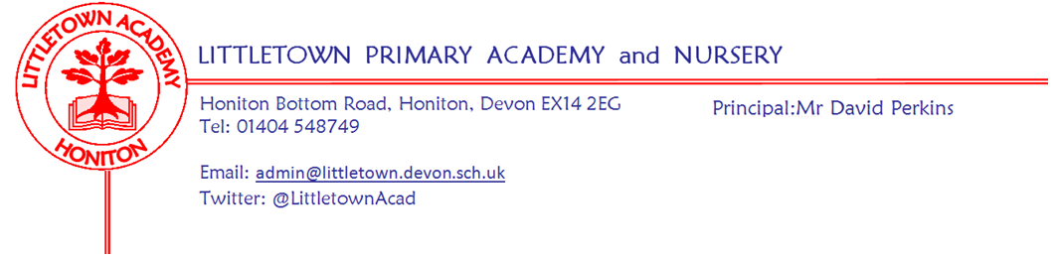

Live . Love . Learn - Littletown
Friday 9th September 2022
Dear Parents and Carers,

This morning I spoke to children from Year 2 to Year 6 in the hall about the death of Queen Elizabeth II. I told them it was sad and it was ok to be sad, but that we can also be happy she lived a long life, happy she died peacefully with family and happy she was in a place that she loved. We reflected on her life of service. Children then watched Newsround from yesterday in their classrooms which celebrated the key events in the Queen’s life. The school will participate in the ten days of mourning as appropriate following guidance from the DfE and I will be in touch with you about this when we know more.

In a short newsletter on Monday I welcomed you all back to school and spoke of the lovely atmosphere. That has certainly continued this week and the staff and I are very pleased with how the week has gone with the children. This afternoon I shared the results of my ‘values detective’ work I’ve been doing throughout the week celebrating all the amazing things happening in the school under our umbrella values of Live, Love, Learn. I have praised the children for their start to the year, but challenged them to keep this up throughout the remaining 38 weeks!

Thank you to all of you for taking so quickly to the new end of day arrangements this year. Thank you also for seeing the humour in the fact it has started raining at approximately 3:30pm at least three days this week!

Today you should receive a Curriculum/Year group newsletter outlining contact details, curriculum overviews and key information for your children’s classes. My thanks to staff for putting these together in a busy first week.

This newsletter is relatively short as we start the new year. Please find an introduction to Miss Talbot, our new Family Support Worker and a reminder about our two week half term in October. We will be up and running with children’s news reports next week.

Next week, on Friday I am looking forward to welcoming Mrs Corinne Delinsky to the school. This September marks 50 years since Mrs Delinsky became the first Headteacher at Littletown to oversee it’s completion and opening. Mrs Delinsky will tour the school, speak to the KS2 children and join staff for coffee and cake. We are already making plans to mark 50 years since the official opening of Littletown in 2024.

Finally, please see an attached letter about Outdoor Play and Learning (OPAL). This is a really exciting and really important school development journey for us to revolutionise our playtimes over the next year. The journey starts with sharing information about the programme and gathering a range of baseline information to inform us in generating priorities. Children and staff will be completing surveys over the next few days and we also want your views too. You can fill in our survey via this link up until the end of next Wednesday. You can, of course, speak to your children as you fill in the survey. Mrs Davis and I are leading this initiative in the school so please do get in touch with us if you have any questions or further thoughts you wish to share. Here is the link to the survey:
https://www.surveymonkey.co.uk/r/X7TBZ3H

Yours faithfully,
David Perkins
Principal

Student and Family Support team update

Family Support Worker
Please see below an introduction to Miss Talbot, our new Family Support Worker. As mentioned in a previous newsletter last year, this is a new role for the school and has been created as part of a restructure to the Student and Family Support team in order to increase support for parents as we all recover from pandemics, grapple with the cost of living and the numerous other challenges parents face currently. We are delighted to welcome Miss Talbot to her role as she transitions across from that of Teaching Assistant. The staff and I are very excited about the impact she will have on supporting Littletown families. I'm sure you would like to join me in welcoming her to this role. Please get in touch with myself or Miss Talbot if you have any questions.

Hello!

My name is Miss Talbot and I am pleased to introduce myself as your new Family Support Worker here at Littletown Primary Academy. My role in the school is to work alongside Mr Perkins, Mrs Hawkins and the Student and Family Support team to provide support, advice and information to our families here within our school community.

I can be the first point of contact in order to help you with any worries or concerns you may have in relation to your child’s education, behaviour and well-being or family life in general.

I am also here as someone that you can talk to should you need it! I may not always have all the answers initially, but I have access to a range of external agencies and support avenues and therefore, we can work together to find them.

I’m really excited to get to know you all and can promise a listening ear, a friendly smile and a good cuppa as necessary.

You may have already seen me on the playground in the morning, where I am always available for a quick hello. Later in the term I will also be running a drop- in session on a Friday morning in our wonderful Community Room.

I look forward to meeting you soon,

Miss Talbot

Miss Talbot will be using the following email address: familysupportworker@littletown.devon.sch.uk

Mrs Canniford, who will continue her role as pastoral care for children in school, can now be contacted on the email address: pastoral@littletown.devon.sch.uk

Two week half term reminder
Please be reminded that we have a two week half term break in the Autumn Term which is different to many schools. Children will break up for half term on Friday 14th October and return to school Monday 31st October.

Week Beginning 12th September 2022 events
Monday 12th September | Tuesday 13th September | Wednesday 14th September | Thursday 15th September | Friday 16th September
 |  |  |  | New Reception parents coffee morning
 |  |  |  | Tour and assembly with Mrs Delinsky (first Headteacher)

Community news
With the cost of living crisis in full swing please continue to see below information about Honiton food save.
Honiton food save
We are committed to stopping food going in the bin. We collect surplus food from supermarkets and give it out for free to anyone in the community. No referrals needed, no questions asked – everyone is welcome, whether you have a specific financial need or have just forgotten an item of shopping.

We are based at the Honiton family church. You can order food from the website on the days they are open:

Mondays – 8:00pm-9pm
Tuesdays – CLOSED
Wednesdays – CLOSED
Thursdays – 8:00pm-9pm
Fridays – 8:00pm-9pm
Saturdays – CLOSED
Sundays – 4:30pm-5:30pm

honitonfoodsave.org.uk

