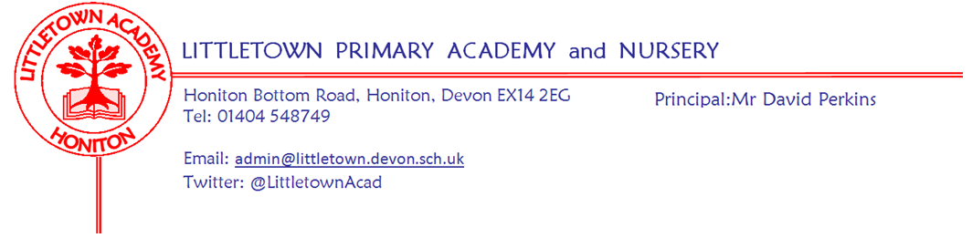
Reception Summer Term 2021 Information
We hope you had a lovely safe Easter break with your family and we also hope you enjoyed sharing your child’s Tapestry with them and your close family, to celebrate their learning last term. We are looking forward to this new term and starting our engaging Wild Animals Cornerstones project.
As we head into Summer we will be spending more time outside and using the field for PE. Please apply suncream in the morning before school to last throughout the day - we cannot apply in school. Also ensure your child is wearing sensible footwear (open toed shoes are not allowed) and has a named sunhat in school.
Literacy
In literacy we will be continuing with our daily phonic sessions to support the children’s reading and writing as well as our daily Funky Fingers to support and teach pencil grip, control and handwriting. The children’s writing will be focused around our topic, writing words and developing independence writing simple sentences. They will continue to have access to a range of writing materials for free writing including books, cards, lists, invitations and letters. If you are writing with your child at home please ensure they are holding their pencil correctly and firmly. We will be looking at capital letters this term and using them to start our sentences. We will spend lots of time this term developing their listening skills and language through storytelling, small world play and role play.
Reading books will continue to be changed every Monday and Thursday. To support reading you could play phonics games at home, listen to and chat about stories, and you can look at levelled books online on Oxford Reading Owl (https://home.oxfordowl.co.uk/reading/free-ebooks/). Tricky words and sounds will continue to be checked fortnightly; we check your child knows their words and sounds independently in their reading and phonic games. Tricky words are needed in order to progress through the levelled reading books - please spend time helping your child learn these at home.
Please record any reading and activities, including learning sounds and tricky words, in your child’s Reading Record. The expectation is for parents to record in the book at least 4 times a week and staff will now check the Reading Record once a week when your child changes their book.
Maths
In maths we will be continuing recognising and ordering numerals 1-20 and beyond and working on knowing 1 more and 1 less of any number. We will be learning to add and subtract to 10 then 20, using objects and number lines for support to solve simple maths problems. We will be looking again at weight, length, height and pattern as well as continuing to explore 3D shapes.
Last term we learnt how to subitise (quickly visually recognise how many without counting) amounts to 10. At home ask your child ‘how many’ when they see groups of objects or play dice games. If they are unsure please encourage your child to touch items when they are counting and ask them ‘how many’ when they have finished. Play games, puzzles, sing number songs or listen to number rhymes on the BBC Children’s Radio. (https://www.bbc.co.uk/teach/school-radio/nursery-rhymes-songs-index/zhwdgwx?scrlybrkr ).

Cornerstones Topic
Our topic for the Spring term is ‘Why do Zebras have Stripes?’. We are sending a letter home with more information including ways to support your child at home with this theme.
Jigsaw - Personal, Social & Emotional Development (including Relationship, Sex and Health Education)
Relationships topic: For the first half of the summer term, with Jigsaw Jennie and Jerrie's help, we are learning how to make good friends to stop ourselves feeling lonely, think of ways to solve problems to stay friends, understand the impact of unkind words and learn to manage our feelings.
Changing Me topic: More information to follow

Foundation Stage Curriculum News
At Littletown we are always keen to be at the forefront of any changes in education. We are fortunate that we have been trialling the new Foundation Stage Profile before it is due to be implemented September 2021. It is very similar to the previous profile but places more emphasis on language development. Our philosophy of early years education remains the same with play and wellbeing at the heart of everything we do. Nothing has changed for your child, we continue to offer them the highest quality learning experiences and develop their interests and fascinations in the world around them and they will be unaware of any changes. If you have any questions or would like more information please email your class teacher.

Key reminders
Outdoor Classroom: Outdoor Classroom will continue every week on Fridays. If we ever need to change our plans for outdoor classroom because of special events, children should continue to come in non-uniform on Fridays. As we are heading towards the summer please ensure your child has appropriate clothing to wear outside; sun hats and suncream applied at home.
Book Bags: Please bring book bags to school every day (with your child’s Reading Record).
Tapestry Learning Journey: As you are aware Tapestry Learning Journeys are updated at the beginning of each term. Thank you to parents who have added photos, videos, and comments about their child’s learning. We have seen children reading, writing, dancing, singing, counting, growing and lots of holiday fun. If you are having trouble accessing Tapestry to view your child’s learning please see your child’s teacher.
Water Bottles: Please ensure your child has a named bottle of water (not juice) in the classroom for drinking throughout the day, we will refill them when they are empty. They may have juice in their lunchbox but no fizzy drinks.

Packed Lunches: We have peanut allergies in school so we ask that no children have nuts or nut based snacks/spreads in their lunchboxes. We are a healthy school and ask that children do not bring in chocolates or sweets for lunch.
School Dinners: Please ensure you book your child’s school dinner by Friday midnight for the following week. If your child does not eat enough school lunch we will send a note home to inform you.

Medication: Please let us know if your child has to take any prescribed medication at school. There is a green form for you to fill in so that we can administer it. We can only give prescribed medication and the medication must have the prescription label on. Please phone the school if your child is off sick. If you have a medical appointment please let the office know.

Birthdays: If it is your child’s birthday they can come to school in their home clothes. Please do not bring cake/sweets.

Toys: We ask that toys/valuables are not brought into school.
Parent helpers: We would normally love Parent Helpers but unfortunately we cannot have parents into school at the moment.
Junk Materials: We are desperate for yogurt pots, small boxes (not cereal size boxes) and cardboard tubes (not toilet rolls). Please ensure they are clean because the children use these to build models with. If you have any please bring them in a bag on a Friday so we can leave them over the weekend in ‘quarantine’ for building fantastic models the following week.
Key Dates for the Autumn Term
Friday 23 April Outdoor Classroom resumes (every Friday)
Tuesday 27 April Vision Screening in school
Monday 3 May Bank Holiday
Friday 28 May Break up for Half Term
Monday 7 June Back to school
Tuesday 27 July Break up for summer
Thank you for your support,
Miss Croft, Mrs Katene & Mrs Hawkins
Miss Croft’s Class: classrnc@littletown.devon.sch.uk Mrs Katene & Mrs Hawkins: classrnkmh@littletown.devon.sch.uk

