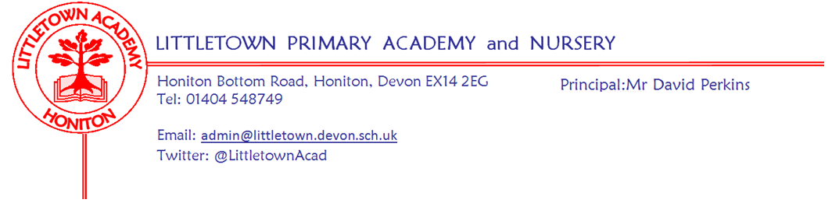

Friday 7th January 2022

Dear Parents and Carers,

I would like to start by welcoming you all back to school for the Spring Term and wishing you a very happy and prosperous 2022. It has been great to see the children return to school with energy and happiness this week despite the dreary January weather.

You will be aware that I did not write to you prior to the start of term with any changes to our Covid-19 risk assessment. The Department for Education announced changes to guidance, but there were not any relevant changes for Primary schools. This week however, has seen the announcement of changes to testing and isolation periods so please see details on this below in this newsletter.

It won’t surprise you to know that we have staff absences this week due to Covid-19. Schools nationally are reporting an average of 10% workforce absence this week and we are inline with this. Most predictions have this rate of absence increasing as a return to school sees a higher rate of transmissibility of the virus. We have worked hard to have a fantastically high quality and reliable bank of teaching staff who help us cover absence in the school and this has this week helped to minimise disruption to classes. However, this is a finite resource and like all schools, we will struggle to cover much higher levels of staff absence. ‘Closing’ classes will always be a last resort and one we will always do everything we can to avoid. You will have seen in the media a call for qualified teachers not currently in employment to help schools with cover. If this applies to you and you would like to discuss teaching at the school should such a need arise, then please do get in touch. Likewise, if you know of any qualified teachers who might be interested then please do pass on this information to them and ask them to contact me: head@littletown.devon.sch.uk

Yesterday, we were pleased to welcome Axe Valley Wildlife Park to school showing a range of their wonderful animals to Year 1 children in order to launch their topic ‘Paws, Claws and Whiskers’.

Today, we welcomed Virgin Care to administer Flu nasal vaccines to the children. They were impressed with the children’s behaviour and maturity today.

As we start 2022, our Housecaptains and Pupil Voice representatives have been sharing with children in assemblies their thoughts on dreams and goals as part of our new whole school theme this term. You will see below we are looking for some ‘VIPS’! to visit the children in assemblies who might be able to speak on this theme! Please do get in touch if you can help.

Next week, on Monday, Year 3 visit Honiton Leisure Centre for a Gymnastics workshop. Also on Monday, we welcome our Education Welfare Officer for our Autumn Term attendance review. On Tuesday we welcome back to school our external School Improvement Partner, David Herbert, to focus on curriculum development in the school.

Yours faithfully,
David Perkins
Principal

News from pupil reporters

Nursery
This week, in Nursery, we have been making cheese and veg muffins.

Reception
This week, in Reception, we have been writing Christmas letters and jigsaw Jennie came to our assembly

Year 1
This week, in Year 1 we have welcomed a new teacher called Mrs Hudson - Pike. We also saw all the animals that Axe Valley Wildlife Park came and showed us.

Year 2
This week, in Year 2, we have found Dragon footprints and Dragon eggs in the classrooms. We have also written our own Dragon stories and in Maths we learnt about money.

Year 3
This week, in Year 3, we started a new topic about the Stone Age and began reading the Iron Giant.

Year 4
This week, in Year 4, we have been learning about Romans, which is our new topic. We have finished our book called’ Leon and the place between’ and we have also talked about hopes and dreams in P.S.H.E.

Year 5
This week, in Year 5, we have been doing column multiplication in Maths and building up a character. We have also started to compose music for our topic Alchemy Island.

Year 6
This week, in Year 6, we have been doing lots of work on coordinates. We also did a warm up called Popcorn for our dance in PE. We have also been reading about snails.

Staff news
This week we say a warm welcome to Mrs Hudson-Pike who is teaching in Year 1 and to Mrs McFadden who is teaching in Year 3.

Dreams and Goals
In assemblies this week we have launched our new PSHE (Personal, social, health education) theme for the new term called 'Dreams and Goals’. An enormous thank you to the House Captains and Pupil Voice representatives for sharing their aspirations in the assemblies.
The children have voiced how they would like to meet some 'real life grown ups' who have made their dreams come true. If you, or anybody you know would be happy to pop into school as a VIP assembly guest to share information about your job/hobby please contact Mrs Hawkins or Mrs Lambert for further information. admin@littletown.devon.sch.uk
The children are keen to hear about: Marine biologists, paramedics, doctors, military, footballers, authors, vets, ballerinas and astronauts!

Changes to isolation periods and testing for Covid-19
The Dfe have issued guidance to schools and families on shortening of isolation periods when infectious with Covid-19:
- Pupils can take an LFD test from 6 days after the day their symptoms started (or the day your test was taken if they did not have symptoms), and another LFD test on the following day. The second LFD test should be taken at least 24 hours later. If both these test results are negative, and they do not have a high temperature, they may end self-isolation immediately after the second negative test result.
- They should stop testing after they have had 2 consecutive negative test results and can return to their education setting on the 7th day if they have tested negative in the morning.
If you have any questions about this please don’t hesitate to contact me: head@littletown.devon.sch.uk

Inform us of household cases if you can
There is currently no requirement for parents to let us know at school when there is a case of Covid-19 in the household. However, it is very clear that household cases result in cases in the school children with the Omicron variant. Therefore, to be able to make rapid protective measures when necessary it would be useful for me to know when we have cases in households of Littletown pupils so we can see where potential cases could arise that could result in us reaching certain thresholds for mitigation. Thank you for your cooperation in this. If you have any questions or queries, please let me know.

Week Beginning 7th January 2022 events
Monday 10th January | Tuesday 11th January | Wednesday 12th January | Thursday 13th January | Friday 14th January
Year 3 Gymnastics festival |  | Nursery outdoor classroom |  | Reception outdoor classroom

