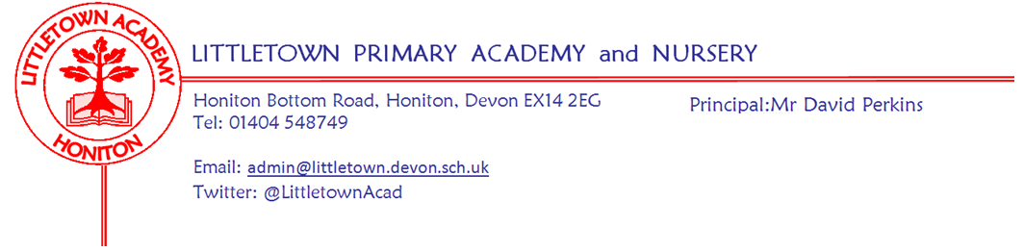

Live . Love . Learn - Littletown
Year 2 Autumn Term 2026 Information
Welcome
Thank you all for helping us make a terrific start to the new year. The children have been great at settling into their new routines and surroundings. Most of the children are now lining up in the morning, ready for us to bring them into school. Please encourage your child to line up with their friends so that we can leave the playground promptly.
Literacy
This Autumn, the children will continue to build their reading, writing and grammar skills through the daily Read Write Inc lessons. This teaches children the phonics sounds, the letters that represent them and how to write the letters. This follows the same format as in Year 1, children will have a literacy lesson including phonics teaching in a group of children of similar ability. The adult will revise known sounds as well as teaching new sounds. The children will be reading, writing and practising what they have been taught.
Children will bring home 2 books every 3-5 days depending on their reading level. One book will be a black and white version of the story that the children have been learning to read in class. The second book will have the same sounds and words but within a different story. Your child will be able to read these books which will help them become a confident and successful reader. The expectation is that children read at home 5 times a week.
Spellings will be sent home every Monday. The spellings that are sent home will be a mixture of spelling patterns and common exception words. Spellings will be checked on a Monday, before new spellings are given.
Maths
In our daily maths lessons this term, we will be using our Power Maths scheme to learn more about Numbers to 100 (recognising tens and ones, place value, comparing and ordering numbers and counting in steps of 2, 5, and 10) and Addition and subtraction (Adding and subtracting 1 and 2 digit numbers, finding how many more/fewer, finding the difference and solving word problems). If you would like to provide extra support for your child at home, please help them to identify and count different coins and remind them of their experience with telling the time from Year 1 where they learnt o’clock and half-past times.
Cornerstones
Our main topic for the Autumn term is a history-based topic called ‘Movers and Shakers’, which focuses on significant individuals who have made their mark on history - these people include Mary Anning, Neil Armstrong and Emmeline Pankhurst. We will also be teaching mini topics in Science, Geography, RE, Music, Art and Design and Technology.
Within our classes rather than individual books for each child, we use big floor books to show and evidence what the children have been learning within each topic. During the term children may bring work home that they have completed within class. You will have an opportunity to look at floor books during parent consultations.
PSHE (including Relationship, Sex and Health Education)
In the first half term, our Jigsaw topic will be ‘Being Me’. We will learn about hopes and fears for the year, rights and responsibilities, rewards and consequences and working with others. In the second half term our topic will be ‘Celebrating Difference’. We will learn about boys and girls (stereotypes), why bullying might happen, standing up for ourselves and others, gender diversity and celebrating differences and still being friends.
Outdoor Classroom
Children will have outdoor classroom days throughout the year. An email will be sent once these term dates are decided. Please ensure children are dressed appropriately in old, warm clothes and have a waterproof coat. Hats and gloves will also be needed in winter as we aim to be outside in all but the most extreme weathers. Welly boots should be brought to school in a carrier bag and the children wear clean shoes to school to be worn indoors.

Key reminders
Coats: Please send your child into school with a coat if there is any chance of wet weather as we go outside at playtime and lunchtime even if it is raining.
PE: Our PE days are Monday (outdoor PE) and Thursday 2DB/CL (indoor PE) - Friday 2AL (indoor PE). Please ensure your child comes to school in their PE kit on those days, and bring joggers and sweaters when the weather is colder.
Book Bags: Please bring book bags to school every day, with your child's reading books.
Water Bottles: Please ensure your child has a bottle of water (not juice) in the classroom for drinking throughout the day. They may have juice in their lunchbox but no fizzy drinks.
Packed Lunches: We have peanut allergies in school so we ask that no children have nuts or nut based snacks/spreads in their lunchboxes. We are a healthy school and ask that children do not bring in chocolates or sweets for lunch.
School Dinners: Please ensure you book your child’s school dinner by Friday midnight for the following day. If your child does not eat enough school lunch we will send a note home to inform you.
Medication: Please let us know if your child has to take any prescribed medication at school. There is a green form for you to fill in so that we can administer it. We can only give prescribed medication and the medication must have the prescription label on. Please enter absences on Arbor if your child is off sick, specifying the reason for the absence. If you have a medical appointment please let the office know and log on Arbor.
Birthdays: If it is your child’s birthday they can come to school in their home clothes. Please do not bring cake/sweets.
Celebration Assembly: We have a whole Key Stage Celebration assembly once every half term, where children are encouraged to bring in any certificates, trophies or photos of achievements from outside school. E.g. Swimming, Cubs, Horse Riding etc. Your child’s teacher will remind them a few days before.

Staff in Year 2
Teaching staff: Alongside Mr. Luxton, Mrs. Bentham and Mrs. Lambert, 2AL will also have Mrs. Shrubb teaching on Wednesday afternoons. Mrs. Lambert will be teaching 2AL on Wednesday mornings.
Teaching Assistants: We are very fortunate that both classes have a teaching assistant every morning to help support the children’s well being and learning in the classroom. In 2AL the Teaching Assistant is Mrs Salter and in 2CL/DB the teaching assistant is Mrs. Thomas. Mrs. Thomas also works in Year 2 every afternoon, to provide focused support to groups and individuals from both classes.

Key dates for the Autumn term
Open Classrooms: Tuesday 22nd September 3:45 - 4:45
Open wide (dental care visit) Tuesday 29th September
CMT Awareness Day (pink and purple) Friday 2nd October
Hello Yellow (mental health): Friday 9th October
1st Outdoor Classroom: Dates to follow
Last day of 1st half term: Friday 23rd October (2 weeks)
First day of 2nd half term: Monday 9th November
Last day of 2nd half term: Friday 18th December

If you need to contact your child's class teacher please email admin and your email will be forwarded to the teacher.

Thank you for your support,
Mr Luxton, Mrs Bentham and Mrs Lambert

