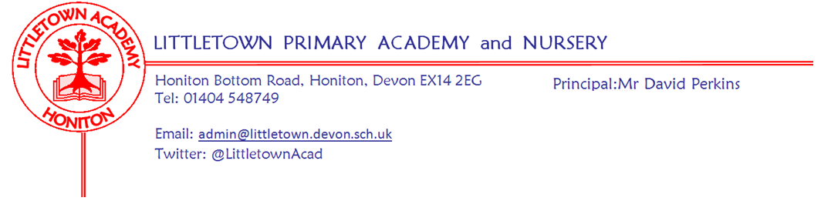
Friday 5th June 2020
Dear Parents and Carers,

I hope you all had a good half term and enjoyed some of the wonderful weather. I can tell by viewing padlets and google classrooms that children have returned to their remote learning with great energy this week!

As you know, it has been a week in which we made the difficult decision to postpone the start of the phased reopening of school until Monday 15th June. I would like to start by thanking parents, especially those directly affected by the changes, for their understanding. I have been very touched by the messages of support and understanding I have received. On Monday, all parents of returning children will receive a letter giving them detailed information about coming back to school on Monday 15th June. Parents will then have opportunities to ask questions. By next Friday, we will have uploaded photos and videos to our website for parents to view and discuss with their children over the weekend, prior to returning on the Monday. As mentioned in my letter, teachers will also spend next week creating a bank of quality resources in order to support remote learning for non returning year groups, via padlets in the remaining weeks of the Summer Term.

As part of our preparation this week, we have had all staff in school in small groups to complete training for the phased reopening of school. It has been great for staff to see each other again after working remotely for so long, apart from when they have been supervising the children of key workers. I was instantly struck by how much they have been continually thinking, caring, worrying and considering ways in which to support all the children in the school. They really can’t wait to welcome all of the children back.

Finally, I would like to thank Chair of Governors Tina Sillitoe and especially her husband, Bob Sillitoe for volunteering and working so hard to support the school in preparing the outside of the premises for reopening in recent days and weeks, by clearing undergrowth and painting markings and lines to ensure everyone remains safe on site.

Yours faithfully,
David Perkins
Principal

