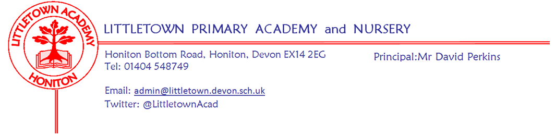
Friday 5th February 2021
Dear Parents and Carers,

Children’s Mental Health week 2021
Thanks to Mrs Davis and the wellbeing team for all of the activities this week as part of Children’s Mental Health week via the resources from Place2Be. As mentioned last week, focussing on the mental wellbeing of our children has probably never been so important. I hope those of you at home enjoyed working through the activities on the padlets like the children did at school. It was great to see the bright colours on show in school on Wednesday and I understand that google meets have been awash with colour this week which is amazing. Remember that every week the ‘10 a day’ mental wellbeing strategies are on the padlets. We also have the Student and Family Support (SAFS) padlet. This has resources for all parents. You will now be able to click a link to the SAFS padlet from any remote learning padlet from now on. Here is the link if you would like to explore it this weekend: https://padlet.com/lianechilds/ewjn9i9gxfpw

Next week we move to focusing on Internet safety day. Mrs Hawkins has taken the lead on this and II thank her for all her hard work on this. Please do read carefully all the relevant information below and do take the time to discuss this with your children. Like Mental wellbeing, this issue has likely never been so important with our children currently spending a lot of time online for both learning and leisure. Please note that even if your child is in school, you can still access all of the resources referenced below on the year group padlets via the remote learning section of our website here: https://littletown.eschools.co.uk/website/remote_learning/463458

Internet Safety Day Tuesday 9th February - In School and at Home!

We are pleased to have Internet Safety as an additional theme on all of the Padlets next week to recognise the importance of helping all of the children to keep safe online. I am certain you will agree that this is crucial in these unprecedented times, with many children both learning and chatting with friends online.

Please can I ask all Parents/Carers to go through these activities with their children to ensure they understand how to keep safe online. Completing these activities together will provide opportunities for your children to ask you any questions, discuss any misconceptions and most importantly disclose any worries or concerns they may have.
(Please remember that these are accessible to all families on the Padlets, so if your child is in school for the internet safety lessons, you are able to share these activities with your child at home too. All Padlet links are on the school website https://littletown.eschools.co.uk/website/remote_learning/463458 )

An overview of the themes covered on the Padlets next week include:

Nursery, Reception and Year 1: Smartie the Penguin (a story based powerpoint) - pop ups, inappropriate websites, upsetting images,, unreliable information, talking to strangers

Year 2: Detective Digiduck - (3 short stories) - not all information online is true, not everyone is who they seem, sharing photos etc

Year 3 and 4: SMART rules - (5 short shows) -Staying safe, Meeting strangers, Accepting requests, Reliable information, Telling a grown up if worried.

Year 5 and 6 Kara, Winston and the SMART crew (cartoon and quiz) - Staying safe, Meeting strangers, Accepting requests, Reliable information, Telling a grown up if worried.

No Screen Day- Friday 12th February
You will notice a difference on the Padlets on the last Friday of the half term, we have planned a No Screen day. The teachers have specifically planned the learning to not require any screen time! As with all of the learning provided on the Padlet, the activities are planned for both the children at home and at school. Have fun!

Online Monitoring
As we have mentioned in previous newsletters, we are secure in the knowledge that our robust filter system ‘Securly’ will help all children keep safe whilst online using their Littletown google accounts. The Securly filter monitors any inappropriate language, google searches, key phrases the children use as well as allowing us to block any inappropriate sites. Mr Perkins and Mrs Hawkins receive instant alerts to any of the above and are able to follow it up as required.

Advice for Parents/Carers
Please have a look at the attached top tips for parents on helping your children stay safe online during lockdown and use the link below to see online guidance from the DFE

https://www.gov.uk/government/publications/coronavirus-covid-19-keeping-children-safe-online/coronavirus-covid-19-support-for-parents-and-carers-to-keep-children-safe-online

Please do not hesitate to contact us if you have any questions or concerns about internet safety.

Parent consultations
It won’t surprise you to know that we have decided next week isn’t the best time to hold parent consultations. We will postpone these for the time being. We will then discuss with teachers when we think these will be most beneficial to hold after children return to school. We will also have to refer to the DfE guidance and risk assessments at the time to establish whether these are held in school or via phone call as they were in October. If you have any questions about this please don’t hesitate to contact me head@littletown.devon.sch.uk

Message from the Devon and Cornwall police
We have been asked to share a ‘How to contact the police’ document which we’ve attached to this newsletter. Devon and Cornwall Police feel there is a lot of confusion currently about how to contact the police with different queries. These include reporting breaches of Covid-19 protocols and restrictions. Please familiarise yourselves with the information attached, thank you.

Yours faithfully,
David Perkins
Principal

In school bits

Half term closing
A reminder that as per the Government announcement last week we will be fully closed to all pupils during the week of half term 15th February 2021.

Dog mess
We seem to be having a bit of an issue at the moment with dog mess on the pavements on the approach to school. We will try to clear this up when we see it. This seems to be from dog walking before the school day. Thank you to parents who have both pointed this out and assisted with the removal. Sadly, without knowing when this is happening or who the dog owner is, there isn’t much more we can do at the moment.

------------------------------------------------------------------- ----------------------------------------------------------------------------------

At home bits

Tweaks
This week we have been considering additional things to add in to our model and making tweaks to continue to improve provision as we go and learn. Some of these have been supported through feedback from parents for which I thank you. Obviously, some things are more relevant to certain year groups and age ranges so not all of these things will be happening in all year groups. Some changes you might notice over the coming weeks are:
- More exposition about learning and clearly outlining expectations in lessons via google meets to help parents reiterate this to children
- Some video content from teachers giving overview and top tips for learning for the week
- Assemblies and messages from myself each week when capacity allows
- Telling children what learning we want children to bring and share at the next google meet to help give motivation
- Increased range of video content to compliment Oak Academy lessons such as BBC bitesize (we are all aware that 5 weeks of Oak Academy is starting to get a little repetitive)
- Feedback on learning which gives targets for next time to increase quality as well as celebrating and valuing the engagement from the child

Please keep the feedback regarding remote learning coming. As a school, we know that every family circumstance is different and we will continue to do everything we can to support each individual family as best we can in a range of different ways.

Lexia log off
Can you please check that when your child finishes Lexia they remember to log off. If they leave it logged in the programme will flag that they are spending far too long on a unit and divert them into support lessons which won’t be necessary. Can we also ask that you monitor the amount of units being completed by your child at the end of every week as this is another effective way to monitor progress and engagement.

