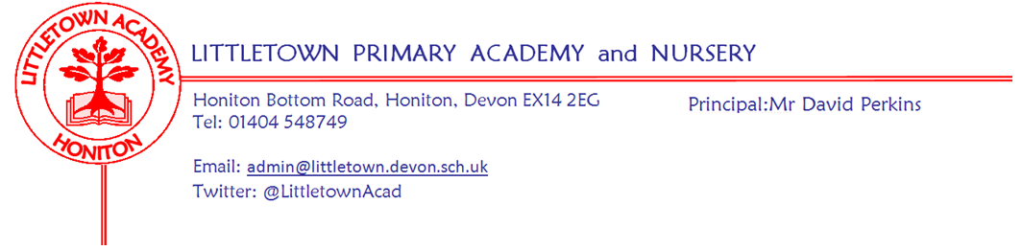
Friday 30th April 2021
Dear Parents and Carers,

I would like to start by thanking all of you for speaking to the teachers this week about your children’s learning in our parent consultations. The teachers and I are so encouraged by the amount of parents who have shown a great commitment in supporting their child’s progress at home over this term. Between now and the end of the year, teachers may be asking you to work on specific things with your children at home to support what is happening in the classroom. This may include, but not be limited to, Lexia usage and TimesTables Rockstars. It is crucial that all parents continue to support reading at home every day as has always been policy here at Littletown. Teachers have also passed on to me just how many messages of gratitude they received during phone calls from parents. I know just how hard they have worked to support the children and prepare for these conversations with parents, so I know how much all your kind comments will have meant to them. I too would like to thank teachers for all their hard work for parent consultations this week.

I know lots of you are wondering about when things might change regarding our risk assessment at school as restrictions end in the wider society. Headteachers like me continually make this point to the DfE. Today we have been told that we can expect to receive guidance in ‘mid May’ about a potential road map for the loosening of restrictions pertaining to schools. As soon as we receive this roadmap we will be able to share with you plans for events between now and the end of the year. Thank you for your understanding and patience in this.

Finally, I would like to wish you all a lovely bank holiday weekend and I look forward to seeing you all on Tuesday.

Yours faithfully,
David Perkins
Principal

Mental wellbeing
This week’s 10 a day focus is to; ‘Actively Care for Others’. If you would like more information about the 10 a day and Normal Magic then please visit normalmagic.co.uk
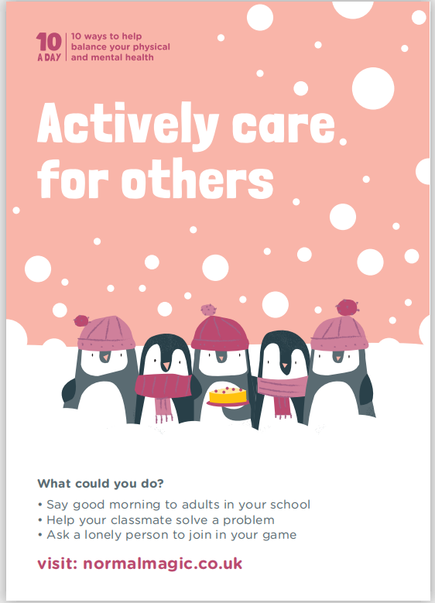
At the end of May, we will be holding our final Mental Wellbeing Week of the term. It is being organised with the Mental Wellbeing Ambassadors and we will have more information in next week’s newsletter.

School meal queries
If you have any school meal queries or questions please ensure you call the school during school hours or email the school if outside of school hours. Please do not contact the Fresha staff who work in the Littletown kitchen. Our admin team will liaise with the Fresha team and deal with any queries.

Vision screening
On Tuesday this week our Reception children received their NHS Vision Screening here at school. An important message to all parents is to remind you that all children under 18 can have a free eye test every two years. This can be arranged via Specsavers, boots, vision express and other opticians.

Devices donated
My thanks to Luke Dolby of Honiton Tech Shop in Lace Walk who yesterday presented me with some tablets and devices which have been donated to him by generous Honiton residents. These have been industry cleaned and donated to our school. My thanks to Luke and to the residents who donated the devices. If you know of anybody who is looking to donate devices to schools or the local community, these do need to be industry cleaned so donating them to Luke to then clean and issue in the community is a good first step.

Music at Littletown
Unfortunately, it has been the case that the music at Littletown has been affected greatly by the current situation. With an end in sight, we are thinking about moving forward with music at our school. As soon as the restrictions are lifted, we will be thinking about recommencing the Key Stage 2 choir which is an after school club run by Mrs Binmore. We are very lucky to have 4 music teachers who come into the school to teach individual and group lessons in a wide range of instruments including brass, guitar, piano, drums, and strings, plus a new brass ensemble which is being trialled this term. Music lessons are available once children reach Year 3, with the occasional exception for Year 2 children in certain instruments. If you want anymore information about any of the music opportunities, please email littletownmusic@devon.sch.uk

