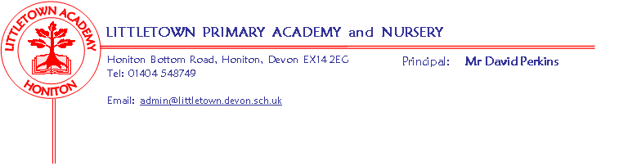

Year 2 Spring Term 2020 Information

Literacy
Literacy lessons will be taught in the morning every day with part of the lesson being daily reading. This term we will be using the stories of ‘Rapunzel’, ‘The Tunnel’ and information about Isambard Kingdom Brunel and different buildings around the world to help with our writing. The children will have opportunities to write diary entries, poetry, wanted posters, an explanation and their own stories. Spelling will be practiced in the afternoon through Spellodrome and written spellings.
Children who would benefit from extra support going over reading, punctuation skills, or handwriting will work in small groups with a teaching assistant in the afternoons or during assembly times with a teaching assistant or teacher.
Maths
Maths will also be taught in the morning every day and we will continue to follow the Power Maths scheme which will cover money, multiplication and division, statistics, measuring length and height, shapes and fractions this term. Children who would benefit from extra support going over skills, or preparing for future lessons will work in small groups with a teaching assistant in the afternoons.
Please could you help your child by letting them play with real coins, count different amounts of the same coins, and different amounts of different coins. Challenge them by asking how many different ways they could make 35p.
Cornerstones
We had a great afternoon of tower building to begin our topic of Towers, Tunnels and Turrets. This is a Design and Technology focus, although we will also explore the history behind castles and significant people. We will be sending home an overview of the topic with this letter and as usual, we would love to see all of your creative home learning throughout the topic. Our topic after half-term will be Bounce which will have a PE and science focus.

Key reminders
PE kits will be needed in school every day. For this term we will have indoor PE on Friday afternoons and outdoor PE on a Wednesday afternoon. Please ensure that your child has some warm trousers (eg jogging bottoms) in their PE kit and spare socks (especially if the girls wear tights to school). A reminder that all belongings in school need to be clearly named, including water bottles, uniform, shoes and trainers and any bags.
If it is your child’s birthday, they can come to school in their home clothes. Please do not bring in cakes/sweets in for other children.

Please let us know if your child has to take any prescribed medication at school. As before, green forms must be completed so that we can administer it. We can only give prescribed medication and the medication must have the prescription label on. Please phone the school if your child is off sick. If your child has a medical appointment please let the office know.

Reading records need to be filled in every day and the expectation is that children will be reading for 20 minutes a day. Your child will be able to change books each day from outside the classroom and take ‘quizzes’ on a computer when they have read each book. They will be shown how to do this in school and can also do these at home independently.

We are always grateful for parents to help with reading. If you would like to volunteer to hear readers from your child’s class or the next door year 2 class please let us know. All volunteers who come into school require a DBS check; this is free and simply requires some forms to be completed in the school office.

Junk materials: We would appreciate any yogurt pots, cardboard tubes (not toilet rolls) and small sized boxes. Please ensure they are clean because the children use these to build towers and buildings.
Key dates for the Spring term

Outdoor Classroom: Dates to follow.

Tower, Tunnels and Turrets Express event: Thursday 13th February at 2:30
Bounce Express event: Dates to follow.
Parent information workshops for Maths: Tuesday 14th Jan
February Parents evening meetings: Dates to follow.

