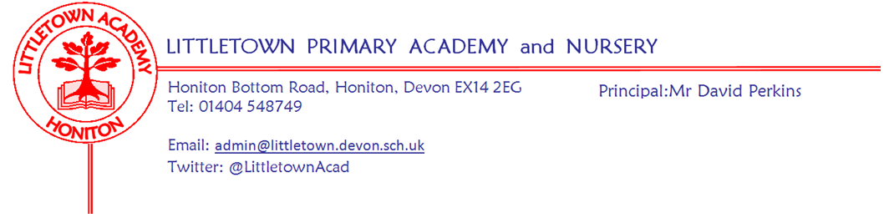
Friday 19th June 2020

Dear Parents and Carers,

For the first time in over three months I am delighted to be able to start a newsletter by saying what a great week children have had in school! We have had 105 children join us at school over the course of this week via Critical Worker provision and returning Year groups of Nursery, Reception and Year 1. As we knew they would, the children have been just amazing at embracing school life and adjusting quickly to all the new arrangements and procedures! We have also been very impressed and grateful for how well parents of returning children have responded to new expectations and rules and listened to myself and Senior leaders as we explain procedures. Thank you also to the many parents who have given positive feedback verbally or sent kind emails to me about this week. It certainly helps encourage all of us as we continue to make school the best it can be for our children in these challenging circumstances. I would also like to thank Honiton Carnival Club who have kindly lent us all the wonderful yellow cones that now adorn the playgrounds!

Senior leaders and I this week have been continuing to plan arrangements for Phase2 of our provision and welcoming back Year 6. At time of writing we anticipate this beginning the week of 6th July. We will be communicating details of these plans in due course. One of the challenges in making such plans is the ever changing and increasing demand for Critical/Key worker places. We have continued to do our absolute utmost to provide places for children of these parents, but even a school our size has a maximum capacity for the number of children we can safely receive.

I am pleased to see that remote learning has gone well for non returning year groups. I really appreciate parent’s patience with the reduced access to teaching staff and I thank the staff for their commitment and hard work in juggling teaching at school with supporting those children not in school.

Finally, with announcements today and many more in the pipeline, it looks like there will be much more information about the future of schools for us to work through and share. As ever, please do ask me any questions you might have about the Summer or September, but as I seem to have been saying for a long time now, apologies if I don’t know the answers yet!

Yours faithfully,
David Perkins
Principal

