Strategic items for Full Reopening of school September 2020

There are 3 strategic elements required in addition to normal school improvement initiatives and cycles due to the nature of circumstances pre academic year 2020-2021

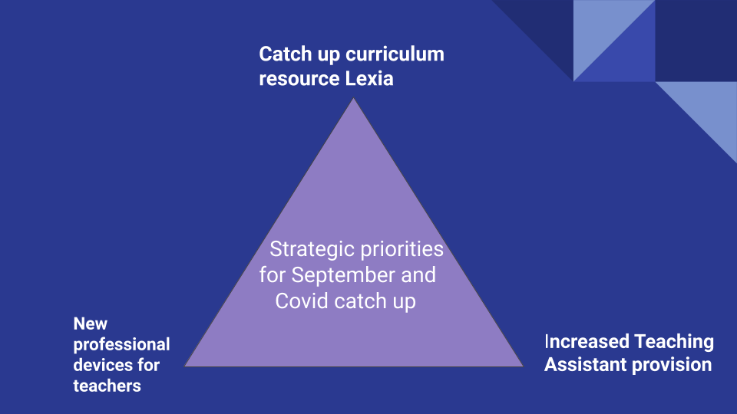

There are 3 sources of funding these initiatives as we bridge budget cycles and secure additional specific funding such as Covid catch up funding

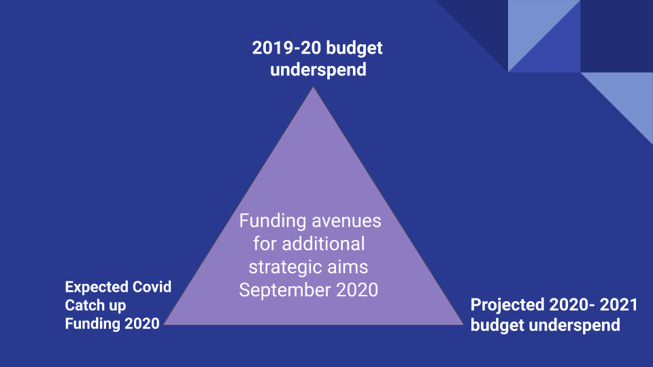

Costs and funding
Initiative | Costs
Lexia Core 5 literacy support | £22,000 for 3 year period
Teaching Assistant support bolstered to every class 5 afternoons per week | £30,666
Teacher professional Devices | £13,632 (based on cheapest quote)
Total cost of initiatives | £66,298

Funding sources ‘available’
Source | Amount (predicted)
2019-20 underspend | £23,151
Covid Catch up funding expected | £33,440
2020-21 budgeted underspend | £48,931
Total funding available | £105,552
Total excluding 2020-21 underspend | £56,591

Proposal
Initiative | Funding
Teacher laptops £13,632 | £13,632 from 19-20 underspend
Lexia literacy 3 years £22,000 | £22,000 from covid catch up
Teaching Assistant support £30,666 | £7,000 from 19-20 underspend  £11,400 from covid catch up  £12,266 from 20-21 underspend
Spending | remaining
19-20 Underspend £20,632 | £2,519
Covid catch up funding £33,400 | £40
2020-21 budgeted underspend £0 | £36,665

