Littletown virtual sports day Week beginning 13th July 2020

As we cannot hold our usual sports days this year, the PE team have come up with a virtual sports day that can be done whether you are at school or home! Choose from the activities below for each day (you can choose to do either activities or both) and fill in the attached score sheet. Perhaps if you are at home, you could compete against your family. We will post videos on the school website (click sports) to see how to complete each challenge. Have fun and we cannot wait to hear how you get on!
How many pairs of rolled up socks can you throw into a bucket/ hula- hoop in 30 seconds?  KS1, take 3 big steps away.  KS2, take 5 big steps away. |  | Throw a ball in the air and clap as many times as you can then catch the ball again. |  |  | How many times can you sit and stand up on a chair without using your hands in 1 minute? |  |  | How many times can you bounce a ball on a tennis racket? Or a pair of socks on a frying pan? In 30 seconds.
R/N KS1 Points  Gold - 7+  Silver – 4-6  Bronze – 1-3 | KS2 Points  Gold - 12+  Silver - 7-11  Bronze - 3-6 | R/N KS1 Points  Gold - 3+  Silver – 2  Bronze – 1 |  | KS2 Points  Gold 6+  Silver 4-5  Bronze 1-3 | R/N KS1 Points  Gold - 17+  Silver 11-16  Bronze 5-10 | KS2 Points  Gold - 24+  Silver 17-23  Bronze 10-16 |  | R/N KS1 Points  Gold - 5+  Silver - 3-4  Bronze - 1-2 | KS2 Points  Gold - 9+  Silver - 5-8  Bronze - 1-4
How many jumping jacks can you do in 30 seconds? |  | 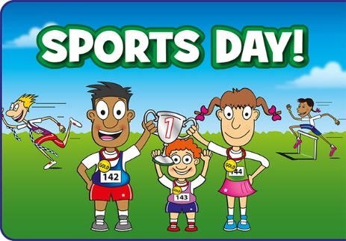 |  |  |  |  |  | Jump over a small object as many times as you can in 30 seconds.
R/N KS1 Points  Gold - 20+  Silver – 11-19  Bronze – 5-10 | KS2 Points  Gold - 30+  Silver - 21-29  Bronze - 10-20 |  |  |  |  |  |  | R/N KS1 Points  Gold - 20+  Silver – 11-19  Bronze – 5-10 | KS2 Points  Gold - 30+  Silver - 21-19  Bronze - 10-20
How far can you jump starting on 2 feet and landing on 2 feet? |  | How many ‘step ups’ can you do in 30 seconds? Use a pavement or the bottom stair. |  |  | How long can you stand on one leg, BLINDFOLDED! (Optional!) |  |  | How many ‘keepy ups’ can you do?  Use your hands or your feet, use a ball, socks or a toilet roll!
R/N KS1 Points  Gold – 70cm+  Silver – 50cm-70cm  Bronze – 30cm-50cm | KS2 Points  Gold -1m 20cm +  Silver - 80cm - 1m 20cm  Bronze - 50cm - 80cm | R/N KS1 Points  Gold- 14+  Silver - 9-13  Bronze 4-8 | KS2 Points  Gold- 20+  Silver - 13-19  Bronze 7-12 |  | R/N KS1 Points  Gold- 11+ seconds  Silver - 7-10 seconds  Bronze- 3-6 seconds |  | KS2 Points  Gold - 2 minutes +  Silver - 1-2 minutes  Bronze - 20-59 seconds | R/N KS1 Points  Feet Hands  Gold 5+ 9+  Silver 3-4 5-8  Bronze 1-2 2-4 |  | KS2 Points  Feet Hands  Gold 10+ 16+  Silver 5-10 10-16  Bronze 3-5 5-10

Monday -Red Tuesday - Blue Wednesday - Green Thursday - Purple Friday - Orange

