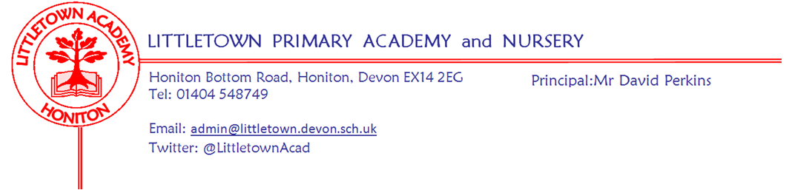
Thursday 18th March 2021

Consultation on Relationships, Sex and Health Education 2020-2021

Dear Parents/ Carers,

I am writing to share information with you regarding the statutory implementation of Relationship, Sex, and Health Education in Primary schools commencing this academic year.

With a more ‘normal’ school life beginning this half term I thought it would be an appropriate time to reassure you that we are prepared, resourced and teaching your children the new statutory Relationships, Sex and Health Education referred to as RSE and Health education.

Please read the information below which explains the Department for Education’s expectations alongside our journey as a school in preparing our children for the world today.

To embrace the challenges of creating a happy and successful adult life, pupils need knowledge that enables them to make informed decisions about their wellbeing, health and relationships and to build their self-efficiency. Pupils can also put this knowledge into practice as they develop the capacity to make sound decisions when facing risks, challenges and complex contexts. (Department for Education July 2020)

Preparing for RSE and Health Education
Back in September 2019 Littletown was selected to become a pilot school for RSE and Health Education for the DFE. This meant we attended National training on the new expectations, were able to network with both primary and secondary pilot schools, train staff and be in a position to purchase a high quality resource to be used from Nursery to Year 6 to help us deliver this new content.

Whether your children have been in school or remote learning for periods of time since September they will all have been taught PSHE (personal, social and health education - which encompasses RSE and Health Education) either in class or on the class Padlets under the curriculum platform Jigsaw (comprehensive details of Jigsaw are within the policy and the information leaflet for parents/carers).).

Statutory Expectations for Primary Schools from September 2020

The following four bullet points are the key expectations for Primary schools set out by the Department For Education:

- Relationship Education is compulsory for all Primary aged children
- Health education is compulsory for all Primary aged children
- Parents have the right to withdraw children from some or all of the Sex Education delivered as part of the statutory RSE
- The DFE continues to recommend that all primary schools should have a Sex Education Programme. It should ensure that both boys and girls are prepared for the changes that adolescence brings and - drawing on knowledge of the human life cycle set out in the science curriculum - how a baby is conceived and born.

NB The National Curriculum for science is statutory and includes subject content in related areas, such as naming external body parts, the human body as it grows from birth to old age (including puberty) and reproduction in some animals and plants.

Policy Consultation
It is a requirement that all primary schools review their PSHE policy and consult with parents/carers. The reason for this consult is to ensure all parents/carers have an understanding of the statutory requirements, the school's approach to teaching healthy relatiosnships (and sex eduation) and your right as a parent/carer to withdraw your child from sex education. The 2 week consultation period is Thursday 18th March until Thursday 1st April

Sex Education
As you will see in the policy, and as recomended by the DFE we will be teaching Sex Education at Littletown Academy. This will be delivered during the second half of the summer term and all parents/carers will be written to before the lessons commence.

The RSE and Health Education policy attached provides detailed information on:
- Statutory expectations
- Schools approach
- Parents/Carers rights

Safeguarding
At the heart of these subjects there is a focus on keeping children safe, and we, as a school, play an important role in preventative education. We continue to ensure children are taught about safeguarding, including how to stay safe online as part of a broad and balanced curriculum.

Equality (including SEN)
The DFE legislation and our own school policy complies with the Equality Act 2010 (Referenced in both our Equality Policy and RSE and Health Education Policy). Consideration will be made for children with SEN to ensure it is accessible to all children and the needs of all pupils are appropriately met, and that all pupils understand the importance of equality and respect, (LGBTQ is referenced in the Policy and information leaflet for parents/carers).

I am hoping the information received in this letter, the detail in the policy, the 2 Jigsaw information leaflets and the Curriculum Mapping document will enable you to have a clear and thorough awareness of Relationship,Sex and Health Education at Littletown Academy.

Please respond to this consultation if you wish to by emailing admin@littletown.devon.sch.uk or phoning the school with any comments or further questions regarding this policy within the allocated consultation period of 18th March -1st April.

Yours faithfully,

Michala Hawkins
Vice Principal

