Year 1 – Home Learning Activities 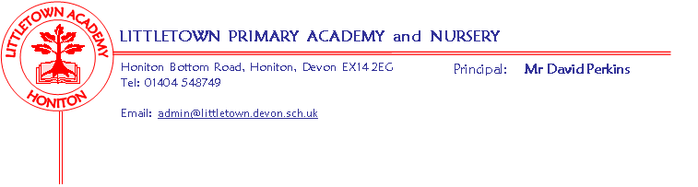

Play is a crucial part of your child’s development, therefore opportunities to learn through constructing with junk materials or construction sets like lego provide experiences for physical development but also encourage problem solving, planning, discussion, adapting and reviewing skills. Playing with small world or role playing/imaginative play can encourage language development as well as offering up opportunities to mark make, use mathematical skills and develop their social skills and understanding of the world – you will be amazed what learning can be achieved while playing ‘shops’.

Below are a few ideas for more specific learning to support what your child may be missing in school whilst at home:
Literacy
Reading
Please continue to read books at home – asking questions about the characters, setting and predicting what will happen next. The website www.oxfordowl.co.uk/for-home/ has lots of book banded reading books as ebooks for you to continue reading at home.
Watch Alphablocks on Cbeebies – there are videos for each phonic sound as well as games to check learning.
Take this opportunity to practise your tricky words.
Play games on Phonicsplay.co.uk (there are lots of free games) to support recognising letters and reading words.
Continue to practice real and alien phonics words – see attached phonics screening paper from 2019.
Writing
Continue to practise letter formation – see attached handwriting booklet
Children could keep a diary of the week or practise writing sentences about what they are up to.
Use Spellodrome as a fun way of further practicing tricky words and Y1 & Y2 common exception words.
Maths
Practise recognising, ordering and writing numbers (see attached sheets).
Play ‘guess my number’ games – give clues to a number e.g. it is one more than …, it is two less than … , it is … add … Play board games like snakes and ladders, dice games, dominoes or games where you are adding and taking away objects.
Watch Numberblocks on Cbeebies – at the end ask questions about the number introduced or the method taught.
Our new topic for maths is Length and Height - ask children to measure everyday objects around the home and order them from shortest to longest.
Play maths games on topmarks.co.uk

Cornerstones Topic
As we’ve just started ‘Paws, Claws and Whiskers’ we’ve attached a list of ideas related to our topic you could try at home.
We would love your child to find out about their favourite animal. Maybe they could draw and label different animals that we saw at Axe Valley Wildlife park. Make a poster with facts about your favourite animals. Use the Internet to find out information – the national geographic kids page is great for images, noises and fun facts www.natgeokids.com/uk.
We look forward to seeing what you are up to during this time.

