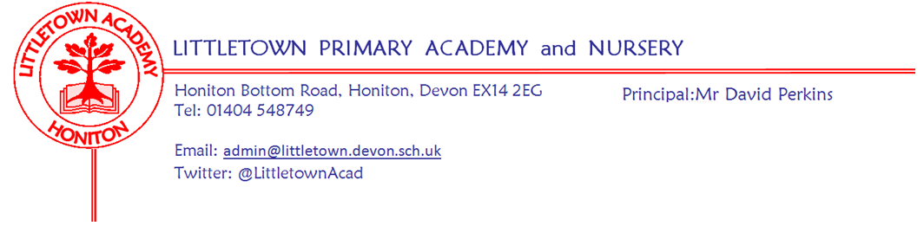
Friday 12th November 2021

Dear Parents and Carers,

Welcome to this week’s newsletter. As the COP26 comes to a conclusion in Glasgow, I start to wonder what exactly parents and school leaders around the world are supposed to say to our children about the future should an agreement not be reached to make enough of a difference. One can only look forward to the time when the world is led by our children (perhaps even current Littletown pupils!) where hopefully the future may look brighter.

Yesterday, we hosted our External School Improvement Partner at school for the first time since the Covid-19 pandemic. One of the observations was focussed on the pace and purpose of the start of day learning. We noticed great improvements compared to last time. This is largely due to the new start of day arrangements and procedures we have had in place since September. I wanted to thank all of you for supporting us with this each morning and for the impact it is having on children’s learning.

On Wednesday you should have received a letter outlining the arrangements for Christmas performances in the school. Please do get in touch if you have any questions.

Thank you to parents who have filled in out the google form on Vision and Values. You still have until next week to complete the form which can be found here:
https://forms.gle/MRBvLrbnWdryqVqh6

Next week is a very busy week for us. It is national anti bullying week and this will feature learning, assemblies and our odd socks day on Monday. We have our school photographs on Thursday and Children in Need on Friday. Full information on all of these events can be found below. Next Friday our Cross Country runners take part in the East Devon finals at Bicton College. You will notice below that I am now going to include a weekly events grid in each newsletter to act as a quick reference point. This could be pinned to a board or stuck to a fridge etc! Let me know if you find this helpful.

Yours faithfully,
David Perkins
Principal

News from pupil reporters

Nursery
Nursery have been reading a story about pumpkin cake.

Reception
Reception have decorated a picture of their bedrooms and have been reading a book called ‘Peace at Last’ in literacy and labeling pictures.

Year 1
Year 1 have been learning about how different weather affects us and their number bonds to 10.

Year 2
Year 2 have been thinking about describing fireworks and learning about materials in science.

Year 3
Have started their new topic called ‘Light and Shadow’ and have been learning where light comes from. We also made poppies and have been writing acrostic poems for Remembrance Day.

Year 4
We have been story planning about Rama and Sita and have been drawing a digestive system. We have also been learning about Hinduism and have started another book called ‘Lion and the place between’.

Year 5
We have been learning more about prime numbers and the Tudor justice system.
We have been writing winter poems and have started a new unit in power maths on factors. .

Year 6
We have spent a day making Anderson shelters in Design Technology.
In Maths we have been learning about BODMAS.

Pupil consent form
I have now managed to fix the google form from last week which you’ve received asking for various image consents. Please do make sure you complete this so we can proceed with photographing/filming children within parental wishes. You should all now be able to access this without it telling you to sign in to google!

School photos
A reminder about school photos next Thursday in school. Please remember we will be able to do sibling photographs for siblings in school. However, due to Covid-19 restrictions, we are not able to take family photos or photos with siblings who are not Littletown pupils. Mrs Jackson will explain arrangements for Nursery children who are not booked in sessions on this day and have siblings in school.

Anti bullying week 15th - 19th November
Next week we will be joining in with this years' National Anti-bullying week, including participating in assemblies, anti-bullying activities and odd socks day.

What is Odd Socks day?
Most importantly, Odd Socks Day is designed to be fun! It’s an opportunity to encourage people to express themselves and celebrate their individuality and what makes us all unique! All you have to do to take part is wear odd socks to school, it couldn’t be simpler! Odd Socks day will take place on the first day of Anti- Bullying Week 15th-19th November to help raise awareness of bullying. We would like to invite families to make a 50p donation to the Anti-bullying Alliance to support them in continuing to coordinate this week every year.
However, you do not have to donate money to take part - the most important thing is the message of Odd Socks Day!
The fundamental theme this year is 'One Kind Word'. I am certain that you will agree kindness is more important today than it has ever been. The isolation of the last year has underlined how little acts of consideration can break down barriers and brighten the lives of the people around us.
Please do have a look at the Anti-Bullying Alliance website for further information
Children in need
Next Friday we mark Children in Need on Friday 19th November and we are inviting staff and children to come to school dressed in their favourite pyjamas or non uniform to raise money for this year's appeal. Donations of 50p per child or £1 per family to be brought into school on the morning of the 19th. There will be no Reception outdoor classroom next Friday so they can dress for children in need.

Next week’s events
Monday 15th November | Tuesday 16th November | Wednesday 17th November | Thursday 18th November | Friday 19th November
Odd Socks Day  Wear odd socks to school to start our Anti-bullying week  50p donation to the Anti-bullying Alliance |  |  | Tempest Photography  Only siblings in school will be able to have their photographs taken together  Everyone comes to school in school uniform. Children who have PE to bring in their kit | Children in Need  Wear your pyjamas or non-uniform to school  50p per child/£1 per family  Classes will be carrying out lots of different activities during the day including joining Joe Wicks for a live work out with a difference!  East Devon Cross Country finals  Some Y4,5,6 pupils to Bicton College
4GW/GA Outdoor Classroom | 4SD Outdoor Classroom |  | Nursery Outdoor Classroom

Community news

British library competition
Honiton library have shared the following information with us regarding a competition which ongoing currently:
What makes your hero super?
bl.uk/superheroes
From 11 October to 30 November, we’re asking children to create a comic and help us assemble a new galaxy of superheroes! We’re celebrating heroes of every kind – whether they have the power to scale walls, save forests or make someone smile.

Teachers and parents can help themselves to a raft of free online resources. There are top tips, videos and templates to inspire you to make comics, flying heroes and flip-books: https://www.bl.uk/childrens-books/activities/what-makes-a-hero-super

Share your creations
Share photos of children’s work on Twitter @BL_Learning or by emailing childrens.books@bl.uk. On 30 November we’ll pick 5 lucky schools and 5 lucky families out of our (virtual) hat to win National Book Tokens.

