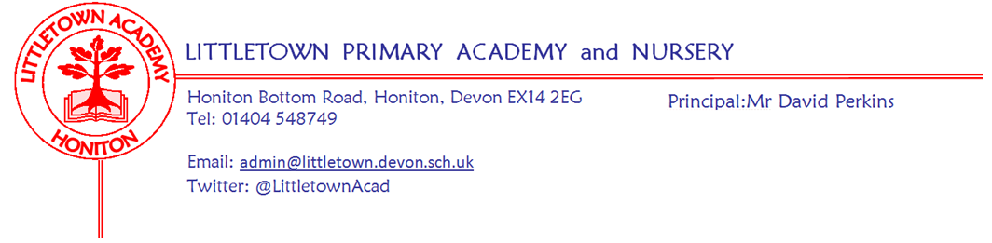
Tuesday 17th March
Dear Parents/Carers,

Following Mr Perkins’ email regarding preparation for a potential school closure, we are writing to inform you of the year 5 home learning tasks which we would expect to be completed during such a time.

Relating to our current topic ‘Time Traveller’, we would like the children to create a family tree. You might like this to include:
- Names of relatives
- Relationship to them
- Birth (and death if appropriate) dates
- Profession
- Pictures

It would be great if your child could speak to some of their older relatives, (Don’t forget to use technology to do this, rather than a face-to-face interview. Let’s keep our oldies safe!) and interview them about what life was like for them as a child.

This project can be presented in any format, either being shared with your class teacher on the Google Drive if completed digitally, or brought into school upon reopening if completed on paper. We will also re-send home the home learning ideas for the topic. Please ask your child to choose 2/3 ideas to have a go at.

We will be sending home a spring literacy activity booklet for the children to attempt. Most of the elements of the booklet have been taught to them, however there may be a few activities that they struggle with. You can either assist them with these activities or leave it for us to cover in school.

The children’s Power Maths Term A book will also be sent home with them. This covers the work that was completed in the autumn term. They can work through any questions which they either didn’t complete or completed incorrectly.
In addition to this, we expect that the children will access and use the following online learning platforms: (user names and passwords are provided in the pack)
- Times Table Rockstars
- Spellodrome
- Accelerated Reader. (Many of the books your children will read from home will have AR quizzes attached to them and can therefore be quizzed on. Of course, any reading is valuable even if there isn’t a quiz at the end of it!
Children can check the ZPD of their books on Accelerated Reader book find https://www.arbookfind.co.uk/
Reading can still be recorded in journals and should be completed a minimum of 5 times a week.

PTO

Please encourage your child to check their Google Classroom area daily, if we do close, as additional work and support will be uploaded when required.

If you have any questions, please do not hesitate to contact us. Our email addresses are as follows:

zara.urry@littletownacademy.org
c.binmore@littletownacademy.org

Thank you for your continued support,

Year 5 team

