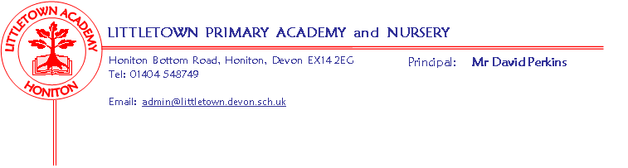
Year 2 Spring Term 2019 Information
Literacy
Alongside our First Cornerstones topic, children will write recounts, narratives, letters and posters. We will use the book The Tunnel by Anthony Browne and traditional tales such as Rapunzel and The Three Billy Goats Gruff to develop the children’s literacy skills. After half-term, children will look at nursery rhymes and adverts to help them write their own recounts, captions, instructions and diary entries.
Maths
We will continue to follow the Power Maths scheme this term and will be covering multiplication and division, statistics, measures (length and height), properties of shapes, and fractions.
Cornerstones
In the first half term we will be studying the topic of Towers, Tunnels and Turrets. The children will make models, create sculptures using natural materials, using drawing software to create castles in computing, learn about amazing structures around the world and towers and bridges in our local area, about castles and castle life, and about significant individuals from history such as Isambard Kingdom Brunel.
After half term, we will become Street Detectives. The children will learn about changes within living memory, significant people, places and events in our local area, carry out fieldwork in our local area noticing the physical and human features, use and make maps with keys, and look at famous local artists, drawings or paintings of our local area.
More information and ideas for home learning will be sent home at the start of each new topic.
Key reminders
Our PE days remain Wednesday and Friday but please ensure that children have their named PE kits in school every day.

Children are expected to read for 20 minutes every day at home, and spellings will be sent home on Fridays to be handed in the following Wednesday.

Key dates for the spring term
SATs Parents information meeting: Dates to follow
Outdoor Classroom: 2AL Mon 4th February
2CB/JP Tuesday 5th February
Parents Evenings: Week Beginning 11th February, Dates to follow.
Towers, Tunnels and Turrets medieval day: 21st January – to be paid for on ParentPay (thank you to all those who have already paid).

