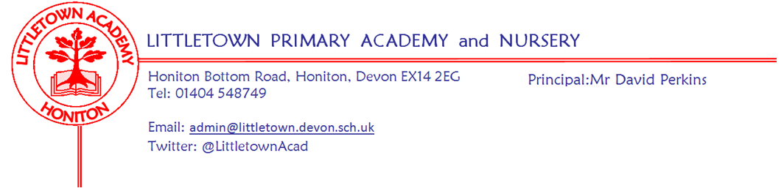

Friday 21st January 2022

Dear Parents and Carers,

Thank you for your ongoing patience and understanding as we navigate the school through ever changing numbers of Covid-19 cases and Covid related staff absences. Lots of Littletown staff are continuing to work extra hours and show great adaptability in order to assist with cover across the school so I am sure you would want to join me in thanking them for this. Please find below in this newsletter information about changes to testing and isolation periods since the last newsletter. Understandably, there has been lots of discussion in the community and on social media about Covid cases in schools, restrictions/containment measures and government policy this week. Please can I once again urge parents to get in touch with us directly if there are any questions or concerns.

This week, I have been able to spend some time around the school seeing the children take part in some highly engaging learning across the curriculum. Nursery showed me some great learning on the Gruffalo and told me all about their Gruffalo crumble! Reception have been analysing ice and frost under microscopes. Year 1 showed me some brilliant learning about patterns of 2D and 3D shapes. Year 2 have made very informative leaflets instructing me what to do if I spot the Dragon in school. Year 3 have done some beautiful artwork mixing watercolours. Year 4 showed me some brilliant mindfulness and PE with a Yoga flow session. Year 5 have been having some very deep conversations about future careers as part of the whole school topic on dreams and goals and finally, Year 6 particularly enjoyed showing me in great detail their skills in dissecting pig hearts in class! Despite us spending lots of time discussing Covid and managing the resulting impact in school, it is very clear that there is still great learning taking place for the children every day at Littletown.

Next week, some Key Stage 1 children are visiting Honiton Community College to take part in the Honiton Learning Community coordination festival. On Thursday, Mrs Davis will be taking 12 Year 5 and 6s to the East Devon Athletics Final at King’s School.

Please see below in this newsletter, a reminder about uniform and playground at the end of the day, information about our next upcoming Mental Wellbeing week and notification of an additional day of holiday due to the Queen’s Platinum Jubilee.

Yours faithfully,
David Perkins
Principal

News from pupil reporters

Nursery
This week, Nursery have been making Gruffalo crumble and learning about the Gruffalo.

Reception
This week, Reception have made pig puppets and have been finding missing numbers.

Year 1
This week, Year 1 have been learning about 3d shapes and about different types of animals.

Year 2
This week, Year 2 have been learning about climate change and have been using adjectives. They have also made leaflets about Dragons.

Year 3
This week, Year 3 have partitioned numbers to help with division and have been learning about colours. They have also been doing gymnastics and finished their topic by doing an art challenge. They have begun learning about stone age tools and weapons.

Year 4
This week, Year 4 have made Pompeii pictures and have started a Roman poster of what they would look like as Romans.

Year 5
This week, Year 5 have started learning about fractions and begun writing their gatekeeper raps.
They have also made working torches in Science.

Year 6
This week, Year 6 have been dissecting pig hearts and dividing decimals in maths. In P.E they have begun making up dances.

Covid-19 testing and isolation rules
As I am sure you are all aware, changes to testing and isolation periods have now come into effect in England. Those testing positive on a Lateral Flow Device can now end isolation on Day 5 if they can evidence two negative test results. As with all of these Covid-19 rules and guidance, please get in touch with us if you have any questions at all.

Additional bank holiday
Due to the bank holiday allocated for the Queen’s Platinum Jubilee in June 2022 falling in the existing half term week, schools have been asked to schedule a day of school holiday as close as we can to the date. Therefore we will be having an extra day of school holiday on Friday 27th May 2022 which is the Friday leading into the May half term week.

Uniform reminder
With many classes and sporting groups beginning to make trip and visits once again, I am certain that you will agree that from a safeguarding perspective and a ‘representing Littletown’ perspective it is important that all children are in the correct school uniform.

We have noticed several children in all year groups wearing a variety of clothing to school. Please can I remind you of the uniform policy (attached). Trainers seem to be a common theme and a variety of hoodies - neither of these are in the policy.
However, it is pleasing to see the children are remembering their P.E days and coming to school prepared, however please remember the P.E kit is navy.

Playground at the end of the day
Since returning from Christmas holidays, we have had a couple of injuries and incidents caused by children running around the playground at the end of the day once released by the teachers. I know it can be tricky when younger children are waiting for younger siblings, but please can you try to stop children running around the playground and playing games at the end of the day so we have less chance of further injuries. Thank you for your cooperation with this.

Mental Wellbeing
Our second Mental Wellbeing Week 7th - 11th February, will be held during Children’s Mental Health Week organised by the charity, Place2B. The children will be involved in various activities during the week and then a non-uniform day will be held on Friday 11th February to raise money for the charity ‘Place2Be’ and wellbeing at school, 50p per child/£1 per family. The theme for the non-uniform day will be ‘Dress to Express’.

If you have any used, clean small yogurt pots (not the large family size pots) which you were going to put in the recycling bin please could you bag them up and bring them into school by Friday 4th February. I need enough for every child in the school!

Week Beginning 24th January 2022 events
Monday 24th January | Tuesday 25th January | Wednesday 26th January | Thursday 27th January | Friday 28th January
12 children KS1 HLC coordination event |  | Nursery outdoor classroom | East Devon Athletics Final Kings school | Reception outdoor classroom

