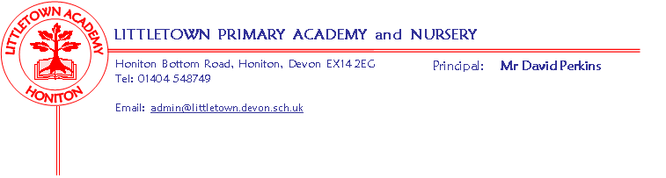
Literacy
Year 2 Summer Term 2019 Information
The first half term we will be looking at poetry through riddles and acrostic poems. We will also be working on understanding what is inferred in texts during our reading sessions.
Maths
We will continue to use the Power Maths books for learning about Fractions, before revisiting the most important areas of maths prior to the SATs.
Cornerstones
We will continue with our topic of Muck, Mess and Mixtures for the first half term focusing on art skills (along with giving the children the best preparation for the SATs in May). We will be inviting you in to share our learning with you after the half-term break (see dates below)
In the second half term our topic will be Bounce.
Throw it, catch it, roll it, bounce it! Up and down and side to side, can you catch the bouncing ball? Can you bounce too? Jump like a horse, leap like a frog or kick like kangaroo! How many bounces can you do?

Key reminders
The children are still expected to be reading for 20 minutes every day, alongside using Times Tables Rockstars if possible, and completing weekly spellings.
Please could the children have named PE kits in school every day, with joggers and shorts as the weather can be unpredictable.

Key dates for the spring term
Outdoor classroom dates: 2CL/DB Thursday 23rd May
2AL Friday 24th May
Muck, Mess & Mixtures Express event: Tuesday 11th June 2:30 in the Year 2 classrooms.

