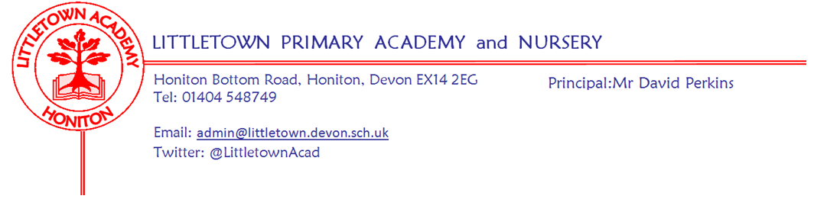
4th October 2019
Dear Parents and Carers,

This week, Year 3 outdoor classroom just about survived the weather with the skillful dodging of heavy showers. Yesterday we had our crazy hair and burger day. Thank you for supporting this with 307 (73% of the school) children having the school dinner on our census return affecting our school income for the next academic year. My thanks to the kitchen staff and office staff for doing such a great job with this busy day.

Next week, Year 1 have their Gymnastics session at Honiton Community College on Monday morning, on Tuesday 3RB/GH have their first visit to Adelaide lodge as we continue this valuable initiative for another year. Thursday is ‘Hello Yellow’ World Mental Health day. Please see further information below as in last week’s newsletter. On Thursday evening at 6pm we welcome Reception and Nursery parents for our first curriculum information evening.

Your child will be bringing home today your confirmed parents evening date and time – please look out for this - or contact your child’s class teacher if you haven’t made an appointment yet.

Next Thursday and Friday Mrs Hawkins and I will be attending the Devon Association of Primary Headteachers Empowering Leadership conference in North Devon. We will hear from a range of guest speakers, network, share our practices and work alongside other headteachers on school based projects as well as reflecting on Littletown Primary Academy’s school improvement journey.

Finally, I would just like to request that parents try to abstain from requiring the time and attention of the class teachers at the very start of the school day. Although, we pride ourselves on being approachable and having strong relationships with all parents, I really need the teachers to be focussed on settling and teaching the classes first thing in the morning. Unless it is absolutely urgent, please remember to respect the system we have in place which is to pass messages via the office which we can get to the teachers on your behalf. Appointments can be made to see teachers as necessary after school. School leaders are also available at the start and the end of the day to assist. Thank you for your cooperation with this.

Yours faithfully,
David Perkins
Principal

News from the children

Nursery
We have had crazy hair day.
We have been counting candles on birthday cakes.

Reception
We have been finding sound and pictures in our letter game.
We have been practising writing our names holding the pencil correctly.
Year 1
We have made superhero models.
We have been learning all about parks.

Year 2
This week we have been playing new musical instruments.
This week we have started our new project books.

Year 3
We have been designing our own chocolate bars.
We have started our egg experiment using vinegar and lemonade - More results next week!

Year 4
We have made reindeer Christmas cards
We made artificial poo using leggings to squish the digested food.

Year 5
We have been learning to add 5 digit numbers in maths.
We have done Tudor portraits.
We are learning about Henry VIII wives.

Year 6
We have been doing division in maths and doing a poster.
We have done some cross country running.

Staff news
During the October Half Term, Mrs Davis, together with family and friends will be climbing Mount Snowdon raising money for Devon Air Ambulance. If you would like to sponsor Mrs Davis and Thomas there is a collection box on the front desk or a donation can be made at www.justgiving.com/fundraising/susannah-davis3 any donation will go towards the valuable service the charity provides. In 2018 it cost £7.5 million to keep the service operational so every donation made is greatly appreciated.

Messages
Accelerated reader
Children completing quizzes on books at home has definitely had a positive impact on children’s reading across the school. However, some families are encountering log in problems with the accelerated reader website. This is because you need to have the actual link to our Littletown Academy Accelerated Reader site. This can be accessed via ‘bookmarks’ in your child’s littletownacademy.org google domain or by following a direct link. This will then allow the site to accept the children’s logins. If you have any questions please do ask the class teacher.

Children must either log in to their Google school account and then follow their bookmarks or go directly to:
https://ukhosted44.renlearn.co.uk/1922601/

World Mental Health day ‘Hello Yellow’ Thursday 10th October
Thursday 10th October is World Mental Health Day and after the success of last year, we are once again saying 'Hello Yellow' with the charity Young Minds, to raise awareness and money to support children and young people's mental health. This year, your children are invited to come in dressed in something yellow if they have it (or any clothes if not) and donate £1 towards the charity, or £1.50 per family. It can be as small as a yellow hair clip or a complete minion or giraffe costume, be as creative as you like! In addition, they can bring in any yellow accessories to join their class for a 'dress the teacher' competition to be judged at the end of the day!
We are also excited to be organising a whole school yellow cake sale, where we will again be raising money for the charity Young Minds. Any donations of yellow baked goods are very welcome and can be brought in on the day.
Of course the most important aspect of the day will be to raise awareness in our children of the importance of looking after our mental health just like we look after our physical health. This underpins a lot of what we do at Littletown and your children will be bringing home a few bits to share and discuss with you. There will be Mental Health information meetings for parents running over the term, please look out for dates in the newsletters.'

A Plea from Year 3
We are looking for donations of good quality board games, such as chess, scrabble and draughts, for the children to play during Golden Time in Year 3. Any donations can be handed into the office or the Year 3 area. Many thanks, Year 3 Team.

A pleas from Nursery
Do you have a slow cooker at home which you no longer use or need? If so, Nursery would be extremely happy to rehome it for you! Many thanks in advance.

Plastic free schools group
Today our group of children on the Plastic Free Schools team met to discuss low waste, plastic free alternatives for Christmas crackers and there will be more information about this in future newsletters. We will also be holding an assembly for children to discuss recycling.

School events/Dates
Week beginning 7th October :
Monday | Tuesday | Wednesday | Thursday | Friday
Year 1 Gym festival | 3RB/BH Adelaide Lodge |  | Nursery and Reception curriculum information evening  Mental Health day

