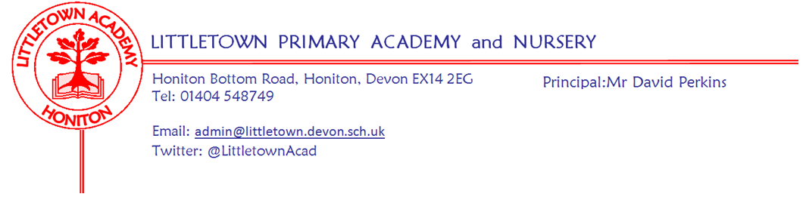

Live . Love . Learn - Littletown
Friday 6th January 2023
Dear Parents and Carers,
I would like to start by wishing you all a happy new year and I hope you all had a wonderful Christmas break. This week marks 5 years that I have had the privilege of being Principal at Littletown - fair to say they have not been uneventful years. It has been lovely to see all the children return energised and with stories of great Christmases and a very generous Father Christmas! My thanks to Mr Bilcock and his Primary Sports colleagues for running a very successful holiday club at school over the Christmas break. You may have noticed we also had some trees cut down on the bank outside Year 3 and 4. This allows more light into classrooms and prevents debris blocking gutters which resulted in surface flooding.

This week we have given a warm welcome to Mrs Burton to our Reception desk, whom I’m sure all of you will get to meet over the next few weeks one way or another. We have also welcomed Mrs Ryerson to her role as Year 3 Teaching Assistant, Mrs Allen to Year 3 Teaching Assistant on Friday mornings and Mr Daniels who joins us in Mr Luxton’s class as Trainee Teacher for the Spring Term. I would also like to say a warm welcome to the numerous children who have joined Littletown across the school at the start of the Spring Term. This week we have revisited some key elements of the school with the children such as our values and the importance of having a Growth Mindset in our learning in 2023.

Next week, on Tuesday, we have our Year 5 children start swimming sessions that they didn’t receive in Year 3 due to covid restrictions. Also on Tuesday some of our Key Stage 2 children take part in a Honiton Learning Community Coordination event at the Leisure Centre. Nursery have outdoor classroom on Wednesday and we have our first school discos of 2023 on Friday evening!

On Thursday next week we start our next Timid to Tiger parenting course. My thanks to the parents attending and to Mrs Canniford and Mrs Layzell for planning and providing the course over the next few weeks.

As usual, we have a busy Spring Term coming up. As the first half term is quite short we will be holding Parent Consultations this term after the half term break in the week beginning 27th February. These will be in school appointments and more information will be shared in due course.

We continue our work in the school as a Rights Respecting School and in 2023 we are taking part in UNICEF’s OutRight campaign. Through this campaign, our children are going to learn about, and speak out on, children’s right to the best possible health and how strong health systems support this. The campaign was launched in the Autumn term and as you are probably aware has since become quite topical for us in the UK. Please do read the attached letter from UNICEF UK which contains more information about how we will be sharing children’s work with UNICEF and the Foreign, Commonwealth and Development Office (FCDO) of the UK Government.

We are also going to continue our OPAL journey at lunchtimes. Next week we plan to ‘mix the children’ on Monday, Wednesday and Friday lunchtimes following previous successes. Thank you for all the donations so far. We are currently on the hunt for large quantities of play sand so do get in touch if you have any ideas! Mrs Davis and the OPAL team will give more detailed updates on the next steps soon.

Yours faithfully,
David Perkins
Principal

Children’s news

Nursery: This week, Nursery made cars using cardboard and were learning how to draw cars with colourful pens.

Reception: This week, in Reception, we made paper castles and read Jack and the Beanstalk.

Year 1: This week, in Year 1, In Maths they learned about 2D and 3D shapes and in P.E they did yoga and they learned about seasons.

Year 2: This week, in Year 2, in R.E they learned about Buddhism and in P.E they did yoga as well.

Year 3: This week Year 3 have learnt how to make numbers 10 times bigger and have started a book in Literacy called Stone Age Boy.

Year 4: This week, Year 4 have started a new book in Literacy, a new song in Music and have been exploring solids, liquids and gases in Science.

Year 5: This week, in Year 5, we have been learning about water resistance with pulleys in Science. In Literacy we are learning about Norse Gods.

Year 6: This week, in Year 6, we are reading a book called Man Fish in Literacy and are starting a new topic called Frozen Kingdom. In PE we have started Tennis.

Attendance/lateness
The children have been praised in assembly today for arriving at school on time despite the dark, wet mornings, lots of late nights and lay ins over the Christmas holidays. Please can all parents/carers continue to ensure the children are in school for 8.50am. The doors are closed at 8.55am and parents/carers must come to the front reception to sign the children in, please do not send children in unattended. If your child is absent or going to arrive late please remember to contact the school to let us know.

Choir starts next week
Fresh from several wonderful community performances in the cold before Christmas, the choir will be back at it, with Mrs Binmore from next Monday from 3:30 - 4:15pm.

Bird feeders for Year 4
Year 4 is in need of some bird feeders if you have any spare that you aren’t using!

Reception Admissions for September 2023
Is your child 4 years old before August 31st 2022?
If so, please remember to apply for a Reception class place by 15th January 2023 at www.devon.gov.uk/admissionsonline.
Please contact us to book a tour of the school on 01404 548748 or admin@littletown.devon.sch.uk

Honiton Littletown Primary Academy Trust
COMPANY NUMBER: 07851471
NOTICE OF ANNUAL GENERAL MEETING
Notice is hereby given that the Annual General Meeting (the “Meeting”) of Honiton Littletown Primary Trust will be held on Tuesday 17 January 2023 at 5.30pm to transact the following business:

- To receive the Chairman’s report;
- To receive and adopt the company's annual accounts for the financial year ended 31 August 2022 together with the directors' report and auditor's report on those accounts;
- To appoint the Company's auditors to hold office from the conclusion of the meeting to the end of the next period for appointing auditors under section 485(2) of the Companies Act 2006, at a remuneration to be determined by the directors;
- To appoint new Members to the Board and accept any resignations from the Board by current Members.
By order of the Board
Tina Sillitoe
Chair
Honiton Littletown Academy Trust
Week Beginning 9th January 2023 events
Monday 9th January | Tuesday 10th January | Wednesday 11th January | Thursday 12th January | Friday 13th January
Choir starts (3:30 - 4:15) | Y5 swimming pm  KS2 Co-ordination event Honiton Leisure centre | Nursery outdoor classroom |  | PTFA discos

