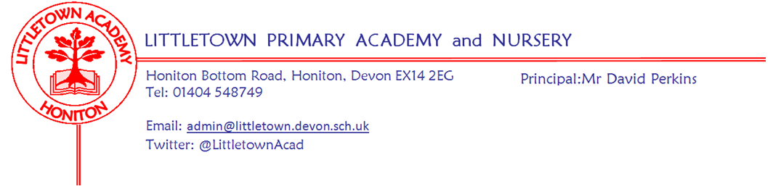
Year 1 Summer Term 2021 Information

Welcome
Welcome back. We hope that you all had a restful break over the Easter holiday.
Literacy
In literacy we will be using our most recent assessments from the Spring Term to plan and teach children their next steps. We will continue to have daily phonic lessons to learn letter sounds and how to blend them together to read words . We will continue to check tricky words weekly to ensure the children are confident with their new words in a range of situations. In school, we check sound and word knowledge through reading and games - please ensure at home they are not just learning the words in a list. Please revise previous words and sounds too, so your child doesn’t forget them as they move on.

Thank you for all your support with listening to your children read during the Spring Term. We kindly ask all parents to read with their child each night and record when you read or look at sounds/words at home. Just a signature on the date is fine, or the title of the book or sounds/words you practised. The expectation in school is for reading at home 4 times a week with a record of this in the diary. We will check the diaries every Monday when we change children’s reading books. All children are able to access both oxford owl and Lexia at home as well as learning tricky words and phonic sounds (www.phonicsplay.co.uk is a great resource for learning phonics sounds).
Great news! We have now purchased lots more books and have enough for the children to change books twice a week. We will all be changing our home reading books on a Monday and Thursday. Please ensure you bring reading books back to school on these days as the books need to be quarantined before the next change over.

Within literacy this term we will be focusing on the children’s writing skills. Children will be working on writing lengthier pieces of writing of 2 of more sentences. We will be asking the children to be detectives, to make sure that their writing makes sense and that they have included important features such as full stops, capital letters and finger spaces. We will be encouraging children to use conjunctions such as ‘and’, ‘so’ or ‘because’ to extend their sentences and to include a range of adjectives to make their sentences more interesting. We will be looking at a range of genres and texts that link to our topics.
Maths
The children will have a Power Maths lesson for an hour every morning. We will continue to practise and develop the children’s number skills so that they are confident with numbers to 50, and beyond.

In the first half term the children will be practising multiplication and division skills. Within multiplication we will be looking at multiples of 2, 5 and 10 and doubling. We will then move onto division by learning to share and group equally. The children will learn about halving and quartering shapes, before moving onto given amounts.

In the second part of the Summer term we will be looking at counting, partitioning, comparing and ordering numbers to 100. We will then look at number bonds to 100 and and learn how they can help us with addition and subtraction. We will then move onto learning about time, looking at calendars, months of the year and reading the time to o’clock and half past. The last topic in maths for the Summer term will be looking at money; recognising, ordering and counting coins and notes.

Cornerstones Topic
We follow a topic led curriculum that is broad and balanced and aims to develop the children’s skills, knowledge and creativity. At the start of each topic there will be an exciting ‘engage’ event to hook the children. At the end of each topic we would usually have an express event where we would share children’s learning with you, however, due to Covid restrictions these may be unable to go ahead.

We will be continuing our topic of ‘Dinosaur Planet’ for the first two weeks of the Summer term.

We will then move onto our new topic ‘Enchanted woodland’ on the 4th of May. If you go down to the woods today you’re in for a BIG surprise. Foxes and badgers, voles and mice, beady eyed owls in the swaying tree tops. Beneath the leaves are tiny footprints – animal or imp? You decide. Deciduous or evergreen? Can you match a leaf to its tree? Can you match a petal to its flower? Let’s build a den, stick by stick and branch by branch. Or we could make a teeny tiny home for a woodland fairy. Then let’s party down in the woods with Mr Fox and all his woodland friends. We’d better not get lost. Let’s leave a trail of conkers as we go. At last, it’s time to rest by the woodland fire, listening to stories and toasting our sweet, gooey marshmallows. Yum, yum. More information about our new topic is attached to this newsletter along with ideas for opportunities for home learning.

PSHE (including Relationship, Sex and Health Education)

Relationships topic:
In this topic, children will learn to identify members of their family and understand there are lots of different types of families. They will identify what it means to be a good friend and know appropriate ways of physical contact to greet friends and know which ways they prefer to be greeted themselves. Children will learn who can help them in the school community and recognise how to help themselves or others if they are upset or hurt. Towards the end of the topic, children should be able to tell you why they appreciate someone who is special to them.

Changing Me topic: More information to follow
Key reminders
Outdoor Classroom: Tuesday 4th May (both classes) and more dates to follow.
Book Bags: Please bring book bags to school every day (with your child’s Reading Record).

Reading books: We will be changing books on a Monday and Thursday
Water Bottles: Please ensure your child has a bottle of water (not juice) in the classroom for drinking throughout the day. They may have juice in their lunchbox but no fizzy drinks.

Packed Lunches: We have peanut allergies in school so we ask that no children have nuts or nut based snacks/spreads in their lunchboxes. We are a healthy school and ask that children do not bring in chocolates or sweets for lunch.
School Dinners: Please ensure you book your child’s school dinner by Friday midnight for the following week. If your child does not eat enough school lunch we will send a note home to inform you.

Medication: Please let us know if your child has to take any prescribed medication at school. There is a green form for you to fill in so that we can administer it. We can only give prescribed medication and the medication must have the prescription label on. Please phone the school if your child is off sick. If you have a medical appointment please let the office know.

Birthdays: If it is your child’s birthday they can come to school in their home clothes. Please do not bring cake/sweets.

Parent helpers: We would normally love Parent Helpers but unfortunately, we cannot have parents into school at the moment.
Junk Materials: We are desperate for yogurt pots, small boxes (not cereal size boxes) and cardboard tubes (not toilet rolls). Please ensure they are clean because the children use these to build models with. If you have any please bring them in a bag on a Friday so we can leave them over the weekend in ‘quarantine’ for building fantastic models the following week.

Key dates for the Summer term
Tuesday 4th May- Engage day in outdoor classroom for the new topic ‘Enchanted Woodland’

Thank you for your support,
Miss Meecham, Mrs Lambert & Mrs Veevers
Miss Veevers: class1cv@littletown.devon.sch.uk Mrs Lambert & Miss Meecham: class1cllm@littletown.devon.sch.uk

