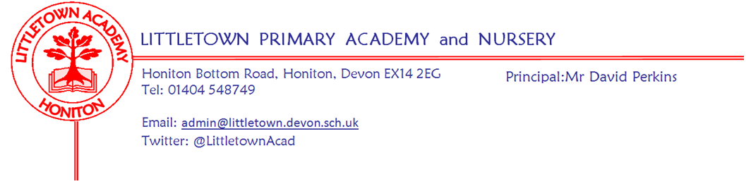
Friday 6th November 2020
Dear Parents and Carers,

I will start by wishing you all a warm welcome back to school for the second half of the Autumn Term. I could see there was a lot of great learning via Lexia taking place over the two weeks. It has been brilliant to see the children return to school with so much energy and enthusiasm for learning.

You will know that as of yesterday, four weeks of lockdown restrictions came into effect. With schools remaining open during this period we have received guidance from the Government regarding the operation of schools. We really do require the cooperation of everybody in the Littletown community to keep us all as safe as possible during this time. Much of how we operate will remain unchanged as we have not been given the ability to move to rotas or extend staggered start and finish times etc. However, there are some changes to come into effect from next Monday (9th November) as follows:

Attendance
There has been no mention of loosening the compulsory nature of school attendance. Only children whose doctors have confirmed they are still clinically extremely vulnerable, are advised not to attend childcare or nursery during the period this advice is in place. Children who live with someone who is clinically extremely vulnerable, but who are not clinically extremely vulnerable themselves, should still attend school.

Face coverings
It is still not mandatory for parents to wear face coverings. However, given that we cannot take other measures to make the staggered start and finish times even safer, we will use the discretion given to us to recommend that parents wear face coverings when coming to school for drop off and pick up from Monday 9th November.

After school sports clubs
Although our wrap around after school club childcare provision can continue, sports clubs are to be cancelled during the lockdown period from Monday 9th November. Parents will either have heard already or will be hearing early next week from Mr Conybeare regarding refunds and rescheduling. We will allow short notice booking to After School Club next week to support parents unable to collect children due to cancelled clubs. Please contact the office to make these arrangements if needed.

School trips
Any school trips and visits planned for lockdown period will be cancelled or rearranged.

We have been told that it is possible for guidance to schools to be amended at short notice so please look out for further communication from me over the next few weeks. Please see below in the newsletter information about use of antibacterial hand sanitiser in school and a plea from me about keeping staggered starts and finishes safe.

Guidance has also recently changed regarding legal expectations on schools and legal expectations on parents for ‘Remote Learning and Teaching’ when children are off school for any Covid related isolation periods. I will be writing to you all on Monday with our amended arrangements, procedures and expectations which will come into effect on Monday. Please make sure you read all of this information thoroughly.

Meanwhile, exciting Littletown learning continues! This week, Reception children have begun their outdoor classroom, learning how to keep safe in our outdoor environment, Year 2 have made some amazing minibeasts using junk modelling and Year 1 have had a very exciting zoom call with the Queen!

Parents who we didn’t manage to contact via phone call for parent consultations should have had email from the class teacher about their child. Please get in touch with us if this isn’t the case.

Next week we host Flu vaccinations on Tuesday (see information below), we mark ‘Remembrance’ on Wednesday and Children in Need on Friday. Further details can be found below courtesy of Mrs Davis.

Finally, please see below a recap of key points regarding Covid-19 procedures on attendance isolation and communicating with school so we are all refreshed of these protocols after the holiday. Remember, if you have any questions or queries about any of this please make sure you contact the school so we can help ensure everyone acts correctly in these uncertain situations.

Yours faithfully,
David Perkins
Principal

Staggered drop offs and pickups
I would like to once again thank the vast majority of parents who continue to follow the procedures we have set in place day in and day out. However, it has been noticeable that over the last few weeks before half term and certainly this week we are having issues with crowding following the second pick up at 3:15. A small element of this will be parents waiting for siblings. We have observed though, that an ever increasing number of children and parents finishing at 3:05pm are choosing to wait socially distanced in a playground for friends or extended family who finish at 3:15. It is this which is then causing the bottleneck and crowding at the gate following 3:15. From today, Senior Leaders and I will be ensuring families and children leave the site as soon as they finish unless collecting a sibling. Please can I ask that you conform with this request? Please remember, none of this is us trying to be unwelcoming, but we are trying to carry out our risk assessment to the best of our ability in order to keep everyone as safe as possible. I know that the staggered pickups work effectively when everyone does their part and follows the procedures as we have seen this on several days and weeks.

Antibacterial hand sanitiser
As your children may well have told you, this week we have changed our hand cleansing approach from soap and water at all times to a mixed approach of soap and water alongside the use of anti bac hand gel from teacher supervised dispensers in classrooms we installed over the half term break. We were able to make this change following assurances from suppliers on continued supply of product, which suppliers were not able to give over the summer, and the fact that it can be safely administered under teacher supervision. This change will make children’s hands cleaner, save lots of curriculum time, save lots of paper towel usage and assist with chapped skin/soap allergy issues. Please do get in touch if you have any questions.

Children in Need
Children in Need is being held on Friday 13th November and this year’s focus is on Mental Wellbeing. Children will be learning about ways to help their mental wellbeing throughout the week, culminating with a non-uniform day being held on Friday for a donation of 50p per child or £1 per family. Many thanks as always for supporting these national fundraising events.

Christmas cards
In next week’s newsletter we will outline our procedures for children giving Christmas Cards this year.

Staff news
Congratulations to Mrs Childs who found out over the half term break that she had successfully passed the National Award for the Special Educational Needs Co-ordinator.

Flu vaccinations Monday 10th November at Littletown
Please find detailed below information from Virgin Care:-
Dear Parents/guardians,
Your child is eligible for a Free Nasal Childhood Flu Vaccination.
This will be administered adhering to all up to date Infection Control, PPE and social distancing guidance at the time. Flu vaccination is one of the most effective interventions we have to reduce pressure on the health and social care system which is going to be more important than ever this year. For this reason, it is essential we deliver the vaccine to as many children as possible to prevent the spread of infection to those most at risk in society.
In light of the above, we are expecting demand to be high and therefore we urge you to follow the link below to consent to your child’s vaccination now.
Even if you do not want your child to receive this vaccination, please complete the consent form stating “no” consent. You will also find answers to your FAQ’s on this link.
https://schoolimms.virgincare.co.uk/flu/2020/devon
If you have any difficulties with completing the consent form please contact the Immunisation Team on our Single Point of Access (SPA).
Governor vacancies last call!
Governors at Littletown are very much part of 'Littletown Big Team' and we would really like to recruit some new members. We are looking for enthusiastic people prepared to give a little back to our school community, governors help in setting the strategic direction of the school, we offer our expertise and knowledge to help support the school leadership team. Governors meet once a month currently online but we are a friendly bunch and would welcome you to join us. We would love to hear from you if you have legal, financial or building skills but equally if you are like me and just want the best for the children in our community get in touch to find out more. Closing date Friday 6th November. tsillitoe@littletown.devon.sch.uk

Covid-19 procedures reminder
Please remember to consult the flow chart if you have concerns about what to do regarding Covid symptoms or track and trace. It can be found on our website here:
https://www.littletown.devon.sch.uk/website/flow_chart_for_covid_symptoms_/506011
Please email me head@littletown.devon.sch.uk even if it is evening or weekend if your child won’t be at school due to anything to do with Covid-19 so I can act accordingly straight away.
- If anyone in your household shows symptoms don’t send your child to school and collect them immediately
- If they show symptoms notify the school and book a test
- Notify the school of test result immediately and return to school if negative

