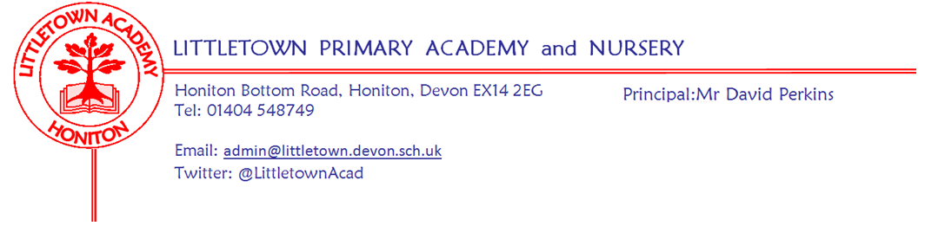
Year 6 – Remote Home Learning Update – 17 April 2020
Dear Year 6 children and parents,
We hope you are keeping well and have enjoyed the lovely Easter weather.
As from Monday 20th April, we are going to use a Padlet Learning Wall to share activities and ideas for your home learning. All of the teachers at Littletown will be using this approach to ensure consistency across school. Your Y6 Padlet link should accompany this letter.
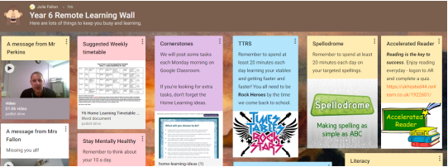

https://padlet.com/juliefallon/omcgf1r5hu7w
On the padlet, you find three video messages: one from Mr Perkins, one from Mrs Fallon and one from Mr Priddle. Each post it note has an activity or idea – if you click on the post it note, it will open up in a new window, in an enlarged form. As time goes on, we will add new post it notes or update original ones. Please read our Remote Learning Wall each Monday to see new ideas and updates. Our wall will be added to our Google Classroom and we want you to continue using the Classroom Stream and/or gmail to message Mrs Fallon, Mr Priddle, Mrs Sweet and Mrs Randall. As a Year 6 team, we are frequently monitoring the stream, gmails and speaking to each other, checking how you are.

You will notice from the suggested weekly timetable that we have reduced the number of Power Maths lessons and Writing activities. We realise that it may be challenging for you at home to have access to a computer or laptop; you may have to share one with other members of your family. We also know that the BBC are launching Maths and Literacy daily lessons which can be accessed from laptops and the TV. These lessons may be fantastic – we haven’t seen one yet – watch out for a post it note if we think they are the way forward.

The Power Maths lessons, Literacy tasks and Cornerstones activities will be posted each week on our Google Classroom. We will continue to include the answers for Power Maths on the slides, hopefully all correct!!☺ You are very welcome to gmail us writing, slides or photographs of activities completed.

It would be lovely for your teacher (Mrs Fallon or Mr Priddle) to receive a quick email at the end of each week to say how you are doing. As always, enjoy your learning. We continue to miss working with you every day at school and look forward to seeing you soon. Please message any of the Y6 Team (6JF: Mrs Fallon & Mrs Sweet) 6CP: Mr Priddle & Mrs Randall) via Google Classroom Stream or Gmail if you have any questions - we’re available to help.

Year 6 children – remember these are difficult times for your parents and carers. Look after them, be as helpful as possible and don’t stress over Home Learning activities; message us and ask for help. Be kind to your brothers and sisters if you have any; stay in contact with your friends through our Google Classroom or other devices and support each other. These difficult times will pass and you will go on to secondary school – hopefully back to primary school for a while – so work hard to keep learning new and exciting things, keep exercising and having fun but most of all be a nice person.
Mrs Fallon and Mr Priddle

Please note message from Mrs Trim and Mrs Childs:
This is the link that all parents can use to access the SEND/SAFS padlet page. There is a lot of useful information, activities, links... for our SEND children and families.

https://padlet.com/lianechilds/ewjn9i9gxfpw

