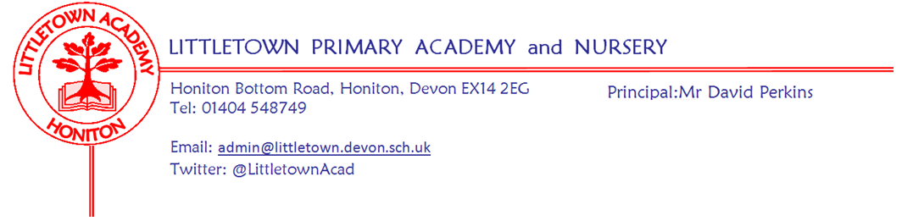
Friday 19th March 2021
Dear Parents and Carers,

It has been fantastic to see our school full of Superheroes today as we contribute to Comic Relief 2021. Thank you to everyone who has donated and to those who have bought red nose for the cause. We have counted the money today and are pleased to say that we have raised £480 through red nose sales and £220 through our superhero dress making a Littletown total of £700. Thank you to Mrs Davis for organising all of the comic relief activities for us this year.

This week, we have continued to support the children with the return of full schooling. Staff have been working with children to support them emotionally and to gently assess children’s understanding of concepts covered over partial closure. Details of these approaches were set out in last week’s newsletter. I’m sure you will have noticed that children are becoming tired as the weeks progress. Restful weekends, early bedtimes and good breakfasts all help the energy levels children need to succeed in school throughout the week.

This week you should have received a letter outlining upcoming changes to Personal, Social and Health Education in terms of Sex and Relationships education and related consultation period. Please make sure you respond to the consultation within the timeframe and don't hesitate to ask us any questions. My thanks to Mrs Hawkins for all her hard work in this important curriculum development.

I have definitely noticed an improvement this week in the balance of the staggered starts so thank you for your cooperation with this. As the weather improves, it is a shame that I have to remind you all to please leave the playground promptly when the children come out of school, but under our Covid-19 risk assessment it is really important we continue to do this. Parents should only be stood waiting if they are waiting for a sibling and please ensure that children already out of school stand with you and don’t run around in the playground. It has always seemed strange to my staff and I to see so many children of different ages mixing in the park opposite at the end of the school day after all the hard work it takes to keep the children in separate bubbles all day at school. However, I know lots of you will choose to visit the park as the weather improves, but can I please remind you that strict social distancing is required in all public spaces.

Finally, I would just like to take a moment to reflect as we reach exactly one year since we were told to close to all but key worker children in light of the Covid-19 pandemic. It has been a challenging and unforgettable year for every teacher, parent and child at Littletown. Who would’ve thought where we would be today one year later. Amazing to think of all the changes, challenges and phases we have been through since 19th March 2020 and yet here we all are still working together as the LittletownBigTeam as we continue to move through these times. Thank you for all your ongoing support.

Yours faithfully,
David Perkins
Principal

Mental wellbeing
This week the children have been learning about Normal Magic and how to balance their mental wellbeing using the 10 a day. Here is the link to the video if you would like to watch it with your child/children https://youtu.be/sWy06DIq7-c Take a look at this week’s 10 a day focus which is Take a Break. For more information about Normal Magic and 10 a Day visit the Normal Magic website https://normalmagic.co.uk/
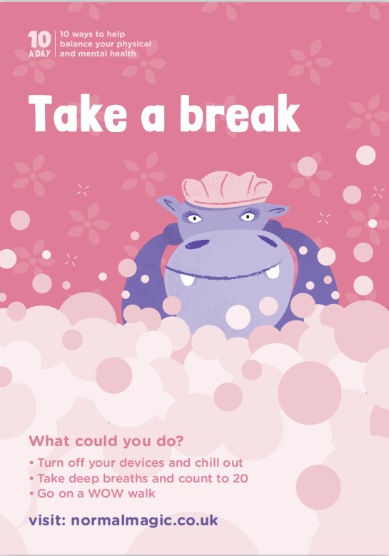

Lateral Flow Tests for Primary school pupils
A reminder that the Department of Health and Social Care announced that from Monday 1st March, households with primary school, secondary school and college age children, including child care and support bubbles, can test themselves twice every week at home as schools return from Monday 8th March. The twice weekly test kits can be accessed:

- at a local test site
- by collecting a home test kit from a test site
- by ordering a home test kit online

Please find here a link which provides further information on how to obtain the tests which is quick and easy to use. https://www.gov.uk/guidance/rapid-lateral-flow-testing-for-households-and-bubbles-of-school-pupils-and-staff?utm_source=1%20March%202021%20C19&utm_medium=Daily%20Email%20C19&utm_campaign=DfE%20C19
As Public Health England states: Around 1 in 3 people with coronavirus (COVID-19) do not have symptoms but can still pass it on to others. Regular testing of people without symptoms (asymptomatic testing) is important to help stop the virus spreading.

