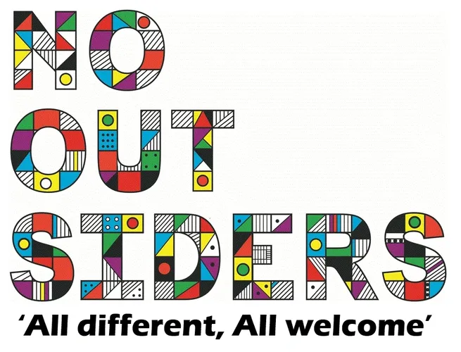
Whole school Overview

 | Autumn 1 | Autumn 2 | Spring 1 | Spring 2 | Summer 1 | Summer 2
PSHE Unit | Being in my World | Celebrating Difference | Dreams and Goals | Healthy Me | Relationships | Changing Me
Reception | Hello, hello | The Family book | Red rockets and rainbow jelly | You choose | Mommy, Mama and me | Blue Chameleon
Year 1 | Going to the volcano | Elmer | Errol’s garden | My World your world | Hair, it’s a family affair | Want to play trucks
Year 2 | All are welcome | Can I join your club? | Amazing | How to be a lion | The great book of families | What the jackdaw saw
Year 3 | The hueys in the new jumper | This is our house | Beegu | The truth about old people | Planet Omar | We’re all wonders
Year 4 | Aalfred and Aalbert | Along came a different | Dogs don’t do ballet | When sadness comes to call | Red, a crayon’s story | Julian is a mermaid
Year 5 | Rose Blanche | Mixed | How to heal a broken wing | Kenny lives with Erica and Martina | The girls | And tango makes three
Year 6 | King of the Sky | The only way is badger | Leaf | Introducing teddy | The island | A day in the life of Marlon Brando

