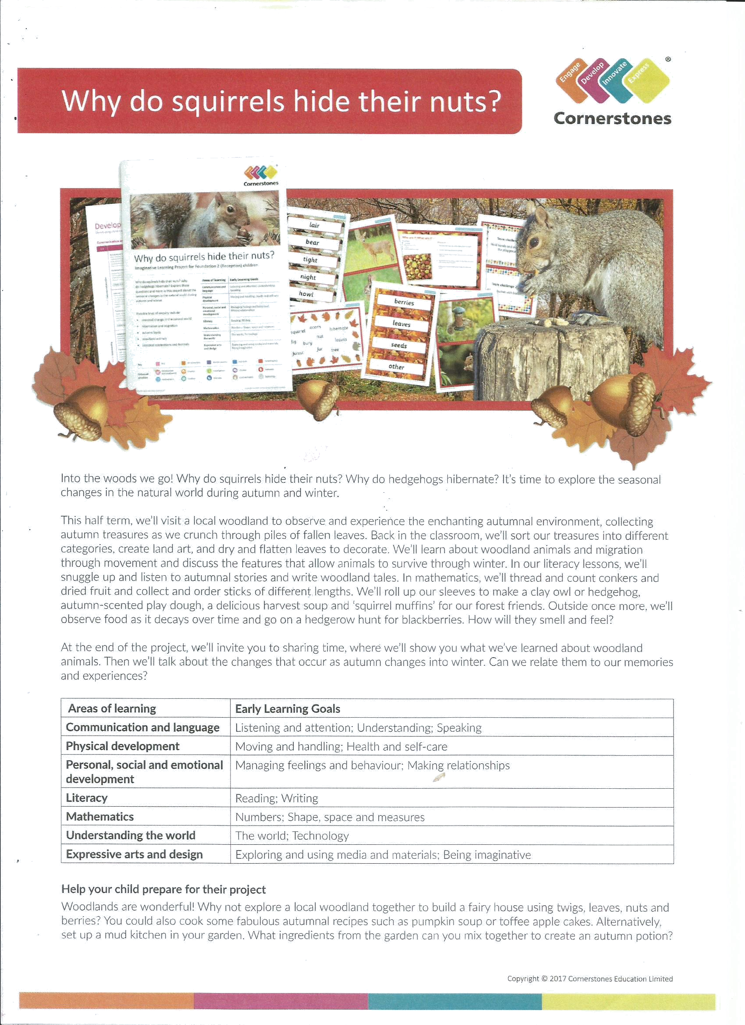

Into the woods we go! Why do squirrels hide their nuts? Why do hedgehogs hibernate? It’s time to explore the seasonal changes in the natural world during autumn and winter.

This half term, we’ll be introducing ‘Outdoor Classroom’ to the children and using the sessions to observe and experience the enchanting autumnal environment, collecting autumn treasures as we crunch through the piles of fallen leaves. We will be using our senses to notice changes in the environment and make observations. Back in the classroom we will sort our treasures into different categories, create art, and learn about woodland animals and hibernation. We will listen to woodland and autumnal stories, like Percy the Park Keeper and the Gruffalo and make homes for woodland creatures. Our literacy skills will continue to develop as we read and write labels for autumnal items as well as read and write simple words and sentences. We will develop our maths skills by counting, sorting, comparing and measuring natural resources.

Area of Learning covered in the topic
Communication and language | Listening and attention; Understanding; Speaking
Physical development | Moving and handling
Personal, social and emotional development | Managing feelings and behaviour; Making relationships
Literacy | Reading; Writing
Mathematics | Numbers; Shape, space and measures
Understanding the world | The world
Expressive arts and design | Exploring and using media and materials; Being imaginative

Important Dates
Our topic starts with a Pyjama day, listening to our favourite autumn stories around a (pretend) campfire, making biscuits and drinking hot chocolate. We will have a walk around our school to collect autumn items. The children will need to bring some pyjamas into school to change into on Wednesday 6th November.

At the end of our Topic we will host an Express Event – you are invited to join us for some of the children’s favourite Autumn activities. Please join us on Wednesday 27th November 9 - 9.30am. (We have these events at the end of each topic so if you cannot make this one don’t worry, there are more across the year).
Help your child prepare for their project
Woodlands are wonderful! Why not explore local woodland together to build a fairy house using twigs, leaves, nuts and berries. You could also cook some fabulous autumnal recipes such as pumpkin soup or toffee apple cakes. Alternatively set up a mud kitchen in your garden. What ingredients from the garden can you mix together to create an autumn potion.

If you are out and about and collect an abundance of conkers, acorns and pine cones we would love to use them in our classroom so please drop them in to any adult – we can never have too many conkers!

Thank you for your continued support.

The Reception Team

