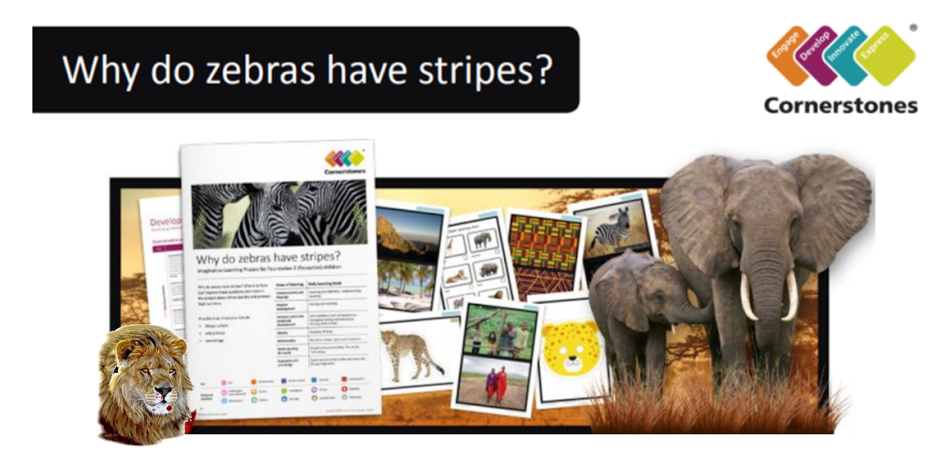

Why do zebras have stripes? Where do lions live? What is camouflage? It’s time to discover amazing wild animals from around the world. This half term, we will engage the children with virtual tours of wildlife parks and on-line lessons from Paignton Zoo where they will encounter all kinds of wild animals. In literacy, we will be naming animals and looking at their different features and habitats. We will be learning the features of non-fiction books and use books and the internet to find and write information about our favourite animals. We will be writing labels and captions to identify animal traits and then become authors to create our own class Dear Zoo book. We will be making maps with labels and instructions and posters for different wild animals. In mathematics, we’ll count and estimate animal numbers and solve simple addition and subtraction problems. We’ll get creative looking at animal patterns and how they use their features to camouflage themselves. We will use our imagination to create small world wildlife parks and create our own crazy animals using features from our favourite wild animal.
Help your child prepare for their project
Animals are awesome! Why not visit your local library together to find out more about different animals? You could also curl up on the sofa and watch The Lion King, Tarzan, Born Free or Madagascar. Alternatively, tear up coloured paper and work together to make a vibrant animal collage. Can you include a range of animal markings? If you would like to share stories at home we will be having a focus on Dear Zoo, Elmer stories and non-fiction text. Can you create a small world wildlife park using animals and bricks - maybe make labels for the enclosures and maps.

Areas of Learning covered in the topic
Communication and Language | Listening, Attention & Understanding. Speaking
Physical Development | Gross Motor Skills. Fine Motor Skills.
Personal, Social and Emotional Development | Building Relationships. Managing Self, Self-Regulation
Literacy | Comprehension. Word Reading. Writing.
Mathematics | Number. Numerical Patterns.
Understanding the World | The Natural World
Expressive Arts and Design | Creating with Material. Being Imaginative & Expressive

Thank you for your continued support.

The Reception Team

