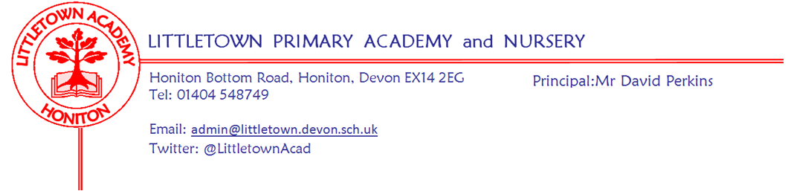
Friday 17th July 2020
Dear Parents and Carers,

It is hard to believe that we find ourselves today at the end of the last full week of the school year. I want to start by saying a huge thank you to all parents for being so patient and understanding whilst wading through all our various letters, emails and google forms. More to come, but hang in there - I promise it is nearly at an end..!

Thank you to everyone for returning forms for Breakfast and After School Club provision. I am very aware that we were asking for information that some parents simply don’t know yet and I apologise for this. We only did this because it was absolutely necessary in order to plan a provision which complies with the restrictions we have to follow. I very much hope we can return to usual booking arrangements after half term once the model is established. Many schools have decided not to offer wrap around care or have delayed it until half term, but we felt it essential to put provision in place as we know it makes such a big difference to so many families especially after an incredibly challenging period of time for all families. We will be writing to you on Monday explaining the details of the provision for September. My thanks to Miss Groves for working so hard this week to collate responses and assist us with planning.

You should also have this week received your child’s end of year report. As explained in last week’s newsletter and the covering letter, these have had to be different this year, but still contain the valuable facet of a school report - comments from the adults who work with your children. Mrs Hawkins and I always really enjoy reading them and writing our comments, but this has been especially the case this year. Reading them and reflecting on how brilliant the young people are in our care, reminds us why we do what we do and what is truly important when there is so much else going on. I would like to thank the teachers for writing these reports so well at a time when we are asking them to teach pods in school and support remote learning for those out of school simultaneously.

All Year 5 to Reception parents should have received today a letter from me explaining a new curriculum initiative, ‘Lexia’. This is a strategic approach to ensure your children begin making academic progress and fill gaps that have resulted from school closure. You should also have received or will receive an email from Mrs Binmore via our lexiasupport email address with your child’s individual login details and instructions for getting started on the programme. As the letter explains, this is by no means compulsory, but some engagement with the programme over the Summer will make a big difference to your child’s learning. We will be here to support you over the Summer via the lexiasupport@littletown.devon.sch.uk email address. My thanks to Mrs Binmore for all her hard work in setting the programme up for use in such a short period of time.

This quality literacy resource, alongside extra Maths support via our Power Maths programme, increased staffing provision and a sharp focus on Mental Wellbeing will form the basis of our ‘Recovery Curriculum’ from September. These strategies make use of the Government’s Covid Catch-up Funding (the amount of which we still do not know), but also the re-aligning of school priorities and budgets. We will share much more detail on our ‘Recovery Curriculum’ in the new academic year. We currently have two Teaching Assistant vacancies advertised on ‘Devon Jobs’ with a closing date of Monday.

To inform teachers of individual circumstances, how the children are feeling about school and in place of transition, we will be sending out a google form to parents of each year group at the end of the Summer Holidays. Teachers will look through these completed forms on Friday 5th September so they can make even more detailed plans for meeting the needs of the children returning the following Monday.

Practical arrangements for September, such as start and finish times, one way systems, visiting protocols etc as well as links to our Transition Padlets will be shared with you all via letter on Monday and a reminder will come out nearer the end of the holidays as it is possible that some circumstances could change between now and then. The full Risk Assessment for school reopening will be on our website by the end of next week.

Finally, it has been amazing to see children in school and at home this week taking part in our Virtual Sports day. This has been a brilliant way to bring the school community together, despite only some of us being here at school. I just know you are all sad we couldn’t manage to recreate my voice droning all day through a microphone and PA system! There are certificates for children at school and copies on padlets which can be printed for children at home. I would recommend these being put somewhere safe as it may well be a very unique event. A full review can be found below, but I would like to here thank the PE team for all their hard work in making this so successful.

Yours faithfully,
David Perkins
Principal

Thank you for virtual sports day!
We have had a fantastic week at school completing all the sports day challenges in our class pods. We hope you have enjoyed completing the challenges at home with your children as well! It has been great watching the children try their best with the challenges and really show support and encouragement to each other. The teachers have said how amazed they have been and it has certainly tested all of our fitness levels and skills this week! To celebrate the end of our virtual sports day week the children at school will come home with a certificate today celebrating their personal achievements. If you would like to print one for your child at home they will be available on class padlets or via the sports page on the website.
Well done everyone!
The PE Team

