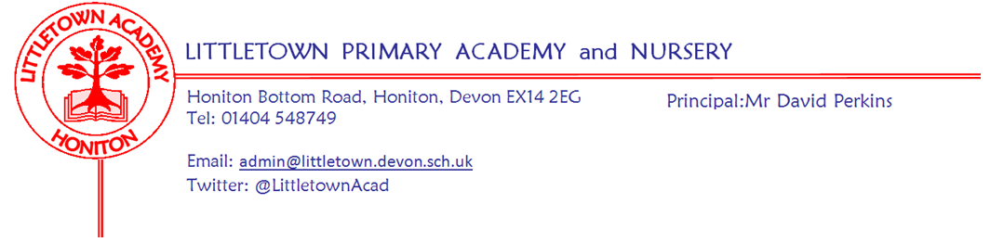
14th February 2020
Dear Parents and Carers,

I would like to start by saying how lovely I have found being around the school for Parent Consultations this week. I am always pleased that these are so well attended and it is great to have conversations with parents who are so pleased with how their children are learning and thriving at Littletown. I know that the teachers really value these discussions too. My thanks to the teachers for all their hard work during the evenings this week.

On Monday Year 3 enjoyed swimming and Year 4 had their outdoor classroom amongst storm Ciara! On Tuesday Year 1 had their outdoor classroom and some of our Year 5 and Year 6 children visited Honiton Community College for a Science workshop. It has been great to end the week and half term attending brilliant express events. Yesterday, we welcomed Year 2 parents to join their children to construct castles for ‘Towers, Tunnels and Turrets’ and this afternoon Year 5 parents joined us to experience an exhilarating journey through ‘Alchemy Island’ completing quests on their way!

On Tuesday, as a school, we undertook a range of age appropriate activities to mark Safer Internet Day. Details of which can be found reported via the children’s news reporters below. As mentioned in last week's newsletter, if you ever have any concerns about your child’s safe use of the internet please do let us know so we can support as necessary.
On Wednesday, children from across Key Stage 2 braved the mud to take part in the latest Stockland Cross Country running. Last week I referenced a TAG rugby report from children which wasn’t then inserted into the newsletter. Apologies for this. This can be found below along with a report from Wednesday’s Stockland Cross Country.
The week after half term begins with our ACE assemblies recognising children’s Attitude, Commitment and Effort. Year 6 will then have their second ‘Earth Heart’ workshop on Monday. On Wednesday Year 4 parents are invited to a meeting about the upcoming residential. On Thursday some of our Year 4 children will have a visit from Colyton Grammar school to begin a Literacy workshop project.
Thank you to parents who have been in touch regarding the attendance information sent out last week. Please see below in this newsletter information about school meals and World Book Day.

I hope all families have a wonderful half term break. Please see information below about the new ‘Reading Well’ books in Honiton library. Why not give it a visit over half term. I look forward to seeing everyone back at school on Monday 24th February.

Yours faithfully,
David Perkins
Principal

News from the children

Nursery
We have been reading a story about Buddy the Dog and how he keeps us safe on the internet.

Reception
We read about Smarty the Penguin who is always safe on the computers
We have learnt a song about learning how to be safe when using the internet

Year 1
We learnt that we need to ask an adult if we don’t know what to do on the internet
We learnt about not to go on apps we are scared of.

Year 2
We learnt that you never tell strangers your real name.
We are doing what is safe on the internet.

Year 3
We have been taking a quiz and looking at clues about internet safety.
We learnt that If you are talking to people on the internet, make sure you know them.

Year 4
We have been learning not to give out personal details on the internet for safety.
We have been learning not to accept lies even if you know who sent it for internet safety.

Year 5
We have been learning about internet safety and what age you need to actually be for some games and apps.
We have been learning that when you post something on the internet, it can’t be deleted and stays there forever

Year 6
We’ve been learning about being smart and being safe on the internet.
We looked at some scenarios and how to stay safe and the appropriateness of comments and usernames

Tag Rugby Tournament
Last week, Natalie, Miles, Kyle, Bryony, Harry, Ella, Jayden, Oliver, Imogen and Zac went to a tag rugby tournament from 3:30pm to 5:00pm at Honiton Primary School. They played 7 matches, winning 4, drawing 2 and losing 1. Even when they conceded a try they kept their heads up and persevered and didn’t give up at all.

Stockland Cross Country
On Wednesday, Fay (who came 19th), Finnan (who came 24th), Harry (who came 13th), Zac (who came 3rd), Natalie (who came 33rd), Logan (who came 19th), Imogen Cre (who came 20th) , Imogen W (who came 26th), Imogen C (who came 24th), Zoey D (who came 21st), Taylor A (who came 21st) and William W (who came 20th) went to Cross Country at Stockland (in the pouring rain and in what seemed like -1000 degrees celsius along with knee deep mud!) and did exceedingly well! With one of our representatives (Zac) even winning a medal with 3rd place.

Messages
School meals
We have unfortunately had lots of issues over this term with children ordering school meals and lining up with wrist bands etc. Whilst it is fantastic that school lunch numbers are so high and the food is so popular, we continue to have problems with children taking off their wrist bands and receiving food which they weren’t supposed to have. In some cases we are then running out of certain food for older children whose parents have paid and ordered. Obviously this is not fair. Despite speaking several times to the children about this, the problem persists. Referencing and ticking lists takes staff time, slows service and results in children losing essential time for outside play and exercise. Therefore after half term we will be issuing children with wristbands if they are ‘main meal’ and having the ‘main pudding’ option. This will mean no child will be able to access these options incorrectly. We will review the impact of this in the first week.
Breakfast club
Please could children attending breakfast club be dropped off by an adult no earlier than 7:50am as it has come to our attention that children are being left unsupervised in the entrance way to the school before there is any breakfast club staff on site. Thank you.
After school club request
We are looking for any U or PG films, complete board games or toys such as cars or duplo that parents don't mind donating to after school club
World book day
Early warning that one of the biggest dress up occasions of the school year is coming over the horizon! World Book Day is Thursday 5th March. Children will again be invited to dress in their own clothes as a favourite book character. We are registered to be part of the worldwide ‘Share a million stories’ campaign. More information to follow, but some information can be found here: https://www.worldbookday.com/share-a-million-stories/ We will also be issuing National Book Tokens as usual.

Week beginning 24th February 2020 :
Monday | Tuesday | Wednesday | Thursday | Friday
Earth Heart workshop Y6  Year 3 swimming  ACE award assemblies  KS2 9am  KS1 2:30pm | Nursery outdoor classroom | Year 4 Residential meeting for parents  3:30 - 4pm | Y4 Colyton literacy workshop

Community news
In assembly today I spoke to the children about a new set of books in the Honiton library under the category of ‘Reading Well’. These are a collection of books recommended by children and health professionals and are ‘books to make you feel better’. These are grouped under themes of ‘Healthy minds’, ‘Feelings’, ‘Worries’ and ‘The world around you’. We also have some flyers about this in Reception at school.

