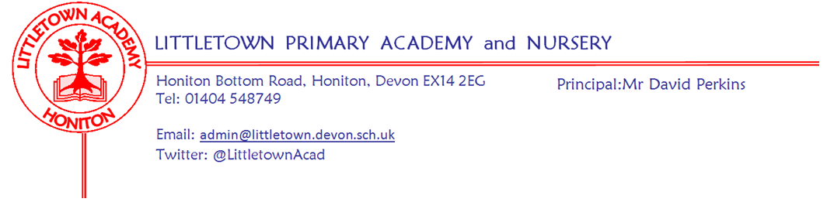
Friday 20th November 2020
Dear Parents and Carers,

This week we have been sharing resources and lessons with the children as part of anti bullying week. Staff have been really impressed with children’s maturity and attitude to this key issue. This included assemblies, videos and on Monday we also took part in ‘Odd socks’ day to celebrate the importance of diversity, difference and individuality. All classes from Reception to Year 6 also took part in the NSPCC ‘Speak Out to Stay Safe’ assembly. There is lots of excellent information for parents in this Anti Bullying Week toolkit for parents and carers: https://www.anti-bullyingalliance.org.uk/sites/default/files/field/attachment/Anti-Bullying%20Week%202020%20-%20pack%20for%20parents.pdf The most important thing you can do as a parent to support your child around bullying is to remind them of the ‘STOP’ acronym which stands for Start Telling Other People. Of course, bullying is not limited to children and to schools. This website is useful for if you feel there is ever any bullying of any kind happening to you or anybody you know. https://www.nationalbullyinghelpline.co.uk/ You can always get in touch with us as a school and we can support and signpost accordingly. At Littletown we are continually returning to and re-empathising these messages to children throughout the school year and will continue to always treat and deal with bullying very seriously in the school.

Thank you to everyone who attended the PTFA Annual General Meeting on Monday. There are some exciting things coming up from the PTFA despite restrictions we are all living under - please do support them if you can as they play such a key role in both fundraising for the school, but more importantly, bringing us together as a school community. Parents and Carers are also invited to the Annual General Meeting of the Governing Board on Tuesday 8th December. Please see all details below in this newsletter and get in touch if you have any questions.

Finally, a quick thank you from me to parents who have given verbal and written messages of support regarding the various challenges I continue to grapple with at the start and the end of the day. They are greatly appreciated. Please be aware of increased traffic on Honiton Bottom Road due to nearby road closures. The closure is due to a burst water main so hopefully the road will be reopened by Monday morning.

Yours faithfully,
David Perkins
Principal

Nursery and Reception 2021 Virtual Tour
If you or a friend has a child due to start Nursery or Reception in September 2021 please see and share the poster attached with details on our virtual tour and open day. Please encourage them to call us at school.

Christmas cards
From 1st December we welcome all children to write Christmas cards to their friends within their own class, these cards will be quarantined within the class and handed out the following week. Therefore all cards must be brought in by Friday 11th December in order to be given out before the end of Term.

Governors AGM
Honiton Littletown Primary Academy Trust
COMPANY NUMBER: 07851471
NOTICE OF ANNUAL GENERAL MEETING
Notice is hereby given that the Annual General Meeting (the “Meeting”) of Honiton Littletown Primary Trust will be held virtually on Tuesday 8 December 2020 at 5.30pm to transact the following business:
1. To receive the Chairman’s report;
2. To receive and adopt the company's annual accounts for the financial year ended 31 August 2020 together with the directors' report and auditor's report on those accounts;
3. To appoint the Company's auditors to hold office from the conclusion of the meeting to the end of the next period for appointing auditors under section 485(2) of the Companies Act 2006, at a remuneration to be determined by the directors;
4. To appoint new Members to the Board and accept any resignations from the Board by current Members.
By order of the Board
Tina Sillitoe
Chair
Honiton Littletown Academy Trust
If you would like to attend please contact Jenny Rawlins (littletownclerk@littletown.devon.sch.uk)

