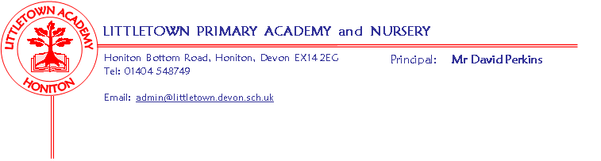
Nursery Autumn Term 2020 Information
Settling in:
We hope your child has enjoyed their first week at Nursery (or have enjoyed returning after their long gap since March!). They have all settled in well, but please come and speak to us if you have any concerns. Thank you so much for your help and cooperation using the new system of dropping off and collecting. We will continue to put the boxes and trays out for water bottles and lunch boxes to be put in. This hopefully means that your child should have much less to carry into Nursery! Please ensure that your child only has water in their water bottle, not squash.

Theme:
Just as the rest of the school do, we will follow a theme, following the children’s interests. Our first topic is called ‘You and me’ and will last until half-term. The children’s interests will help to lead where this topic takes us. We will decide on which topic to choose next, based on what we learn about the children’s interests over the coming weeks. Please see some additional information below about our topic, what we will be covering and how you can support your child’s learning at home. Please upload anything special you do with your child to Tapestry so that we can celebrate this with them at Nursery.

Literacy:
This half term we will be assessing what your child can do already to enable us to plan their next steps. We will have daily phonic inputs where we will developing the children’s listening skills and distinguishing different sounds. There will be lots of opportunities daily to work on the children’s fine motor control including; cutting with scissors, pencil grip and control and strengthening the muscles in our hands and fingers using playdough etc... We will also be providing lots of opportunities for the children to mark make in their child-initiated learning. We will spend lots of time this term developing the children’s listening skills and language through story-telling and role play.
Maths:
In maths we will be assessing your child’s confidence and knowledge of numbers and shape in order to plan and teach their next steps. We will be learning to recite number names in order to 10, matching numerals to quantities and looking for numerals in the environment. We will also be naming and describing simple patterns and 2D shapes.
Key reminders:
Collecting at the end of the day: Please ensure that if someone on your named list is collecting your child after Nursery, that they know your chosen password. Your child’s safety is of the upmost importance to us so they will be asked for this. Please remember that we will open the doors to start sending children home from 2.50pm if you wish to avoid the crowds at 3pm.
Clothing: Please ensure all items are named including shoes and wellies. We already have some lost property!

Footwear: Please ensure that your child wears suitable footwear to Nursery every day, to enable them to access the equipment safely. Children should not be wearing open-toed sandals, ‘croc-like’ shoes or wellington boots to Nursery as they cannot run or climb safely in these. When the children use the climbing tower, they will only be able to use if they are wearing suitable footwear. Using the tower supports the children in developing their upper body strength, vital for learning to write and control small tools. Once we start our outdoor classroom sessions, your child will need wellies, but these should be brought to Nursery in a named bag and left on their peg to prevent mud being walked into the carpets.

Water Bottles: Please ensure your child has a bottle of water (not juice) in the Nursery for drinking throughout the day. They may have juice in their lunchbox but no fizzy drinks.

Packed Lunches: We have peanut allergies in Nursery so we ask that no children have nuts or nut based snacks/spreads in their lunchboxes. We are a healthy school and ask that children do not bring in chocolates or sweets for lunch.
Birthdays: We are always excited to celebrate the children’s birthdays with them, but please do not bring in sweets or cakes to share.

Toys: We ask that toys/valuables are not brought in to Nursery.

Health: Please remember that if your child has either a persistent cough or a high temperature, they must not attend Nursery. Please also be aware that if a child has been given Calpol for any reason before Nursery, they also may not attend as the Calpol could mask any symptoms of Covid-19.

Key dates for the autumn term:
- Friday 16th October – Break up for 2 week half term holiday
- Monday 2nd November - Start of term

- Friday 18th December – End of term

Nursery Topic Information
You and Me
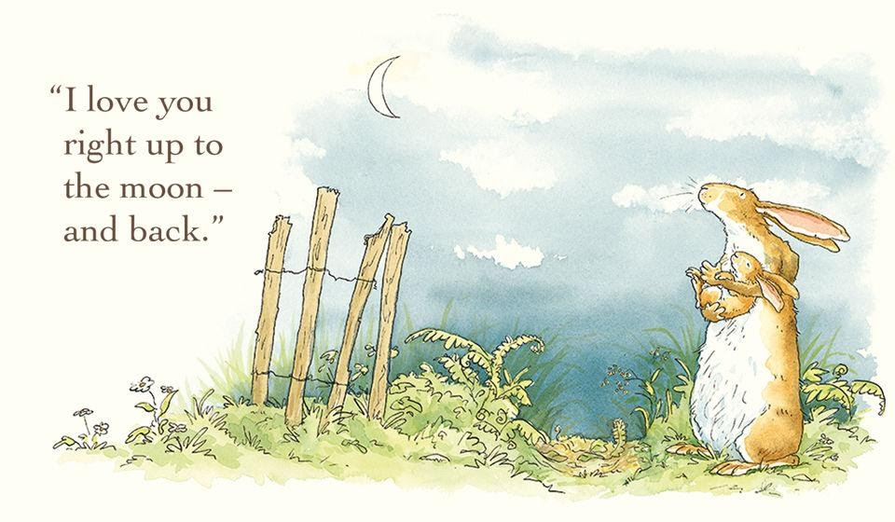

Guess how much I love you… What is special about me? How do we show that we care?

This term, we’ll learn about ourselves, families and how people are the same and different. We’ll talk about babies and ask lots of questions about how to look after babies. We’ll pose for photographs and recognise ourselves, our names and our friends from a photograph display. Mirror, mirror on the wall… We’ll look at our reflections and talk about what we can see. In our cosy home corner, we’ll care for dolls and teddies. We’ll enjoy sharing books about love, feelings and families. Outside, we’ll practise following instructions and think about how our brilliant bodies move. Using our mathematical skills, we’ll measure and compare our hands, feet and heights. We’ll count candles and think about why we celebrate birthdays. Getting creative, we’ll make amazing artwork of people we love. We will also be thinking about Autumn and all the changes we find as the weather starts to get cooler.

How you can help your child prepare for their project:
We’re all special! Why not help your child to take photographs of family members and friends, to create a fantastic photo album? You could also visit the local library to share picture books about families and feelings. Alternatively, make a family collage with images of all of your family members’ favourite things.

