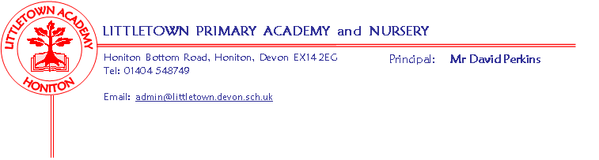
Year 4 Summer Term 2019 Information
Literacy
Our book in Literacy this first half term is ‘Moon Man’, written by Tomi Ungerer. Described as a ‘quirky fable’, ‘Moon Man’ will enable the children to explore and write a variety of text types, including poetry, diary entries, information texts and creative fiction writing. We will also continue to focus on SPAG, Reading Comprehension, including Accelerated Reading.
Maths
The focus in Power Maths for the first half of the term is fractions followed by decimals, time, angles and shape.
Cornerstones
This term, our projects are Potions (Summer 1) and Road Trip USA! (Summer 2). We will be visiting HCC on Tuesday 7th May to observe some exciting experiments!
Key reminders
Please ensure that your child has their P.E kit in school every day, especially as we will be out practising for Sports Day more often! Please can your child also bring a named hat into school, for when we get some warmer weather!
Key dates for the summer term
Swimming: Monday 29th April, Monday 13th May
Bank holiday: Monday 6th May
HCC visit: Tuesday 7th May
Outdoor classroom: Tuesday 14th May, Tuesday 9th July (both Y4 classes)

