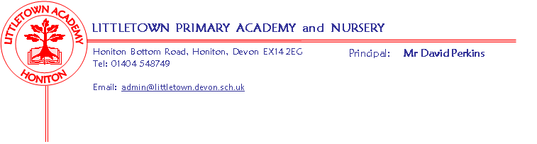
Reception Spring Term 2020 Information

Literacy
In literacy we will be continuing with our daily phonic sessions to support the children’s reading and writing as well as our daily Funky Fingers to support and teach pencil grip, control and handwriting. The children’s writing will be focused around our topic, writing words and beginning to write simple sentences. They will continue to have access to a range of writing materials for free writing including books, cards, lists, invitations and letters. If you are writing with your child at home please ensure they are holding their pencil correctly and firmly. Please also encourage writing in lower case letters apart from at the start of their name.
Tricky words and sounds will continue to be checked fortnightly; we check your child knows their words and sounds independently in their reading and phonic games. Please continue to change your child’s book with them daily (or as needed). If your child is at breakfast club we will encourage them to change their book when they come into class. Please record any book reading and reading activities, including learning sounds and tricky words, in your child’s Reading Record. The expectation is for parents to record in the book at least 4 times a week and staff will now check the Reading Record every Monday to give you an opportunity to record any reading activities you have done the week before.
Maths
In maths we will be continuing recognising and ordering numerals 1-20 and beyond and working on knowing 1 more and 1 less of any number. We will be learning to add and subtract to 10 then 20, using objects and number lines for support to solve simple maths problems. We will be looking at weight, length and height and comparing sizes.

Cornerstones
Our topic for the first half of Spring term is ‘Will You Read Me a Story’. We will be sending a letter home with more information including ways to support your child at home with this theme.

Key reminders
Outdoor Classroom: Outdoor Classroom will continue every week on Fridays. If we ever need to change our plans for outdoor classroom because of special events, children should continue to come in non-uniform on Fridays. As we are in Winter please ensure your child has appropriate warm & waterproof clothing to wear outside including wellies (all labelled!).
Book Bags: Please bring book bags in to school every day (with your child’s Reading Record) and place them in their tray.
Tapestry Learning Journey: As you are aware Tapestry Learning Journeys are updated at the beginning of each term. Thank you to parents who have added photos, videos, and comments about their child’s learning. We have seen children reading, writing, dancing, singing, counting, growing and lots of holiday fun. If you are having trouble accessing Tapestry to view your child’s learning please see Miss Croft.
Junk Materials: We are desperate for yogurt pots, cardboard tubes (not toilet rolls) and small sized boxes. Please ensure they are clean because the children use these to build models with. We would love the inserts from till rolls to use for puppet making this term.
Clothing: We had a lot of unclaimed jumpers and cardigans last term and have noticed names are fading or have fallen off clothing. Please check your child’s clothing and ensure all items are named including PE kit and shoes.
Key dates for the spring term
Stay and Play: Stay & Play sessions will continue this term. You are welcome to stay from 8.50am to 9.15am to join your child on a focused activity that help raise your awareness of how we are teaching in the Early Years, how your child is learning across the curriculum and how you can promote learning through play at home. This term will be on a Wednesday morning:
29th January 12th February 4th March
Friday 17th January - PTFA School Disco
Monday 17 - Friday 21 February - Half Term – 1 week
Wednesday 18th March (9 - 9.30) - Express Event ‘Fairy Tale Day’
Friday 27th March - End of Term - 2 week holiday - Return to school Tuesday 14th April

Thank you for your support,
Miss Croft, Mrs Katene & Mrs Hawkins

