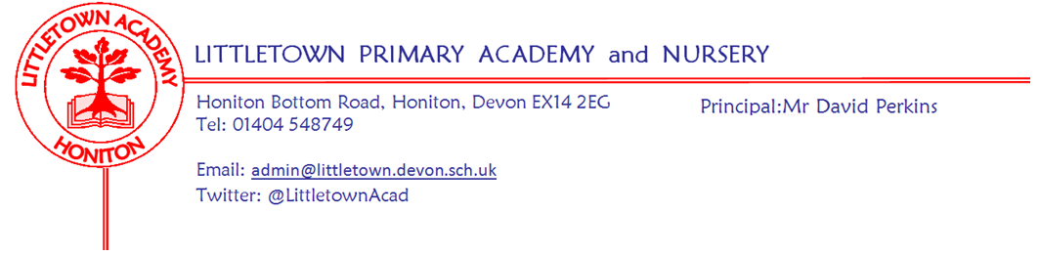

Friday 14th January 2022

Dear Parents and Carers,

It has been a busy first full week of the Spring Term. On Monday Year 3 visited Honiton Community College for a gymnastic festival with children from other Primary schools. My thanks to the Honiton Community College sports leaders for facilitating this event for the children. On Tuesday some year 6 pupils represented the school in the Honiton Learning Community Netball festival where they had great success. A full report from sports leaders can be found below.

On Monday, we had our attendance review from the Autumn Term. Littletown attendance was 95.6% for the term which, although above the national average, is below our school target of 97% minimum. Over the next few weeks we will be reaching out to engage parents where attendance for children has fallen below 95% since September. We know that Covid-19 cases and related absences do have an impact on school attendance whilst we are in the pandemic. If your child is not going to be attending school it is crucial that you call us to inform us of the reasons so that absence doesn’t get recorded as ‘unauthorised’. If you have any questions about attendance and absence please don’t hesitate to get in touch.

I do have to tell you that currently we do have several Covid-19 cases within the school community in multiple year groups. To help limit transmission and inline with current guidance, we have taken measures to reduce the amount of mixing in school. We won’t be holding assemblies in the hall until case numbers recede. Where specific measures are required for certain year groups and classes parents will be emailed separately. If you have any questions about Covid-19 in school and/or the protective measures in our evolving risk assessment please don’t hesitate to get in touch. We also continue to have staff away with Covid related absence. Thank you for your ongoing understanding of this challenging situation.

Please find in this newsletter lots of updates including information about safeguarding from Mrs Hawkins and some information from our catering partners, Fresha. Next Thursday is ‘census day’. Elements of school funding are calculated based on the number of children who have school dinners on this day so if you are usually packed lunch, but might be interested in trying a hot meal, next Thursday would be a great place to start! Attached to this newsletter is the menu for census day next Thursday.

Next week Nursery have outdoor classroom on Wednesday and Reception have outdoor classroom on Friday.

Yours faithfully,
David Perkins
Principal

News from pupil reporters

Nursery
We have been exploring icy weather.

Reception
We have been building little pig’s houses and learning about more and fewer numbers.

Year 1
We have been learning about 3D shapes and have been reading the book The Lion Inside.

Year 2
We have been learning about climate change in science and using describing words to describe different types of textures.

Year 3
We have been learning about colour in art, read another page of our class book, went to our gym workshop and started learning about the colour theory.

Year 4
We have been learning how muslims pray, about the Roman timeline and we have started a new book called Escape from Pompeii.

Year 5
We have started a new book in literacy and are dividing in maths using short division. We are learning how to play tongue drums in music.

Year 6
We have been learning about perspective drawing, sketching a train track and platform and importing a photograph of ourselves dressed as evacuees. We have been converting decimals into fractions in maths and learning about rhinos in literacy.

Year 6 Netball Competition
The year 6 netball team competed against other local schools at Honiton Primary School winning all except for one of their matches. The scores on their biggest wins were 5-0, 4-0 and many 3-0.
The people that played exceptionally well were: Imogen W, Chloe P and William F. In brief, the team played exceptionally well.

SMART watches
Lots of children were lucky enough to get SMART watches for Christmas which is great. However, some of these have a camera. Therefore these are not able to be worn at school for safeguarding reasons. If your child has a SMART watch please can you check whether it has a camera function and prevent them from wearing it to school if it does. Thank you for your cooperation.

Dreams and Goals
Don’t forget to get in touch with us if you think you or someone you know could be VIP in our assemblies! If you, or anybody you know would be happy to pop into school as a VIP assembly guest to share information about your job/hobby please contact Mrs Hawkins or Mrs Lambert for further information. admin@littletown.devon.sch.uk
As mentioned last week, the children are keen to hear about: Marine biologists, paramedics, doctors, military, footballers, authors, vets, ballerinas and astronauts!

Safeguarding update
As a school we continue to be committed to the safeguarding of all of your children in our care. As part of our safeguarding policy we are dedicated to providing age appropriate education, teaching the children how to keep physically and mentally safe in today's world. We do the majority of this through our Personal, Social and Health Education curriculum (PSHE). You will read more detailed information about the content in your termly year group newsletters.
We also cover additional content throughout the year which will be shared with you in newsletters, with the intention to further improve the shared responsibility of keeping your children safe at school and at home. (You may recall the link to keeping your child safe online sent out before xmas).

Next week we will be talking to your children about keeping their bodies safe, discussing which body parts are private, what kind of behaviours are acceptable or unacceptable behaviours and what to do if they feel unsafe. Please find below links to resources we will be sharing with your children in our class assemblies on Monday.

Nursery to Year 2 children will be shown the Pantosaurus animation

https://learning.nspcc.org.uk/research-resources/schools/pants-teaching

Years 3-6 will be shown the consent animation

https://www.youtube.com/watch?v=h3nhM9UlJjc

The link below is a parents guide to discussing private parts of the body with your child.

https://www.nspcc.org.uk/globalassets/documents/advice-and-info/pants/pants-2018/pants-parents-guide-online.pdf

Mental Wellbeing
If you have any used, clean small yogurt pots (not the large family size pots) which you were going to put in the recycling bin please could you bag them up and bring them into school by Friday 4th February. I need enough for every child in the school!

Week Beginning 7th January 2022 events
Monday 17th January | Tuesday 18th January | Wednesday 19th January | Thursday 20th January | Friday 21st January
 |  | Nursery outdoor classroom |  | Reception outdoor classroom

Spring newsletter from Fresha
The View from Fresha, your school caterer;
Have you ever wondered : ‘What are the actual benefits of eating a hot meal?’
We have explored the research and summarised it for you in our article
School Lunches: It's about more than food!

If you have never tried a school lunch why don’t you give it a go on Census Day, Thursday 20th January

Fresha: Improving the lives of children through food.

