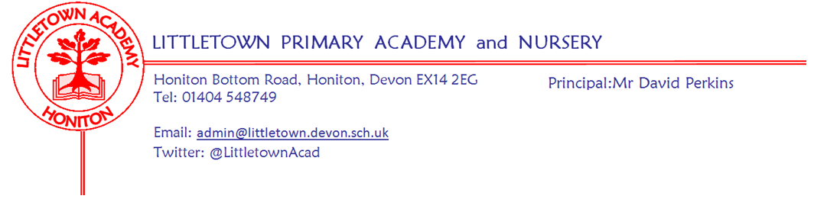
Year 1 Autumn Term 2020 Information
Literacy
In literacy we will be assessing your child’s reading and writing ability and then planning and teaching their next steps. We will have daily phonic lessons to learn letter sounds and how to blend them together to read words. Children also have Funky Finger sessions which provide opportunities to work on the children’s fine motor control including; cutting with scissors, pencil grip and control and letter formation. This half term, we will send home a set of tricky words and all the phonic sounds that your child will need to be able to read by the end of the year. Your child will need support to practise reading their tricky words and they will be regularly assessed at school. We will be focusing on children using their phonics to write short sentences and teaching children the importance of finger spaces, capital letters and full stops. Throughout the year we will teach children through lots of different genres including fiction, non-fiction and poetry. Our literacy lessons will be based around a class book and our cornerstones topics.
Levelled reading books have been sent out to all children. We are issuing all children with new reading records. We ask all parents to read with their child each night and record what they have read. There is a space for you to comment on how they have read. These reading records are to be handed in on a Monday so that the teachers can check on how your child is progressing with their reading. Due to having to quarantine books, children will only be able to change their books once a week. Miss Meecham/Mrs Lambert's class will change books every Tuesday and Mrs Veevers class will change books every Thursday. All children are able to access both oxford owl and Lexia at home as well as learning tricky words and phonic sounds.
Oxford Reading Owl (https://home.oxfordowl.co.uk/reading/free-ebooks/) and Big Cat Books (https://collins.co.uk/pages/big-cat-ebooks ) both have access to lots of books and sign up is free. Children can also access their Lexia accounts using a tablet, computer or smartphone. https://www.lexiacore5.com/register
If your child’s reading record is lost, a new book can be purchased from the office. Your child’s class teacher will not always record when they have read with your child in these books as they have their own records. Your child will be assessed at least once each half term and then this will be recorded in the reading record book.
Maths
In maths we follow the Power Maths programme that follows the children throughout the school. This is a progressive scheme from reception to year 6. The scheme focuses on all the different aspects of maths including number, measures, money and shape. Throughout the first half term we will be focusing on number. We will be counting, ordering and comparing numbers to 20, finding one more and one less and looking at part whole models and how they can help us with our number bonds. We will also be looking at addition and subtraction within 10.
Cornerstones
We follow a topic led curriculum that is broad and balanced and aims to develop the children’s skills, knowledge and creativity. At the start of each topic there will be an exciting ‘engage’ event to hook the children. At the end of each topic we would usually have an express event where we would share children’s learning with you, however, due to Covid restrictions these may be unable to go ahead.
Autumn 1 : Superheroes
Autumn 2: Bright Lights Big City
Spring 1/2: Moon Zoom
Summer 1: Dinosaur Planet
Summer 2: Enchanted Woodland
This half term our topic is Superheroes. Please find more information about our topic and opportunities for home learning in a separate attachment.

PE
Children will receive 2 hours of outdoor PE each week during the Autumn Term (weather permitting). We will not be changing the children into full PE kits during the first half of term to make the most of being outside, however some activities will require the children to wear trainers. Our first 2 PE units are, Monday Mornings: Fundamental skills
Thursday Afternoons: Ball skills.

Outdoor Classroom
Children will have outdoor classroom days throughout the year. An email will be sent once these term dates are decided. Please ensure children are dressed appropriately in old, warm clothes and have a waterproof coat. Hats and gloves will also be needed in winter as we aim to be outside in all but the most extreme weathers. Welly boots should be brought to school in a carrier bag that they can be returned to when they are muddy.
Key reminders
Backpacks: We are trying to limit the time children spend in the cloakroom and it would make the beginning and end of the day much simpler for them if they don't have backpacks to bring into school each day. All they need is a water bottle and book pack which are kept in the classroom and if they have a lunchbox these can be carried without the need to be put inside another bag. Of course, if you feel your child needs a change of clothes at school these could be in a bag inside their PE bag and left on their peg - although most children won't be needing this because we do have lots of spare clothes for an emergency
Collecting at the end of the day: At the end of the day, children will be accompanied out to the front playground where we will send them off once a parent/guardian can be seen (1CV-3.05pm and 1CL/LM- 3.15pm). We will not let children go until we can see whoever is picking them up, so please come forwards to collect your child.
Clothing: Please ensure all items are named including PE kit and shoes.
Packed Lunches: We have peanut allergies in school so we ask that no children have nuts or nut based snacks/spreads in their lunchboxes. We are a healthy school and ask that children do not bring in chocolates or sweets for lunch.
School Dinners: Please ensure you book your child’s school dinner by Friday midnight for the following week. If your child does not eat enough school lunch we will send a note home to inform you.
Mid-morning Fruit & Milk/Snack: Fruit is provided at break time. Named water bottles must be brought in from home and children are encouraged to drink regularly (these are kept in the classroom). In line with our school policy, only plain water is allowed in the water bottles which are bought into the classroom. If you would like your child to have milk each day you can register online at www.coolmilk.com or print the form put and post for free.
Medication: Please let us know if your child has to take any prescribed medication at school. There is a green form for you to fill in so that we can administer it. We can only give prescribed medication, and the medication must have the prescription label on. Please phone the school if your child is off sick. If you have a medical appointment please let the office know.
Birthdays: If it is your child’s birthday they can come to school in their home clothes. Please do not bring cake/sweets in for other children.
Toys: We ask that toys/valuables are not brought into school due to Covid guidelines and cross contamination.
Parent helpers: We would normally love Parent Helpers but unfortunately, we cannot have parents into school at the moment.
Junk Materials: We are desperate for yogurt pots, small boxes (not cereal size boxes) and cardboard tubes (not toilet rolls). Please ensure they are clean because the children use these to build models with. If you have any please bring them in a bag on a Friday so we can leave them over the weekend in ‘quarantine’ for building fantastic models the following week.
Certificates: We have a celebration assembly every Friday in our own classes where we share news and give any certificates out from the week such as golden point certificates or Lexia certificates.

SCITT Student: We would like to warmly welcome Miss Wells who is a trainee teacher working alongside Mrs Veevers this year.
Key dates for the Autumn term
Friday 16th October Break up for 2 week half term holiday
Monday 2nd November Return to school
Friday 18th December End of term
Thank you for your support
Class email addresses:
Mrs Veevers: class1cv@littletown.devon.sch.uk
Mrs Lambert & Miss Meecham: class1cllm@littletown.devon.sch.uk

Mrs Veevers’ Class Timetable
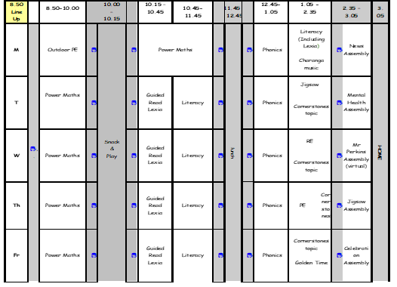

Mrs Lambert & Miss Meecham’s Class Timetable
