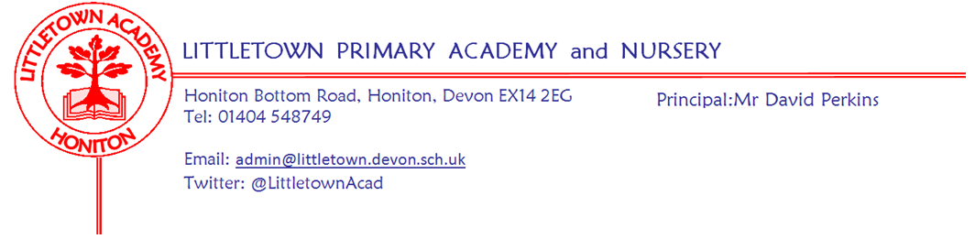
Friday 23rd April 2021
Dear Parents and Carers,

It has been great to start the Summer Term this week with the sun shining and lots of smiles at the school gates. Teachers have been pleased with how the children have settled back into school, they are also looking forward to speaking with all of you next week in Parent Consultation phone calls. There are still parents in each class that haven’t filled in the google form giving us the phone number to call. If you haven’t done this yet, please remember to do so over the weekend. The table of information and form links can be found again below.

Please also see below some information on a competition that Honiton Library is running. You may also be aware that the library is now open and the children’s section has had a refurbishment. It would be great to have lots of Littletown pupils visiting it and using it over the next few weeks.

Over the last couple of days, you should have received a Curriculum Newsletter for your children’s year group. Without being able to welcome you into school, this is one of the most valuable ways to ensure you know what types of things your children are learning at school that you can discuss with them and ask them about over the course of the term.

You may also want to take a moment to ask your child about filling up buckets this week, following an assembly in which I shared a book about filling up imaginary buckets with kindness. Hopefully the children will be filling your buckets this weekend! If you’re interested in owning or finding the book, it is called ‘Have you filled a bucket today?’ by Carol McCloud.

Finally, as we return back to school, thank you for slotting seamlessly back into the rhythm of the protocols and arrangements at the start and the end of the day that we have come to know so well. A couple of specific reminder requests from me as follows: Please try to exit the ‘bubble zones’ on the front playground and exit via the one way system to the exit gate rather than walking across ‘bubble zones’ in the playground where other children and adults are mixing possibly in other directions. Please also make sure that children walk calmly to their lines in the morning and don’t run around the playground after school, as we have had a couple of accidents this week. Thank you for your ongoing cooperation and support.

Yours faithfully,
David Perkins
Principal

Mental wellbeing
This week, we welcomed back the school guinea pigs, Toby and Carrot, who have been enjoying lockdown with Mrs Childs and her family. The Mental Wellbeing Ambassadors and Year 3 children will be looking after them for the Summer Term.
This week’s 10 a day focus is to; ‘Keep hydrated’. If you would like more information about the 10 a day and Normal Magic then please visit normalmagic.co.uk
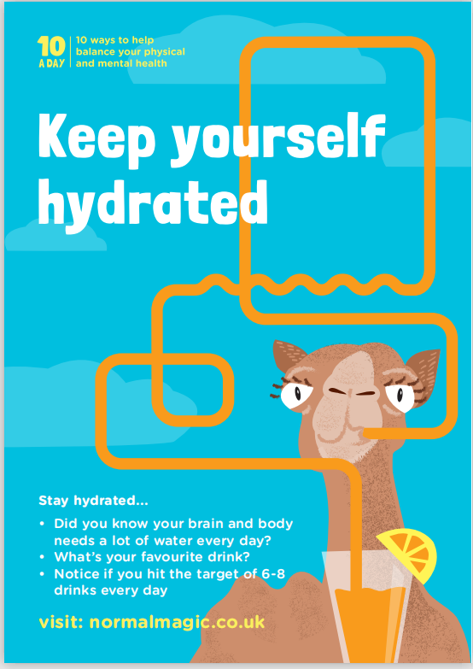

Relationships, Sex and Health Education Consultation
Many thanks for all of your responses to the recent Relationship, Sex and Health Education consultation. It was extremely pleasing to hear from parents/carers fully supporting both the principles and the educational content we value for the children of Littletown. The importance of families and schools working together to teach the children life skills is paramount to keeping them safe now and in their future.

All of the information sent out in the consultation is available on the school website and further details on the Sex Education content coverage will be emailed out before the second half of the summer term, as stated in the policy.

Honiton Library
Here are the details of our growing challenge.
This summer Honiton Library invites you to take part in their 2nd gardening challenge The Longest Runner Bean competition. From Monday 19th April, to enter, all you need to do is to let Honiton Library know you would like to join. They just need the name of the family taking part.
You can do this via the Facebook page, email, telephone or even in person now they have re-opened. (Temporary opening times still, so do check!) They will send or give you 5 runner beans plus the growing instructions and the rest is up to you!
In order to enter your longest bean in the competition, you will need to send them a picture by 1st September 2021 of your longest bean placed alongside a tape measure. You can enter as many times as you like before the closing date. The longest bean wins and a prize awaits the winner. So do not delay and get in touch today!
We have bean lucky enough. (pun intended) to receive two prizes from the lovely people at Combe Garden Centre so one lucky family will win a £30 voucher and another a £20 voucher.
We’ll be giving some tips and sharing staff photos throughout, on Facebook and Twitter.
Good Luck!!

Parent consultation phone call google forms
Please click on the link in the table below to complete the google form for your child’s class.

 | Tuesday 27th April  3.30-6.30pm  By Child’s surname | Wednesday 28th April  1.00-6.30pm  By Child’s surname | Google form link for parents to complete
Nursery | A-L | M-Z | https://forms.gle/Qiopt9qWVTaCdvov9

 | Tuesday 27th April  3.30-6.30pm  By Child’s surname | Wednesday 28th April  3.30-6.30pm  By Child’s surname | Thursday 29th April  3.30-6.30pm  By Child’s surname | Google form link for parents to complete
Rec NC | A-L | M-Z |  | https://forms.gle/qw9EGmZsq6jMLbWU6
Rec NK/MH | A-L | M-Z |  | https://forms.gle/pPtwkSb7XedbHTjTA
Year 1 CV | A-L | M-Z |  | https://forms.gle/Dr5TCzpCAVfrdFtq5
Year 1 CL/LM | A-L | M-Z |  | https://forms.gle/6FZTASTM67aG3syv7
Year 2 AL | A-M | N-Z |  | https://forms.gle/JrsNDx6upYULc7JD8
Year 2 DB/VR |  | A-L | M-Z | https://forms.gle/D91XMawws7v6M9Wj6
Year 3 SD/JS | A-L Mrs Davis  M-Z Mrs Searle |  |  | https://forms.gle/twxd5ybVFXnzf4teA
Year 3 RB/GH | A-L-Miss Bodgin  M-Z- Mrs Huguerre |  |  | https://forms.gle/tFwHkXPDgrPQAscX9
Year 4 SD | A-L |  | M-Z | https://forms.gle/Q3N2Hac9D7279tS99
Year 4 GW/GA | A-L |  | M-Z | https://forms.gle/X3pnnyNcp9pQZen9A
Year 5 ZU | A-H | I-Z |  | https://forms.gle/GNhS2joNJD5PXt7N7
Year 5 CB | A-L | M-Z |  | https://forms.gle/hZdq93CMJhz16DYW6
Year 6 JF | A-L | M-Z |  | https://forms.gle/cWyxxtWrhKka2K1X9
Year 6 CP | A-L |  | M-Z | https://forms.gle/qjDGCTZgX3RyrA8v5

