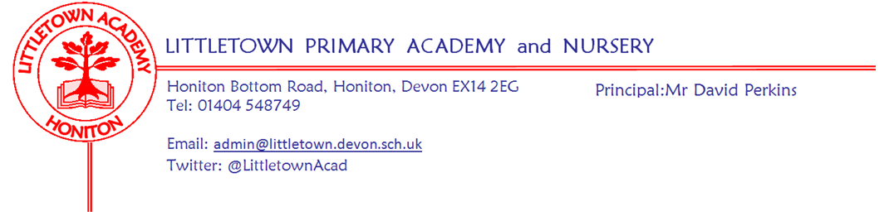
Friday 1st April 2022
Dear Parents and Carers,

As I mentioned last week, we have been trialling a new timetable this week for the structure of the school day. I have been really pleased with the effort of the children in giving the trial a good go. Teachers will ask children how they have found the week and we will carry out a full review next week. What was clear, was that children who arrived late were missing the beginning of core subject teaching. We will continue to start teaching promptly at the start of the day, so please do ensure children are in school on time. Please see below in this newsletter some important information about changes to our late sign in procedure.

I want to say a massive well done to all our Year 6 pupils. Over the last two weeks they have been taking part in the global ‘Word Mania’ competition via Literacy Planet. Littletown finished as the top school in the UK in the national round and are currently representing the UK in the world final. Quite an achievement - well done Year 6!

Yet more sporting success this week as our Year 5/6 TAG rugby team won 5 and drew 1 of their 6 games in the first of three Honiton school competition rounds on Tuesday at Honiton Primary School. Also on Tuesday, I was pleased to host interviews for the Senior Tutor role at Devon Primary School Centred Initial Teacher Training (DPSCITT). This involved lots of visitors entering classrooms and observing lessons. I received lots of great feedback about the learning and the attitude of the children.

On Wednesday Year 5 had an outdoor classroom with a difference when they all designed, prepared and cooked stone baked pizza in a horse box provided by Mr Hibberd as part of their integrated learning project. 2CL/DB experienced life during WW2 as part of an integrated learning project with Miss Synek Herd. This week we say farewell and good luck to Mr Hibberd and Miss Synek Herd as they return to their host schools to continue their teacher training.

Next week, on Thursday, we are very excited to welcome the ‘Space Dome’ to Littletown which will be used by Year 1 and Year 6 children as part of their curriculum topics. Also next week, Year 4 have outdoor classroom with 4SD on Monday and 4GW/GA on Thursday. Year 2 have outdoor classroom on Friday.

Next Friday, parents in Year 1 to Year 6 will receive end of term reports on children’s attainment and progress. Tapestry will ‘go live’ for parents of Nursery and Reception children over Easter.

Finally, although you will definitely be aware due to continued staff absence that Covid-19 is most definitely still with us, today the rules around testing and isolation change in England. This includes the removal of the duty for schools to provide remote learning. I would like to thank the teachers for the many months of workload in preparing high quality remote learning for isolating pupils. Please see all the key information on these changes below and don’t hesitate to get in touch if you have any questions.

Yours faithfully,
David Perkins
Principal

News from the children

Nursery
In nursery, this week, we have been making dinosaur skeletons and salting down fossils

Reception
Over the past few days, Reception have been making information books on animals

Year 1
This week, in Year 1 we have been making chocolate Easter nests and looking at the solar system

Year 2
Over the past few days, in Year 2, we have been learning about the Blitz and painting St Paul’s cathedral

Year 3
This week, in Year 3, we have been starting our art, finishing our topic and we have learnt how to send an email.

Year 4
This week, in Year 4, we have been learning about the Egyptians. We have also made ‘high fives’ by carrying out fun experiments using vinegar, soda and a bottle.

Year 5
This week, in Year 5 we have completed a collage flower and allotment. We have also made our own pizzas in outdoor classroom.

Year 6
We made a model of the DNA double helix using sweets. We also extracted the DNA from a strawberry using buffer extract and rubbing alcohol.

Mental wellbeing
In assembly today I was pleased to share my Mindapples with the children. These are the five things I try to do every day in some way that is good for my mind. Children, staff and Governors will all be making their mind apples over the next few weeks to help us all focus on valuing our mental health as part of ‘loving ourselves’ from our new school values. You’ll have to ask your children to find out what my five things are!

Student and Family Support Team
Each week the Student and Family Support Team (SAFS) will be sharing useful websites, support materials or free courses for parents and carers. We will also be updating you with any up and coming events that are running in school. This week the focus is on Mental Health:
Happy Maps: https://happymaps.co.uk/age-group/primaryschool/
Happy Maps was founded by Dr Jasmin Krischer, a GP with 25 years of Paediatric experience. She developed this Charity alongside other GP’s and CAMHS (Children, Adolescents Mental Health Service). Together, they have pooled what they think are some of the best mental health resources for parents and for young people and children, in one place.

Covid-19 rules in place from today
On Tuesday 29 March, the Secretary of State for Health and Social Care, Sajid Javid, set out the next steps for living with COVID-19 in England from Friday 1 April.
Free COVID-19 tests will continue to be available for specific groups, including eligible patients and NHS staff, once the universal testing offer ends on Friday 1 April. Changes to absence and isolation periods as follows:
- adults with the symptoms of a respiratory infection, and who have a high temperature or feel unwell, should try to stay at home and avoid contact with other people until they feel well enough to resume normal activities and they no longer have a high temperature
- children and young people who are unwell and have a high temperature should stay at home and avoid contact with other people. They can go back to school, college or childcare when they no longer have a high temperature, and they are well enough to attend
- adults with a positive COVID-19 test result should try to stay at home and avoid contact with other people for 5 days, which is when they are most infectious. For children and young people aged 18 and under, the advice will be 3 days

As you can see above, it is now much less likely that children will be absent from school whilst being well enough to learn. Therefore, we will be ceasing to produce the padelts of remote learning each week. In the rare circumstance when a child is isolating due to a positive test and well enough to learn, teachers will liaise directly with the parent to agree on the best way to share and receive remote learning.

New late sign in system
This week we have had a new electronic sign in screen installed on our Reception desk to make recording staff attendance and pupil lateness more efficiently recorded and monitored. From after Easter onwards all pupils who are late will have to be signed in by an adult on the screen. Parent/carers will sign the child in and record the reason for lateness for records. Mrs Bruce will be on hand to support this.

Week Beginning 1st April 2022 events
Monday 4th April | Tuesday 5th April | Wednesday 6th April | Thursday 7th April | Friday 8th April
 | Nursery outdoor classroom |  | Space dome in school | Reception outdoor classroom
 |  |  | Y4 Escot parents meeting after school | Last day of Spring Term

Community news

Sidmouth cricket club
Please see attached with this newsletter a flyer for the youth section of Sidmouth Cricket Club.

Free defibrillator training
Please see attached flyer for free community defibrillator training.

