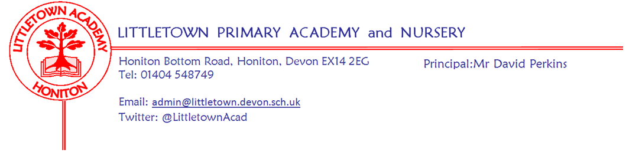

20 March 2020
Dear parents,

As you know school will be closed from end of today. We intend to be open to do our bit to support families that fit very stringent criteria of key working. This includes over Easter holidays. However, depending on number of children and the number of staff absent through illness or through precautionary isolation we may not be able to be open. To make this work we will need support, honesty and responsibility from all parents.

You will read this email and think that it appears that I am saying I do not want children in school. I want to let you know at the outset that this is exactly the case and I make no apologies for this. Telling families they can't come to school is a very strange feeling for a Headteacher and makes it an incredibly hard email to write, but I do so because it really is a matter of life and death. School closure is a key social distancing measure and is to limit risk, illness and ultimately deaths and requires that the absolute minimal number of children should be in school to do so.

This is made crystal clear by the Government here:
If children can stay safely at home, they should, to limit the chance of the virus spreading.
That is why the government has asked parents to keep their children at home, wherever possible, and asked schools to remain open only for those children who absolutely need to attend.
It is important to underline that schools, colleges and other educational establishments remain safe places for children. But the fewer children making the journey to school, and the fewer children in educational settings, the lower the risk that the virus can spread and infect vulnerable individuals in wider society.
This is an absolutely crucial point. Just because you think you might count as a key worker does not mean that you should automatically suggest your children attend school.

Likewise, employers stating that you are a key worker will always suit their agenda, but if your children are at school they and you are at increased risk and it places increased risk on other children, my staff and society in general. I urge you to speak with your employers and put limiting your children's risk first, just as all my staff with children are doing with myself.

I am sure you will understand and agree with the approach that self employed parents will be expected to have children at home if the other parent is a key worker. We will not be receiving children of parents where a parent is self employed. I know this will be a challenge for families and I sympathise, but this is because it fulfills the government first key principle:
Please, therefore, follow these key principles:
- If it is at all possible for children to be at home, then they should be.
As per government guidance, we, like all schools, will have to prioritise school places depending on need. There is no guarantee of a school place:
If your work is critical to the COVID-19 response, or you work in one of the critical sectors listed below, and you cannot keep your child safe at home then your children will be prioritised for education provision

As Principal at Littletown for over 2 years I have been very fortunate in the small number of difficult conversations I have had to have with parents. Hopefully this means you will all know that this isn't something I choose to do, look to do or like to do. However, I am prepared to have difficult conversations today to ensure risks for children, parents, staff and wider society are kept to an absolute minimum and that school opening remains viable in light of these risks.

In order for me to hold these conversations, if you think you might be a key worker that may require a child to be in school for some of a school week please fill in this quick form by 4pm today. https://forms.gle/eDNDqhH7Z4ywjZk69

For the very few children who do end up attending school, provision will be educational in the sense that they will be supported with the same learning children are completing remotely. They will not be receiving teaching or the National Curriculum. This is to ensure fairness of educational provision for all children on roll at Littletown Academy during this period of partial closure.

Again, I apologise for the short notice of this, but we only received government guidance after midnight this morning.

Thank you for all your ongoing support during this unprecedented and very challenging time for all of us.

Many thanks,

David

David Perkins
Principal
Littletown Primary Academy
01404 548749
@LittletownAcad
'a nurturing and exciting place to learn and work'
OFSTED 2019

